###### https://bwsyncandshare.kit.edu/apps/onlyoffice/s/zwC2DXQ32qbXtRZ?fileId=1620650626 Updates: <https://bwsyncandshare.kit.edu/apps/onlyoffice/s/zwC2DXQ32qbXtRZ?fileId=1620650626>

###### Temporal extension of the datasets (up to now):

|  |  |
| --- | --- |
| **DATASET** | **TIME FRAME** |
| UNIPOL | 2017-2020 |
| ESWD | 1995-2020 |
| LAMPINET:  N strikes - 10km grid  LJ index - 20km grid (for now) | 2014-2020  2016-2018  2015-2020 |
| EUCLID | 2001-2020 |
| OT data | 2006-2020 (??) |
| SPHERA “raw” | 2016-2018 (for now) |
| SPHERA gridded (4 D’Aless. Indices) | 2016-2018 (only 20km, must take10 km and original resolution!) |

###### **PRELIMINAR HAIL CASE STUDY ANALYSIS** (updated 19/11/21)

As a first investigation using SPHERA proxies, OT detections, lightning data (EUCLID/LAMPINET) and UNIPOL/ESSL report cases we decided to consider several case studies of recent relevant hailstorms in Italy, Austria and Germany (Baden-Wurttemberg region) that are:

1. 10 July 2019, central-southern Italy (Pescara hail size record 15cm - <https://www.eumetsat.int/severe-summer-storms-italy-and-greece> )
2. 29 October 2018, Italy (Sardinia) (https://www.lastampa.it/cronaca/2018/10/30/news/maltempo-nubifragi-e-frane-sei-morti-un-disperso-in-sardegna-1.34056226)
3. 4/6/2018 in Parma (Noceto) circa 13UTC, Emilia Romagna, Italy (report ARPAE available)
4. 18/8/2017in Bohringen (Romerstein) 15.35UTC(eswd), Germany (south of Stuttgart)
5. 29/7/2017 in Piacenza (Pontenure) circa 19UTC, Emilia Romagna, Italy (report ARPAE available)
6. 24/6/2016 in Dettingen bei Rottenburg 19.10UTC(eswd), Germany (southof Stuttgart)
7. 4-5 September 2015, southern Italy (https://www.eumetsat.int/massive-storms-over-italy-mediterranean-sea )
8. 28-07-2013 Swabian Sura near Stuttgart, very strong convective thunderstorms with hail that caused very large damages (a paper is going to be written on this specific event considering also large ensemble simulations with ICs and parameters perturbartions to quantify uncertainty in model forecasts for this event) (data are computed with higher temporal resolution (fast scanning) of 5 minutes freq instead of 15). Paper of the event: <https://rmets.onlinelibrary.wiley.com/doi/abs/10.1002/qj.3197>
9. 06-08-2013 Swabian Sura near Stuttgart, hailstorm with record breaking hailstones (14cm)
10. 23 July 2009, Austria (max hail size 10 cm, 833 Million euros insured - <https://de.m.wikipedia.org/wiki/Datei:20090723_Hagelunwetter.svg> )
11. 28–29 June 2006, southwerstern Germany (Supercell thunderstorms, severe damage by grapefruit-sized[[44]](https://en.wikipedia.org/wiki/List_of_costly_or_deadly_hailstorms#cite_note-44) hailstones, causing €150 million damage, more than 100 injuries.) (https://archive.ph/20130212011141/http://www.sueddeutsche.de/panorama/286/374096/text/ )
12. ~~4 August 2002, northern Italy (https://www.eumetsat.int/severe-hailstorm-po-valley-italy )~~OT data not available

9/11/21 + 19/11  
  
FIRST GRAPHICAL ANALYSIS OF EVENTS:

**/home/ciccuz/phd/KIT/scripts/HCSAnalysis_1FirstEventsAnalysis.docx**

27/10

**OTHER NOTES (meeting with HJ and Michael):**

* Previously similar works were done using reanalysis datasets at 7 and 28 km res.
* Interest also into looking at specific severe hailstorms events with detailed high-resolution on the vertical
* Other interest is also to study in more detail the conditions for triggering of hailstorms as its not well understood, and is not included in the analyses up to now (e.g. Some studies on convergence zones responsible for triggering)
* Must check if we have as SPHERA output convective precipitation (interesting info on how employing for hail studies in a paper from Groenmeijer)
* First investigation with reanalysis after case studies would be to consider SLI in specific cases (instead of CAPE, more valuable SLI info)
* Analysis could be carried on considering “long” summer (April to October) but also considering only JJA to understand if environmental conditions for hail production change very much
* Analysis carried by Markus: cluster analysis on location and season of convective events
* Another possibility in the future would be to use COSMO-DE data at 2.8km resolution as in a previous work many different convective indices (around 60) were computed in analysis mode, every hour for 2011-2016(?), as e.g. Wind shear at 10 different vertical levels instead of the only 0-6 km shear, so would be interesting for a comparison with SPHERA outcomes (especially since using very similar COSMO configuration to quantify the added value of using a reanalysis over an analysis when coming to hail favouring environment description!).
* When HJ will not be at KIT anymore I could ask to Jannik and Susanna for support/guidance given their experience in this field (must meet with them and Michael)
* Kris Bedka for OT data suppliance
* Script avaialble from HJ for estimating matching between OT data and reanalysis proxies by calculation of performance scores, can be found under:  
  /home/punge/scripts/hss_era_nogrid2.py (machine learning appl)  
  /home/punge/scripts/hss_era_grid.py (thresh method without ML)
* HJ: One question will be, whether you focus on the conditions in the location where most of the hail was detected (e.g. 14UTC, south of Stuttgart for event 28-07-2013), or whether to look at the origin of the storm (in this case near Freiburg more like 13UTC). The former is probably more easy to implement.
* Pierre Hasler: analsis on processing of lightning datasets: code almost finished (up to now considering 10x10 km gridded data with 1h temporal resolution) and available to be employed with other datasets, maybe could be useful for post-processing of LAMPINET???  
  Presentation will follow soon
* HJ: suggestion for when moving to reanalysis + hail obs verification: when checking rean. proxies on grid construct a filter to retain only those cells where there is at least 1 insurance/eswd report and compare the results with or without the filter

**10/11/21 MEETING WITH Michael & Kris:**

* Kris: besides OT detections data suggests to use also **Infrared (cloud top) - Tropopause Temp** to get info on the strenght of the storm -> target little cold spots in the entire anvil area and assign a score of how likely they are. In the scripts: used MINIMUM dTemp (infrared brightness - tropopause), why minimum? →because it’s a negative DeltaT if OT is present (lower temperature on top of OT cloud (infrared brightness temp) than tropopause)
* Am I using parallax correction to get satellite data distributed on the right places? -> YES: when plotting e.g. OT max prob. I use cpclon,cpclat coordinates (corrected for parallax displacement of satellite data)
* Kris: for OT probability dont consider values **< 0.5%** -> as they could be related to anvils not well linked to updraft -> Kris could send a paper of a recent validation justifying this threshold (Request it!)
* No problem for having OT data for the 3 years period (2016-2018) over SPHERA domain as it’s pretty small -> just let know Kris when I am ready to use the data and he will provide us
* Kris: filter developed by HJ used thresholds in order to retain all legitimate thunderstorms (i.e. Eliminate storms that there’s no way the could generate hail) VS focusing on likely-hail generating storms, that is quite different, and that is what also Kris and his group are doing for US with random forest ML approach. Both approach are valid but depend on the application
* Since my application is for agricultural hazard assessment, Kris strongly reccomends to use also their data developed with **Passive Microwave Imagers:**

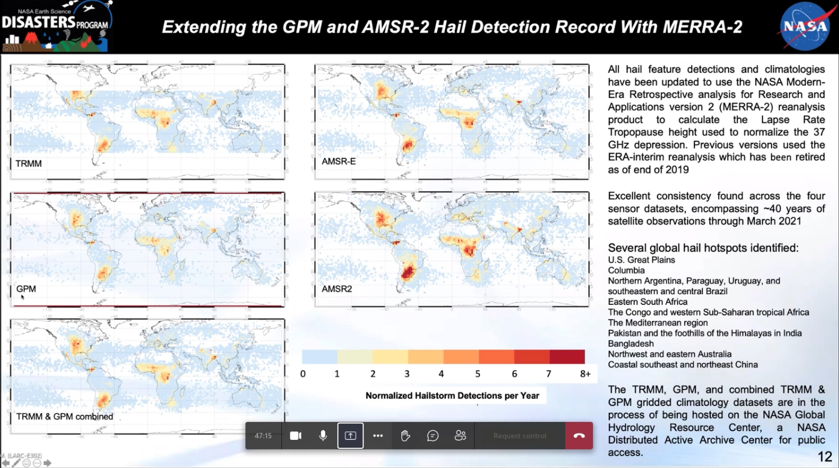

These are global gridded climatologies, with grid steps of 2°, of hailstorm detections per year. It could be useful to take the data-based individual detections over the years and plot them over SPHERA domain maps, to see with this view of hailstorm (that is more robust than geostationary satellite view of hailstorms) how hail detections line up with respect to agricultural applications. I could access these datasets as a collaborator of Michael for free. HJ used them in the South Africa paper. Reference of these datasets: 2019-2021 papers (ask Kris) documenting how they developed these data, the method, and so on BUT still few applications has been made SO it would be very interesting to use these data in my analysis!! -> Just let know Kris if I am interested in that and he will provide them!

Some specs: Obtained from processing over 40 satellite years of convection with different datasets: TRIMM (but does not cover Italy entirely), GPM (2014-present), AMSR-E(died in 2011 circa), AMSR2 (2012-present). AMSRs are sun-syncrhonized (i.e. Only view at 1.30 am and pm), while TRIMM and GPM are ..?? So obs are obtained at random time throughout the day, so you have to be lucky to detect hail events. Coarse resolution of 2° is not related to the satellite data but to the fact that in some regions there are so few passages, so in order to not having data with so much noise is better to keep a lower resolution. From maps:Noticeable is a local maximum in the Mediterranean region

17/11

**SPHERA DOMAIN**: sphera original domain is = COSMO 2I domain (i.e. Includes southern-Germany area) but PROBABLY some grid points were deleted near the borders (around 25 grid point, circa 50km) to avoid border effects (some problems were detected in France alpine area and Dalmazia, but NOT in Germany) -> Checked various original variables as extracted from ECWMF: S Germany included! The problem is in the data gridded (probably to be consistent with more limited LAMPINET domain)

19/11 **MEETING WITH HJ**

* **Hail climatologies from passive microwave imagers:** used a little for South Africa case in a comparison with OT dataset (look at preprint: Michael sent me pdf). Compared to OT data we capture an higher number of events, especially those events with small hail related to thunderstorm not reaching the top of the troposphere (no OT), while with microwave imagers the ice in the atm is detected so it’s easier to not lose events (despite the problem of passing by of the satellite).
* Why minimum in delta T (IR brightness - tropopause temp) to quantify strenght of storm? -> because we are seeking for negative values of this deltaT, meaning an OT colder than environment (i.e. IR brightness temp < tropopause temp), and **the minimum represent the value in which we have the maximum OT extension** (higher temp difference between OT top and tropopause)
* Start to look at sub-daily temporal scales (hourly) with the available data!!
* Study more convective proxies!!:
  + **LI**: must take the minimum not max!! Anything below 0°C is relevant for convection, for strong events reach -10°C
  + **Kindex**: based on temperature differences to quantify atm instability, take max values (the stronger the temperature gradient the stronger the storm). To get some typical values: paper from 2007 Michael (https://nhess.copernicus.org/articles/7/327/2007/), useful also for typical values of many other indices!. E.g comment for the Piacenza case: larger values of 36 °C in almost entire area, indicating that instability conditions in the atmosphere were present in the region so that there was potential for thunderstorm development, but this is only one ingredient not sufficient alone, so it happened in a place where other conditions were fullfilled.

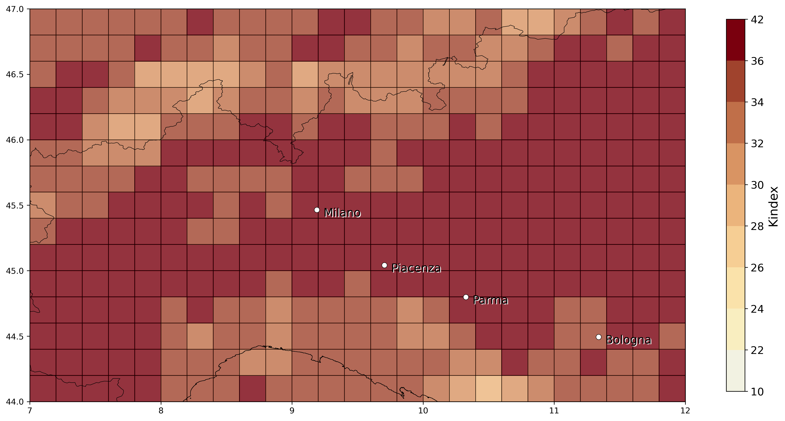

* + **AvvGeoPot500:** quantifying advection: if the geopotential stays the same everywhere all the time this param goes to 0, but when a trough approaces there will form a region of lower geopotential (@500hpa). E.g. in the Piacenza case: West of the thunderstorm there is not much change in geopot as the advective term (velocity * geopotGradient) is low, while in the region of the thunderstorm this parameter increases very much (e.g. if it is a trough initiating convection an increase in the advective term of geopotential will be present). Maximum of the day can be used but since it depends very much on the timing -> take a look at hourly temporal res! (must also check how stable this param is, since noise is detected in the plot,but maybe do to non optimal scale used)

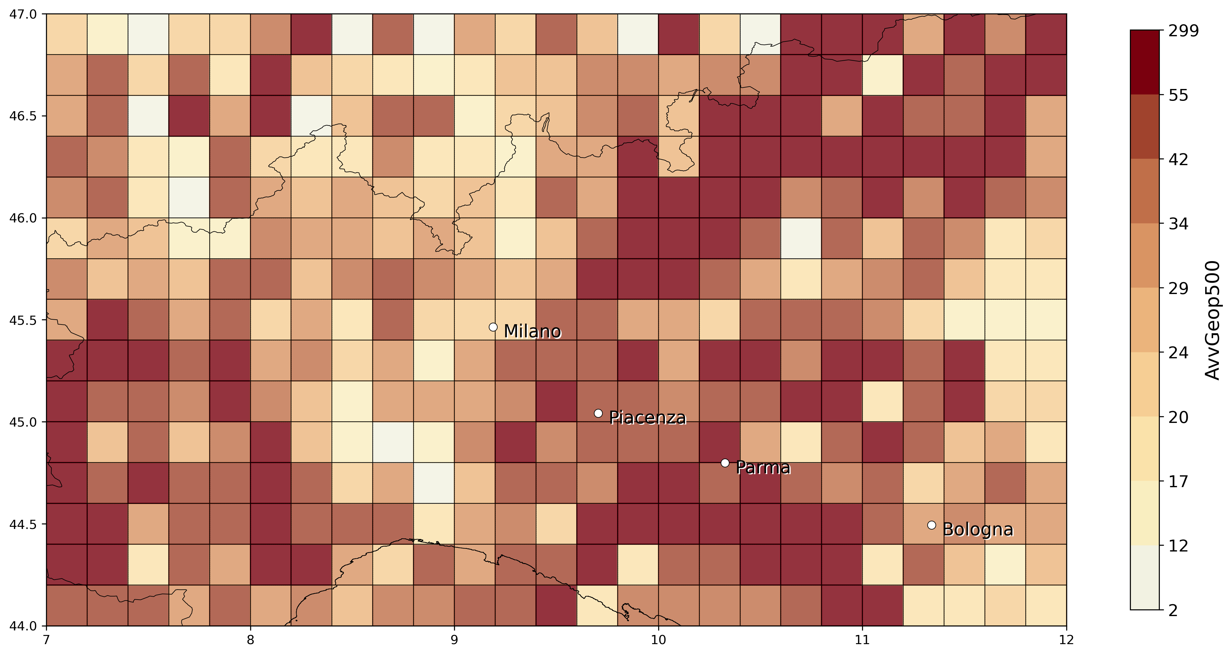

* **%VV700**: quantifying vertical velocity strength (if model represents convection in right location high values of %VV700 should be expected), right to consider the maximum. As definition this param is expressed in isobaric coordinates (Pa/s): for an ascending motion the pressure will be lower for larger altitudes -> that’s why threshold for param calc is set to -0.5Pa/s. Also for this we should take a look at hourly data!

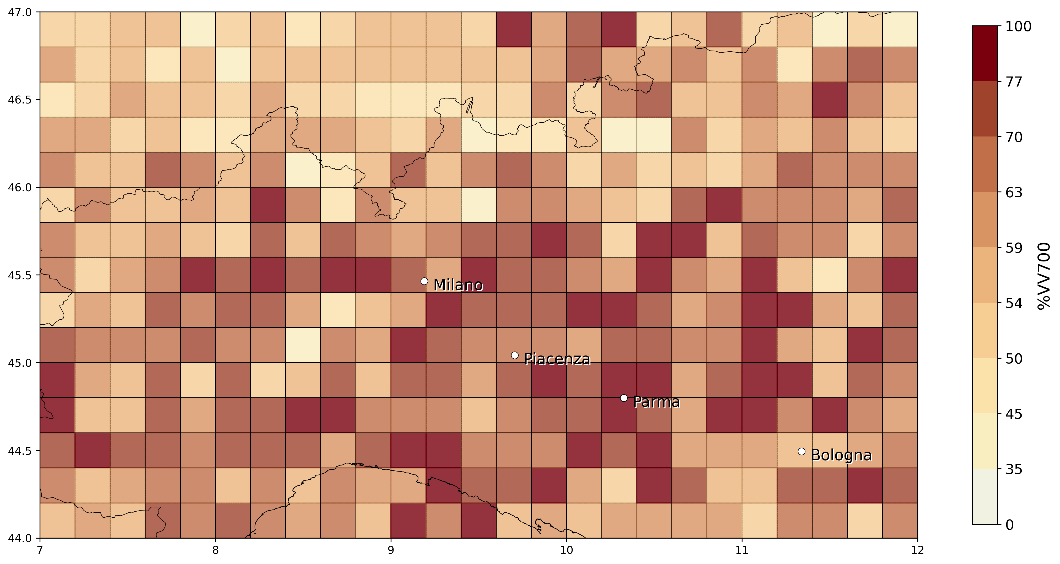

* To proceed: find timing from obs. Of maximum strength of the storm and then look at model parameters and compare them for the same hour, even if it is tricky to get appropriate matches on high temporal scales it is necessary for our purposes!! However different parameters must be considered with care: for atm. Instability the pre-convective conditions are more relevant while for e.g. %VV700 parameter the conditions of maximum intensity of the convective storm is more relevant. e.g. for LI, if there is strong convection occurring in the model means that instability in atm is already established so at that moment you have lower values of LI -> so it should be considered before (1-2 hours) where convection occurs (pre-convective parameter?) -> Could be useful to take a look at modeled precipitation as it should be aligned, temporally and spatially, to region of convection.
* To start with is better to look at events that took place in a limited region and that didnt last too long (otherwise it is more difficult to produce good matches).
* Maybe consider other events in 2016-2018 to compare the most possible data available
* A nice comparison would be to do the same analysis and **compare with ERA5** once the filter with proxies obtained with SPHERA is optimized, must check at appropriate time if data available.

22/11**- MEETING WITH DAVIDE**(SPHERA data domain, 10 and 2.2km res)

* Procedure start to have csv data on larger domain (including southern Germany) and at high resolution (**averaged on 10 (1/10 degree) km** and original 2.2km (for this must try how much time it takes given the much increased number of grid cells!)). Does the averaging from 2.2km -> 10km have a low impact??? These data will include, besides the 4 D’Alessandro indices (leaving out %VV700 for the original SPHERA high-res. as it is calculated from a certain number of grid points entering a cell, that becomes 1 grid point when considering the original resolution), also CAPE (MU and ML) and HZEROCL (two direct outputs of SPHERA).
* SPHERA data are instantaneous: related to model hour at the time the model produced the output (differently than LAMPINET where data are cumulated over the last 15 minutes).
* Once Davide fixed the procedure I will have to maintain it to obtain the data:  
     
   Davide: ho documentato un po' le procedure per la generazione degli indici temporaleschi e relativi file di appoggio, spero sia comprensibile, potete modificarla, l'ho inserita nella cartella condivisa indicata sotto. Ho creato su richiesta di Antonio una seconda serie di griglie e maschere estese di 1 grado a N (49N) per coprire parte della Germania. Attenzione però che alle risoluzioni più alte (sicuramente _5 e _10, cioè 0.2 e 0.1 gradi) non tutte le box sono coperte da SPHERA, per cui ti ritroverai meno punti nel risultato rispetto al numero di punti nello shapefile, e possibilmente alcuni senza dati validi (ma comunque tutti etichettati correttamente).

Ora sta girando il 2018 con la griglia "vecchia" fino a 48N, passo 20 km, poi credo che sulla base delle istruzioni tu ti possa calcolare autonomamente gli indici su 10 km e/o sulla griglia estesa 49N, se hai dubbi fammi sapere.

Resta da estendere gli indici con i dati puri di HZEROCL e CAPE_MU (espandere i dataset grib e modificare il programma per farli uscire così come sono, solo mediati sulle box) e fare il lavoro punto per punto, quest'ultimo lo lascerei da parte per ora, sono un po' scettico, almeno dal punto di vista tecnico.

<https://drive.google.com/drive/folders/1CzBYl9_btHQpDeFnCUxyd8XFCtWvUQCD>

**23/11**

Other events to (maybe) be considered for the initial validation of SPHERA:

* 15 October 2016: Casalbordino, Abruzzo - hail with 7 cm diameter
* 9-10 August 2017: Trentino - Südtirol, moving thunderstorm that caused many hailfalls in the region
* 14 May 2017: Altovicentino, Veneto
* ... CONTINUARE (TROVARNE 10-15 ALMENO)

**MEETING WITH MICHAEL:**

* Good to extend the sample of preliminar events for the analysis, especially since an important point in the preliminar analysis for specific case studies is to consider hailstorms related to **different generating processes**: not only supercells, but also hail formed in multicells, clusters, MCS, or squall lines (relevant case: 11/09/2011 named Felix, squall line extending from north to south of Germany that produced strong damages especially in Eastern Germany (with old buildings destroyed), as well as hailstorms in different periods of the year not only related to summer deep convective processes but convection triggered by other causes such as fronts (e.g. considered event in Sardinia of 29 October 2018).
* Another important source of data could be **DWD app** of individual reports, new dataset useful also for hail (should be more comprehensive than ESWD, but dataset starts from 2020?)
* Understand when SPHERA data for 2019-2020 will be generated and made available?? Because for this period we could use also DWD data!
* SPHERA convective proxies: besides using %VV700, AvvGeop500, Kindex, LI and now when I add CAPE and HZEROCL,is necessary to include also a variable related to change of wind in the vertical. Optimal would be to use Storm Relative Helicity SRH but, due to lack of extracted data from SPHERA, it would be enough to **consider the Deep Layer Shear DLS from 10m to 500hPa**.   
  SRH, from a past study of Michael student, has shown to better discriminate than DLS hailstorms with small hail and short tracks than storms with large hail and longer tracks. Also Jannik in his phd thesis considered many different convective parameters, but used DLS instead of SRH, ask him why?

So, “Final” **set of SPHERA convective parameters** to be used as proxies are:

1. Kindex, (already available)
2. SLI, (already available)
3. %VV700, (already available)
4. AvvGeop500 (already available),
5. CAPE, (direct output of SPHERA) in two variants: CAPE_MU and CAPE_ML (is it possible that in rare cases CAPE_ML >CAPE_MU? Yes, when there is a shallow inversion layer near the surface (see answer below))
6. HZEROCL (direct output of SPHERA) **-> key Q: is this altitude relative to sea level or to topography??** Defined as “Height of the 0°C isotherm **above mean sea level**” from COSMO manual (http://www.cosmo-model.org/content/model/documentation/newsLetters/newsLetter05/cnl5-appendices.pdf)  
   When below the sea level is defined as -999 (substituted with “rmiss”), also when in the same averaged grid (10km) all H0<0m -> Val =0.340282347E+39
7. DLS (to be calculated as from 10m to 500hPa and gridded)

Update 26/11:

* Finished to obtain new SPHERA data (4 D’Alessandro indices) for 2016-2018 (April-October) gridded on 10km, extending to 49°N! -> **next up: obtain data on same grid for CAPE,HZEROCL, DLS**

**Questions for Meeting with Michael (and HJ?):**

* ~~Discuss how to proceed~~
* ~~Insight from SOuth Africa paper~~
* ~~Discuss data transfer/mainteinance when i leave KIT~~
* Passive microwave imagers usage: use them as a comparison a posteriori for validation of the OT filter constructed with SPHERA proxies, or in another way?
* ~~Letter for reporting of the activity carried out by at KIT~~

20/1/22 MICHAEL

* Collaboration with KIT after phd: could be interested in post-doc positions, project as ClimXtreme (so natural hazards in climate change perspective), but will see in due time in case...
* **DLS**: parameter that in US is very much important for describing hail/severe convective events, while in Europe much less, probably due to the much more complex topography, and has shown no added skill when combined with LI in a study (of Michael), BUT still it needs to be considered when considering hail renalysis proxies (as it is widely accepted in the scientific community, and they would ask for it for sure in a potential review)
* **CAPE**: with COSMO 2.8km in assimilation mode gaps in CAPE (i.e. going to 0) have been detected when convective event has started due to the explicit representation of convection, so this must be considered with care also in my case having high-res model! -> look for CAPE gaps in event after convective initiation and development, before hailfall!

21/1/22

HAIL EVENTS EXAMPLES (see .pdf) first comments:  
<https://bwsyncandshare.kit.edu/s/zwC2DXQ32qbXtRZ?dir=undefined&path=%2FHail&openfile=1800609919>

* Comparison of daily and (especially) hourly estimates of OT max prob, eswd/unipol, euclid, Delta temperature (IR bright - tropopause), and daily total number of lampinet lightnings/hourly LJ index:

From two case studies (Piacenza 2017 and Pescara 2019): very good match between all different data sources (despite maybe unipol data sometimes due to large temporal uncertainty) especially when going to high temporal resolution (1 hour), indicating good ability in detecting strong convection going on on limited temporal scales, and also a good ability in representing the evolution of the events.  
Try with more events and extend analysis to available SPHERA proxies for these events.

FOR MEETING WITH HEINZ JURGEN + meeting on 25/1

Insights from **Punge et al 2021 paper (South Africa):**

* OTs: “*An advanced version of the OT detection algorithm described bi* ***Kholopenkiv et al. 2021*** *delivers a 3km gridded probabilistic estimate of OT likelihood based on a statistical combination of tropopause-relative IR brightness temperature, prominence of an OT relative to the surrounding anvil, and the are and spatial uniformity of the anvil cloud surrounding an OT candidate region.*” -> this means that the Delta T (IR brightness temp - tropopause temp) is already included in the OT probability data (and so i should not consider also the other parameter when studying hail events)
* ERA5 filter proxies: “*for South Africa the filter design used for EUrope and Australia has been retained (****Bedka et al. 2018****)*” -> HJ: was actually developed for Europe and then applied to Australia and South Africa but **must try again**, especially now with high-res conv-perm proxies, if it is still valuable AND useful also for doing sensitivity analysis on filter threshold proxies also to quantify uncertainty in the method (as Michael suggests)!
* ERA5 filter proxies design: “*for hazard modeling purposes the focus is on the identification of larger clusters of severe convective storm events likely to have produced hail in the event lifetime rather than detecting each isoletad storm with enhanced hail potential*” -> keep valid also for my case? I would say YES since the main goal is to assess probability of hail hazard for agricultural reasons -> HJ: probably yes, Kris: it makes sense to attempt two different filtering: a “relaxed mode”, to consider all possible hailstorms, and a “stricter mode”, to retain only severe hailstorms
* Produce OT count map as Figure 3, and filtered OT as fig6 for Italy for the period 2016-2018 and 1995-2020 (??)
* Hail reports processing: “*A uniformly distributed random number between -0.5 and 0.5 was added to each reported hail diameter to compensate for rounding in the hailstone measurement process and to obtain a smooth distribution*”, apply procedure also for ESWD data Im using?? -> think on it later in due time if hail-size analysis are going to be performed
* **Algorithm for identification of convective (hail) events** from OTs: could I apply it also to my analysis or criteria should be changed (e.g. spatial/temporal distance between different OTs associated to the same event)?? -> HJ: in principle yes, it’s a matlab code algorithm, but depends on the analysis im intending to perform: if considering hourly-based statistics for hailstorms it does not make sense as these events are defined on multi-hours, so let’s see in due time
* Approach of using generated **stochastic events** to investigate with a larger sample size OTs associated to hail events occurrences: something needed/useful/suggestable also for my analysis or not? Maybe not the main focus, as I would be more interested in using the same algorithm with OT filtering by forcing the filter with different reanalyses: SPHERA and ERA5 to assess benefits of high resolution, also since my main purpose is to develop a hail risk map for italy this is a little out of scope maybe, but in the future could be interesting.
* **Marion et al. 2019** suggest that convective storm severity be linked to OT area -> look at paper?

24/1

Reading Review **Raupach et al. 2021**, “The effects of climate change on hailstorms” -> SUPER interesting and useful, very well explained the main factors influencing hail formation (convective instability and low-level moisture, melting level height and vertical wind shear) and how they could change hail frequency (strong convective events) distribution region-dependently due to anthropogenic global warming.

IMK meeting 26/1 - Michael:

* **Insurance data**, besides being really uncertain for the temporal resolution, spatial localization, also they could be false when people try to **fraud** a bank and flag an insurance claim when there was not a meteo event (relevant issue at least in Germany) -> understand if this is relevant also for UNIPOL data? In teoria no: dati che abbiamo sono tutte richieste di rimborso pagate da UNIPOL (quindi accertate)
* Way of quantifying uncertainty related to hailstorm events based on the data i have available, two suggestions: 1) sensitivity analysis on the reanalysis proxies (CAPE; DLS....) to quantify their impact on outcoming “verification” with hail obs, if there is a lot of impact with small changes in the proxies probably the uncertainty is large.... 2) stochastically simulate uncertainty (not as in SOuth Africa stochastic approach that was used to enlarge the sample of events), but in case discuss at due time with Michael

Find out if there are other reanalysis proxies studies on hail/deep convection based on finding favourable environemnt**s on a hourly basis** (b~~ecause it can be very challenging and tricky to set up proxies thresholds on hourly basis, especially for indices such as LI or CAPE which could decrease very much when convection has initiated in the progresive hours since the storm formation)~~ -> Just consider a temporal window before the OT occurrence (for now considered 4 hours??)

Meeting with Michael:

* For analysis of matching different gridded data for individuating storms and calculating statistical skill scores ask Jannik/ look at his phd thesis (unfortunately in german) because he did something very similar in his phd, maybe ask if in python code if he could give me the code?
* Book reccommendation: **Robert Trapp - Mesoscale-Convective Processes in the Atmosphere**
* Suggestions on how to proceed for the analysis: since hourly-based analysis with convective proxies is very hard (due to too many uncertainties going on such as model uncertainties, spatial uncertainties, temporal uncertainties and so on..) it would be useful perhaps to find some methods to **filter out irrelevant spatial boxes** where certain conditions on the proxies are not met (e.g. values of LI > certain threshold, based on percentiles or on fixed value) BUT keeping those boxes around them of at least a certain distance (like in fuzzy verification) in order to have information restricted only on an area where the storm potentially could be, and another way could be by **finding a daily “footprint” of the event** (e.g. taking the minimum of LI over the day and retaining only the boxes where there was a minimum of at least a certain value, and doing the same with other proxies). Also I need to understand VERY WELL what the proxies I use represents, especially not-so-obvious proxies such as AvvGeop500 or %VV700 in order to construct an optimal filtering for them!!!

**8/3/2022 RECAP: TO DO AFTER PAUSE (per articolo):**

* ~~Check if j-notebooks work~~
* ~~Find a sample of events to extend analysis on 2016-2018 (for now only three events: Piacenza,Parma and Sardinia), at least 10-15 events~~
* Read paper Australia 2018
* Write to Kris for OT data for events + ask for any doubt regarding OT data/application in my case
* Write to Davide to understand how to get SPHERA data gridded on 10 km 2016-2018 of DLS, z0 and CAPE
* Set up a set of thresholds for SPHERA proxies based on literature/quantiles?
* Understand how to start a spatial matching analysis (for the moment between OT and SPHERA proxies) and define score metrics, start the analysis for the sample of hail events considered, perform sensitivity analysis on proxies thresholds?
* A main issue is: how to perform hourly analysis since (for the momtn) no previous literature is found at this temporal resolution? Start maybe with daily analysis to tune thresholds and method of matching, and then move to hourly somehow

**Enlarge sample of hailstorm events in Italy 2016-2018:**

For the moment we have:

1. 29 October 2018, Alghero (Sardinia) (https://www.lastampa.it/cronaca/2018/10/30/news/maltempo-nubifragi-e-frane-sei-morti-un-disperso-in-sardegna-1.34056226)
2. 4/6/2018 in Parma (Noceto) circa 13UTC, Emilia Romagna, Italy (report ARPAE available), 8cm hail +other events in central Italy with smaller hailstones (3cm)
3. 29/7/2017 in Piacenza (Pontenure) circa 19UTC, Emilia Romagna, Italy (report ARPAE available), no eswd reports

Plus to add (selected from ESWD):

* 7 October 2018, Melpignano (Lecce Salento), circa 12UTC, <https://www.trnews.it/2018/10/07/grandine-come-neve-sulla-lecce-maglie/230825>
* 7 September 2018, Carapelle/Orta Nova (Foggia), crica 14.20UTC, 5cm hail, <https://www.foggiatoday.it/cronaca/grandine-carapelle-orta-nova-cerignola-maltempo.html>
* 2 September 2018, Pescara, circa 13.30UTC, 5cm hail, <https://www.facebook.com/tornadoinitalia/photos/a.370143886500651/1056898884491811/?type=3&theater>
* 23 July 2018, Turi (Bari), circa 11UTC, small hail, <https://www.baritoday.it/cronaca/pioggia-grandine-adelfia-turi-casamassima-putignano.html>
* 9-10 August 2017: Trentino - Südtirol, moving thunderstorm that caused many hailfalls in the region
* 28 June 2017, NORD ITALY:
  + Brisighella (Ravenna), 14.25UTC, hail with 2cm, <https://www.ravennatoday.it/cronaca/nubifragio-28-giugno-2017-danni-agricoltura.html>
  + Songavazzo (Bergamo), 10.17UTC, hail with 2cm, <https://myvalley.it/2017/06/grandinata-cerete-songavazzo-danneggiato-mais/>
  + Cartigliano,Mussolente,San Zenone degli Ezzelini (Vicenza), 12:30 UTC, hail with 4-6cm, <https://www.inmeteo.net/2017/06/28/violenti-temporali-veneto-maxi-grandinata-cartigliano-vi/>
* 27 June 2017, Frinco (Asti), 21.15UTC, hail with 8cm, <https://www.inmeteo.net/2017/06/28/disastrosa-grandinata-piemonte-chicchi-10-cm-nellastigiano/>
* 25 June 2017, NORD EST ITALY:
  + Gussago (Brescia), 15.45UTC, 6cm <https://www.quibrescia.it/cronaca/2017/06/26/grandine-e-temporali-molti-danni-nel-bresciano/521053/>
  + Cremona, 17UTC, 3cm
  + AltoTrevigiano (Vittorio Veneto), 6UTC, 5-10cm <https://www.instagram.com/p/BVwJGx4lC7N/>
* 14 May 2017: Veneto-Emilia Romagna:
  + Altovicentino, Veneto 19.30UTC, 5-7cm
* 4 May 2017: Oderzo (Treviso), 12UTC, hail with 2cm, <https://www.trevisotoday.it/cronaca/grandine-a-oderzo-oggi-4-maggio-2017.html>
* 15 October 2016: Casalbordino, Abruzzo - hail with 7 cm diameter  
  <https://pp.userapi.com/c626218/v626218096/31020/9vKyUDRzj3c.jpg>  
  <https://www.zonalocale.it/2016/10/16/-mai-visto-nulla-di-simile-dopo-la-grandine-si-contano-i-danni/22587?e=vastese>
* 29 August 2016, Torino, circa 20.10UTC, hail with 5cm, <https://www.inmeteo.net/2016/08/30/grandinata-torino-immagini-impressionanti-rivoli-collegno.-ancora-lastre-ghiaccio-al-suolo>
* 16 August 2016, Albenga (Savona), 18UTC (in articolo scritto “poco dopo le 20), hail with 2cm, <https://www.savonanews.it/2016/08/17/leggi-notizia/argomenti/attualit/articolo/forte-grandinata-ieri-ad-albenga-continua-linstabilita-in-provincia-di-savona.html>
* 5 August 2016: Mondolfo (Pesaro-Urbino, Marche), circa 17UTC, hail with 4cm, <https://www.inmeteo.net/2016/08/05/maltempo-marche-violenti-temporali-fra-pesarese-anconetano.-forte-grandinata-mondolfo-foto>
* 18 June 2016, Asiago (Vicenza), circa 13UTC, 3cm hail with large accumulation <https://www.inmeteo.net/2016/06/18/veneto-ancora-temporali-violenti-pazzesca-grandinata-nel-vicentino-altopiano-asiago/>
* 8 April 2016, Condove (Torino), 14.30 UTC, hail with 5cm,and large accumulation [andhttps://www.inmeteo.net/2016/04/08/maltempo-piemonte-devastante-grandinata-condove-torino-.-fiumi-ghiaccio-le-strade-video](https://www.inmeteo.net/2016/04/08/maltempo-piemonte-devastante-grandinata-condove-torino-.-fiumi-ghiaccio-le-strade-video)
* 7 April 2016, Berbenno (Bergamo), 6.30UTC, small hail with accumulation layer of 2cm, <https://www.inmeteo.net/2016/04/07/maltempo-fitta-grandinata-berbenno-nel-bergamasco/>   
    
  Julian date conversion:

2016098  
2016099  
2016170  
2016218  
2016229  
2016242  
2016289  
2017124  
2017134  
2017176  
2017177  
2017178  
2017179  
2017221  
2017222  
2018204  
2018245  
2018250  
2018280  
Insights from **Bedka et al., 2018:**

* Analysis of OTs temporal spatial distribution: maybe useful to do something similar also in my case, since OT detected with new algorithm (Khlopenkov et al., 2021) not already employed in Europe, and also to give a sense of the impact of reanalysis-based filtering to retain OT associated to hail

15/3/22  
Prepared SPHERA data of CAPE, HZEROCL, 10uv e 500uv (2016-2018, April-October) for gridding to 10km, must calculate DLS and then grid all hourly data to obtain csv tables (asked Davide for help in calculating DLS)

29/3/22   
SECOND GRAPHICAL ANALYSIS WITH EXTENDED SET OF EVENTS(New set of hailstorms (OT data received from Kris), first comments)

**/home/ciccuz/phd/KIT/scripts/HCSAnalysis_2EventsAnalysis.docx**

**QUALITATIVE RESULTS EVENT-BASED ANALYSIS:**

Sample of 21 hailstorm days considered in 2016-2018 during April-October, when considering daily aggregations of OT (max probability >0.5 from hours 1-23) and hourly LJ indices (but considering only spatial matching with hail obs during the whole day not specifically for every hour) before any reanaylsis-based filtering:

* Total of **89 ESWD** reports and **1294 UNIPOL** reports detected (=**1383** hail reports).
* OT max prob. matched with **70 ESWD** (79%) reports and **1175 UNIPOL** (90%) rep. (=**1245** hail reports (90%)).
* LJ index spatially matched with **44 ESWD** (49%) reports and **871 UNIPOL** (67%) rep. (=**915** hail reports (66%))

Of course only the matching/missing with available obs is considered, all the OT/LJ occurrences not related to observed hail presence (false alarms) are not considered before the filtering with hail-favouring conditions but the false alarm rate in this context would be huge (since not all (i.e. the majority) of non-filtered OT/LJ occurrences are unrelated to hail!)

2/5/22

Analysis with hourly SPHERA proxies for events:

* Case study Chieti-Pescara (15-10-2016) -> 1 eswd report (7cm hail)  
  Thunderstorm developed around 6am in inland and moved towards the Adriatic causing hailstorm (detected at 7.30am)
  + Very good agreement with hourly OT and LJ detections
  + **CAPE_MU**: low values (<400J/kg) at 6 and 7am (CAPE minimum around the thunderstorm location) then increases from 8am
  + **DLS**: large values (>20m/s) in the whole area of the event but a characteristic footprint is lacking (even larger values detected nearby not associated to storms)
  + **H0**: values <3700 m found in the whole area and timings of the event
  + **Kindex**: larger values at 5am (>39°C) then at 6-7am (>33°C), then following storm track in the sea quite well with a blob of maximum K having values >41°C
  + **LI**: decreasing values from before the event (<2°C) to the occurrence (<0°C) to even after (<-5°C)
  + **%VV700**: there seems to be a blob of maximum %vv700 (>75%) in the area and timing of event but overall very noisy as always
* Case study Parma (Noceto) (4-6-2018): 8cm hail (12:30am) + many other hailstorms with smaller hail (3cm): 7eswd reports and >300 unipol reports (many unipol reports issued at delayed times: e.g. at times >16UTC in the Po’ valley (>4h later of the first reports) when OT are lacking everywhere, **probably temporal issue of the dataset!**)
  + Multiple matching of OT with all ESWD reports and many UNIPOL reports, also hourly LJ matches well with eswd reports. SLI shows good matching with deep convective spots where reports are issued!
  + **CAPE_MU**: high values (>2000J/kg) in Po’ valley in the morning, small blob of max CAPE near Parma around 12 (timing of hailstorm), also max blob detected near Ancona around 13-17 (assoc. to other hailstorm)
  + **DLS**: moderate to high (>12m/s) DLS in the morning, and maximum values (>24m/s) near Parma around 12-13utc, also near Ancona in 11-14utc high values (>16m/s) detected but less well visible
  + **H0**: values <3400 m in eastern Po’ valley and near Parma while <3700 m near Ancona over the whole day
  + **Kindex**: high values (>36°C) in Po’ valley and close to Parma event (9-15utc), also high values (>39°C) near Ancona at 11-12am, before the event
  + **LI**: low values (<-5°C) near Parma before the event (9-12am), also very low values (<-7°C) near Ancona before the event (9-12am)
  + **%VV700**: a blob of high values (>60%) seems to precede the event in Parma (11-13utc), and also that in Ancona with vals. >75% at 11-12utc, but always very noisy (many other blobs detected in many places where OTs or reports are not issued)
* Case study N-NE Italy (25-06-2017): two distinct (detected) hail events during the day: 1st during the morning (5-7am) along the alpine foothill area (orographic convection most likely) with 8 eswd reports in Veneto (max hail size:10cm!!) and some unipol reports (scattered in time in the next hours, problem as last event reported above or related to new hailfalls??), and 2nd during the day at 15-16utc near Brescia (max hail size: 6cm) with also several unipol reports issued in the next hours (up to 20utc)
  + Numerous OT issued especially along the Alpine foothill area: good hourly matching with 1st nocturnal event, also a weaker and more circumscribed OT is detected close to the report of the 2nd event at the correct timing. Also hourly LJ matches well: 1st event completely detected at correct timing, 2nd event correct timing but a little spatially mismatched at 16utc, even if consecutive LJ are issued at the correct location at 17-18-19utc (maybe consecutive multiple hailfalls not detected by OT instead of delayed time of the unipol reports??)
  + **CAPE_MU**: high values (>2800J/kg) of CAPE in western foothills and in Po’ valley near Bologna, but lower (<400J/kg) in the area of the event during, but a little higher before (<1200J/kg). A little higher values (>1200J/kg)near second event around 15utc
  + **DLS**: low values (<8m/s) in the location of the 1st event, even before, but all around higher (>16m/s) and much higher (>24m/s) values! Slightly larger values (>16m/s) near the time and space of the 2nd event.
  + **H0**: decreasing values close to Alps and moving towards Po valley during the morning, with <4000m at the time of 1st event, which remains also till the 2nd event.
  + **Kindex**: higher values (>39°C) in the loc. Of 1st event before (3-4am) and decreasing during the event (<39°C). Similarly for 2nd event: high values (>39°C) at 12-14utc and decreased (<33°C) during the event
  + **LI**: minimum of LI (<-7°C) detected in other areas (Piedmont-Lombardy foothills and southern Po valley) and not in the area of the 1st event where it stays <0°C (before and during). Lower values (<-5°C) detected before and during the 2nd event.
  + **%VV700**: 1st and also 2nd events very noisy, i dont detect any non-random pattern
* Case Study Torino/Graz: (29-08-2016) two distinct events during the day: first near Graz between 11-14utc (max hail size 5cm) 6 eswd reports, second near Torino at 20:10utc (5cm hail) 1 eswd report.
  + OTs close to first two reporst around 11am near Graz (lower prob., but >0.5), other 4 reports around 13utc match well with OTs. Also report in Torino at 20:10 shows good match with OT (even if in the hour before the event, so 19-20 and not 20-21 (but if considering 19.30-20.30 would be perfect, so remember about temporal window when considering the matching!!))
  + **CAPE_MU**: 1st event: increasing values east of Graz from 11am (>1600J/kg) to 13utc (>2400J/kh) south-east of Graz close to the hail reports location. 2nd event: high values (>2400) during the afternoon near Torino, decreasing before the event 18-20utc, but very high values south of the event (>3200 J/kg)
  + **DLS**: 1st event: increasing values east of Graz from 9am (>8m/s) to 12am (>16m/s), and reaching >16m/s also at 13utc south of Graz where all the rest of the reports are issued. 2nd event: decreasing values of DLS near TUrin during the afternoon (from >12m/s at 13utc to >8m/s at 18-20utc)
  + **H0**: 1st event: values <4000 m near Graz during the whole duration of the event. 2nd event: the same applies also for the event in Turin. (no particularly low freezing level height anywhere).
  + **Kindex**: 1st event: high values (>39°C) near Graz during the morning (9-13) espcially close to the loc. Of events. 2nd event: also very high values (>41°C) close to Turin in late afternoon-early evening (16-20) and decreasing afterwards. Very good matching with hail events!
  + **LI**: 1st event: low values (<-3°C) east of Graz and close to Graz nearby the events, 11-14utc. 2nd event: low values (<-5°C) near Turin some hours before event (14-16utc), then increasing (<0°C) during the event (there seems to be a blob of max LI circumscribed in the area of the event in the hours closer to the hailstorm!)
  + **%VV700**: 1st event: very noisy (maybe there is a small blob of max vv700 at 12 but hard to say). 2nd event: evident blob of max vv700 at 20utc before the event
* Case study N Italy (28-06-2017): several hailstorms during the day, starting from 10am, largest hailstones in Vicenza around 12am (6cm hail - 4eswd reports), smaller hailstones reported near Bergamo and in central Po valley, and south of Bologna at 14utc.
  + OTs hourly match well with all eswd reports during the day, less with unipol reports (probably delayed in time)
  + **CAPE_MU**: increase of CAPE with values > 2400J/kg in northern Po Valley (Piedmont-Lombardy-Veneto) from the morning till 10, when first events start, then decreasing. ALso before the event south of Bologna high values detected. Interesting to note the presence of some minimum blobs of CAPE, probably associated to the presnce of the storm itself??:

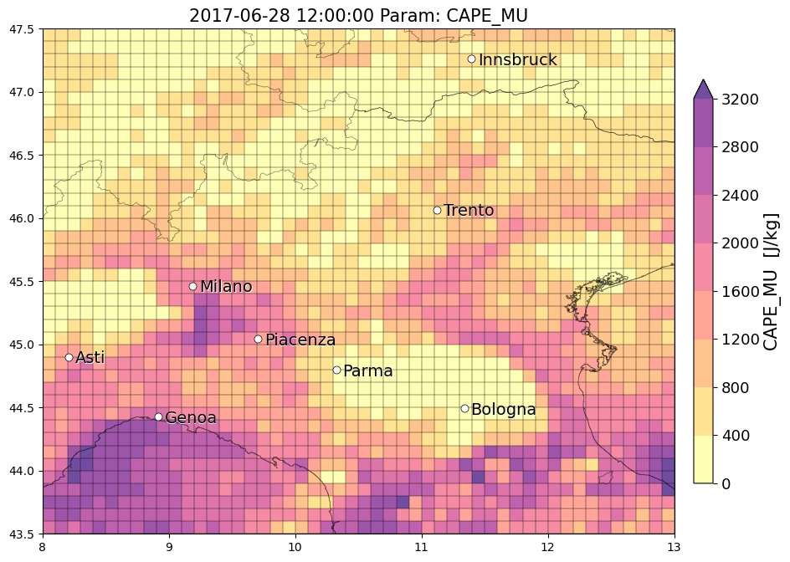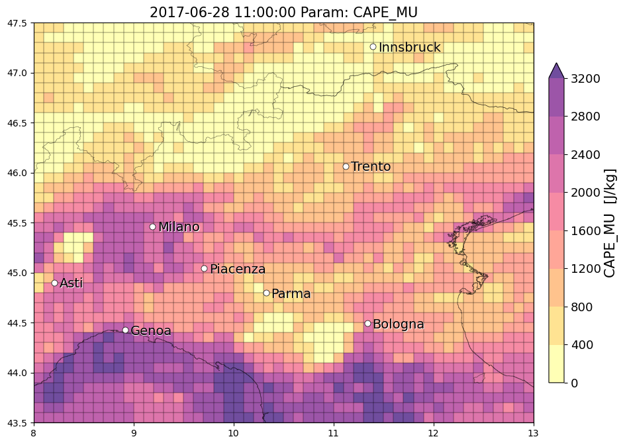

* + **DLS**: mid values (12-20m/s) detected close to the Bergamo event 10am, also for the event near Piacenza at 11am, while very high values >28m/s at 11am in the exact location of the Vicenza event. ALso very high values >28m/s south of Bologna before and during the event 13-14utc
  + **H0**: values <3700m for the event in Bergamo and Piacenza, also before the event in VIcenza H0 goes below 3700m at 11-12am, finally also south of BOlogna H0 reaches lower values from higher ones
  + **Kindex**: values >33°C near Bergamo during and before the event 8-10am, increasing K also near Piacenza from 9-11am reaching values >39°C, at 12-13 also in the location to the Vicenza event, reaching values >41°C, high values also south of Bologna for the last event.
  + **LI**: increase of LI during the morning in the whole north Italy, values <-3°C close to the Bergamo event at 9-10am, close to the Piacenza event <-5°C, the same is true also before the Vicenza event with values <-5°C at 10-11am, then increasing (also for LI the blob of maximum LI are visible as for CAPE, probably associated to the presence of the thunderstorm. Less intense values detected before the BOlogna event at 13-14 utc with <0°C.
  + **%VV700**: very noisy, Im not able to detect any significant pattern (ad occhio)

**Riunione con Michael + Kris 26/4:**

* Finish qualitative analysis for case studies (I need to include also the other 3 SPHERA proxies!!!) and first results
  + Perhaps events in **April** are climatologically not related to convection strong enough for identify them with OT detections or LJ or reanalysis proxies describing hail-favouring conditions? (That is why it is useful/important to do the same **analysis for long-summer** April-October **and JJA** and compare the results!)  
    K + M: Good confirmation of OT detection method as it is designed to consider more the central part of the distribution in summer and not the marginal distribution (April) of events, also because in April convection at these midlatitudes is extremely **shallow**: tests made with radar data showed how some events in April/May or October with 1-2cm hailstones size were related to clouds having Max vertical ext. of 6-8km only (which are cloud not thick enough to be detected with OT, so missing these events makes sense!)
* Reanalysis proxies for OT/LJ filtering:
  + **CAPE** variable: which one to use between MU and ML?   
    most of the time CAPE_MU >= CAPE_ML, but sometimes CAPE_ML>CAPE_MU is it possible??  
    K + M: CAPE_MU should be the biggest, you can not have anything bigger if it’s the most unstable BUT it depends on how CAPE is calculated: since it is usually calculated considering the next intersection between the lifting curve and the ambient temp. lapse rate, when you have a very shallow inversion layer and you quantify the CAPE from the starting point to this intersection (inversion layer) you end up with a very small CAPE (very rare cases), while if in the same condition you calculate the CAPE_ML, when you mix up the lowest 100hpa than the small inversion could vanish and end up with a CAPE_ML larger than CAPE_MU (but quantifying considering the entire profile, if the shallow inversion is dissolved during the day and reaching up to the tropopause level the CAPE_MU > CAPE_ML always)  
    For understanding which performs better to consider in the analysis take a look at paper Michael 2007. Kris suggests to use the most unstable formulation is better to consider all the weird and different things such as local processes affecting the CAPE calculation and avoiding strange values (also from Kris last paper: you could have 2-3inch hail size with almost no cape there, so just be careful in the filtering in not being too strict!)
  + Review which kind of **thresholds** can be considered for filtering convective proxies: Do sensitivity analysis on thresholds values (NO: base motivation statistically) (on the sample of 21 events): also the filter can be constructed in two ways (depending on the end goal):
    - Relaxed mode: considering all potential hailstorms (such as HJ did by deleting the tail of 2% of the parameters distributions) = all possible hail
    - Stricter mode: consider only severe hailstorms (then with higher thresholds, but in this case it is likely to be too strict and maybe withdraw useful data!) = most severe hail (as HJ did in paper 2017 when considering as thresholds the median 50% percentile values instead of the 2-98%)

It makes sense to try both approaches and see the differences!

* + Consider also **LJ** information in the analysis? As a new proxy as OT that must be filtered with reanalysis proxies? How to **combine filtered LJ + OT** information (think about it later perhaps)?  
    K: problem of LJ is that it is a binary classifier that distinguish only between jump and not jump based on a definite number of strikes in a temporal window: if you see LJ you recognize that there is potential for bad convective weather, but if you dont see it you can not exclude bad weather will come (similarly with OT detections, that is why (i think) the newest algorithm assess a probability of OT in a statistical sense and not a binary detection of OT (yes or no only)).  
    There should be a publication in USA with LJ from geostationary lightning mapper (GLM) assessing statistical properties of LJ linked to severe weather. Kris will ask to Chris Schultz (lightning expert).  
    M: also at DWD work done with LJ (Katharin Wabbler ??) several papers, found out relationship assuming a timeshift of 30min between LJ (probably when there is the acceleration of the updraft) and hail on the ground, M: skeptic about LJ because sometimes it works sometimes not, dependently probably from the structure of the convective storm (you could have a supercell producing lightnings but not enough for a LJ detection and then producing the largest hail, like in the cases of the most severe hailstorms in southern Germany (2013)). Anyhow a hail climatology map was produced in 2014 from LJ from a insurance company (Guy Carpenter – see pdf sent by Michael): good matching with other maps produced also with OT data,
  + (((Should we withdraw some reanalysis indices from the analysis that they seem to not show relevant additional information to hail-producing environments (MAYBE THIS IS A LITTLE TOO EARLY TO SAY!), such as %VV700 or AvvGeop500 (THIS ONE SHOULD BE TESTED!!!)))
* Data **matching** criteria:
  + Which methodologies are used for matching OT+rean prox+obs in recent papers? and which kind of statistical metrics are used: Kris methodology:
    - Near every OT cold spot max/min reanalysis proxies are extracted within a spatial window between with radius of 1.5° (i.e. upscaling to 165km!), should we use a finer spatial match?? -> (only accumulate reanalysis where we have cold spots, so this biases our assessment of model performance to where convection has already formed and doesn’t look at situations where model says storms are going to form and become severe but never happen in reality.)  
      K: 1.5° was used because the MERRA-2 data they used had 0.5° resolution. Also the much broader area considered was, besides to account for spatial uncertainties between model and observed data, also because some convective storms could influence their own environment and after they formed the modeled CAPE could vanish at the storm location itself seeming like there is no thunderstorm (so it does not make sense to search for the exact match at the specific location/pixel at that specific time but it is needed to relax temporal and spatial criteria for matching)  
      OT detected in spots presenting reanalysis proxies below thresholds are withdrawn
    - Calc. proability of severe hail (how to do it??)
  + **Spatial resolutions**: How to match e.g. OT(3.3km) or LJ(20km) with SPHERA hailstorm proxies(upscaled to 10km)? Should I upscale OT to SPHERA grid and then filter (NO!), and upscale SPHERA to LJ grid and then filter? -> for OT/SPHERA the idea is to consider a larger spatial grid of **70km**(7x7 SPHERA grid cells? For the moment, retaining it from preci verification)
  + I guess that the spatial resolution used to match the different data must be chosen with care (?)
* Participation to **EMS** 2022 in September with this project
* Other open questions to discuss:
  + How to deal with hourly frequencies and matching hourly data instead of 24-hours fields? (see reply from Kristopher in email to this point also) Consider a temporal window of 4hours before the OT occurrence (?? Are 4 hours enough or too many??)
  + As post-processing validation of the hail “climatology” developed could I use the passive microwave imagers hailstorms climatologies developed by Kris and collaborators?
  + Do you know if any **other study** employing **convection-permitting** reanalysis proxies to filter OTs have been performed? Or only with global coarser reanalyses?
* K: interesting new paper on hailstorm parameters discriminants (for USA), useful perhaps to set up optimal set of thresholds (waiting for imminent publication, as soon as it is published Kris will send me) Scarino et al. 2022
* K: for accessing the OT data for 2016-2018 Kris will send me something to register to
* K: to enlarge events sample size consider in the same days if hailstorms took place in nearby countries included in SPHERA domain!!

28/4/22

Started looking at the rest of sphera parameters for events.

A couple of notes and open questions for when we start (and before) to filter OT data:

**OT-SPHERA FILTER**:

* Firstly: statistical investigation of OT data distribution, in time and space, before filtering: considering firstly the set of 21 events, and then the whole set of OT detections in 2016-2018 to see their original distribution (when data available). How to count number of OT for event? -> using NetCDF4 package and Numpy.MaskedArray (see DataExploration jupyter notebook).  
  Write a dataset containing the whole OT detections during the events considered
* A first **mask** filter must be applied to retain only Italian OT and **only over land** (for validation with observed reports), than that would be the initial set of OT detections before filtering. Only over land at the beginning because we can verify only those events. Maybe extend to sea OT detections later?
* **FILTER DESIGN:**
  + OT (3.3km res., in 15 mins intervals (can be accumulated in 1h)), SPHERA proxies (upscaled to 10km res., 1h intervals) -> spatial and temporal match between the data:
    - **Spatial match**: consider around every OT detection (lat/lon center grid) a spatial box of **70km** (0.63°) (meaning a window considering maximum 35 km away from the center)(retained from sensitivity analysis performed with preci and adapted to SPHERA 10km grid) and check SPHERA data in that subdomain
    - **Temporal match**: idea: consider SPHERA data in the **4 hours before(?)** (not after because instability parameters should drop during the event and even slightly before the report(it can be that the model dont produce any convection so the parameters stays at 0, or it produces delayed convection so the parameters are delayed on time but if we dont catch these it should be fine as they should be few)) the timing of the OT detections, extract parameter max/min over that temporal window to check the parameters vs their threshold and decide to retain or not the OT (if at least one SPHERA gridbox (i.e. the min or max value) contained in the larger 70km box present a proxy value exceeding the min threshold).  
        
      This filter (temp wind: 4h, spat wind: 70km) will be referred to **FILTER4h**  
        
        
       *Update 15/6*: Kris and Michael comment: better to consider a time window o**f 0-3 hours** before the OT/ESWD timing (as the times, e.g., 12, 15, 18, 21 are more convenient and correspond to the SYNOPTIC times compared to, e.g., 12, 16, 20, 00 UTC)  
        
      This filter (temp wind: 3h, spat wind: 70km) will be referred to **FILTER3h**
  + **Thresholds definition** for SPHERA proxies (see in detail below): Design to set of thresholds, one for all potential hail and one only for severe hail. For defining thresholds consider previous work done (Punge 2017) and use the same statistical approach to define threshold: consider the eswd-based distributions of the parameter and extract the percentiles as thresholds, then compare them with values used in literature and adopt them if they make sense
* Apply the same procedure also for LJ? (**must understand well with Valentina LJ formulation!** And in case re-formulate LJ before using it!)

**Are 4 hours enough for the temporal window in the filter?** (update 15/6: better 3 hours)  
**Michael**: good question, but difficult to answer. There are, of course, situations where the temporal resolution has only a minor effect, and other situations (due to, e.g., advection of unstable air masses or frontal systems) where it matters substantially.

In a recent paper ([NHESS - Ambient conditions prevailing during hail events in central Europe (copernicus.org)](https://nhess.copernicus.org/articles/20/1867/2020/)) we investigated ambient conditions prevailing during hail streaks identified from a combination of radar tracks and ESWD hail data in Germany and France. It turned out that in general dynamical conditions such as shear or SRH have a much lower temporal variability compared to thermodynamical quantities.

Thus, I would say 4 hours is sufficient for estimating the dynamical conditions, but not really for the thermodynamical conditions, in particular in the morning hours.

**POST-FILTERING: VALIDATION with ESWD/UNIPOL reports**

* Do statistical analysis for eswd/unipol reports (**DONE**, but possible to continue statistical analysis)
* Validation: UNIPOL reports timing: how to account for temporal uncertainty (see examples in case studies below)? ~~A first suggestion: when in the same area at least 1 eswd report is present consider its timing (+- a certain window) also for all unipol reports which instead can be issued even many hours later (see below),~~
* See below..

RIUNIONE INES 6/5

* Cercare se l’algoritmo 2sigma per il LJ è mai stato usato con LAMPINET (non credo proprio, impossibile per qualità dato lampinet troppo bassa (freuenza fulminazioni))
* **PROBLEMA**: check if SPHERA data plotted with gridded shapefile 10km are correct: it seems that the leftmost column of data should be actually the rightmost!!!! **CHECK!!!! -> RISOLTO:** indice box_id partiva da 1 e non da 0 facendo shiftare tutti i valori delle celle avanti di 1! Sistemato.
* A posteriori fare prova con giorno senza report grandine, in cui ci siano degli OT, e controllare reanalysis proxies come si comportano

17/5 UPDATE

Start to build the OT-SPHERA filter: selected OT detections only over SPHERA domain.

PROBLEMS (spatially-distributed OT data in netCDF format):

* the OTs with **parallax correction** applied are not displaced on a regular spatial grid anymore but, besides the spatial shift to correct for satellite parallax, also the grid boxes are tilted!!   
  Furthermore: parallax correction depends on hour of the day! E.g. comparing cpclat and cpclon after correction for the same day but different hours of the day the coordinates of the grid change!!!  
  -> this prob should not be relevant anymore since we are considering OT detections geolocalized by the center of the grid cells (so tilted grids or not it doesnt matter!)
* Furthermore, it seems that (by reading ncfiles with xarray) all OTs are geolocalized by only one lat/lon point (referring to the left-uppermost corner) and not by polygons (that should be rectangles in a regular grid but here tilted rectangles)! How can one point identify a non-regular grid??  
  -> because they are referred to the centers of the grid cells!
* My idea was to convert OT datasets to geodataframes to find matches with SPHERA data more easily in this way:
  1. Original OT netcdf files: aggregate every hour, limit spatial domain to SPHERA, parallax correction **✔**
  2. Produce 2d matrices of maskedArrays for lat,lon and otpmax (including scalar ot_timing) **✔**
  3. Recombine the scalar and three arrays to form an xarray DataArray dataset **✔**
  4. Write Geopandas GeoDataframe from xarray to store data: to do so the **geometry** is required (i.e. a set of shapes identifiying the spatial locations of the data), BUT
     + ~~without a shapefile of the grid of the OT dataset I do not have a geometry~~
     + ~~Even if i had a shapefile of the original grid of OT, after parallax correction that would be not valid anymore(?) and should be changed as well~~!
     + I tried setting as geometry the points identified with lat/lon couples for every OT (as it seems in the netcdf) but these are not boxes but sparse points (while ~~the correct geometry should consist of polyigons of the grid~~ no actually since the points are the centers of the cells)!

Example of the impact of Parallax correction:

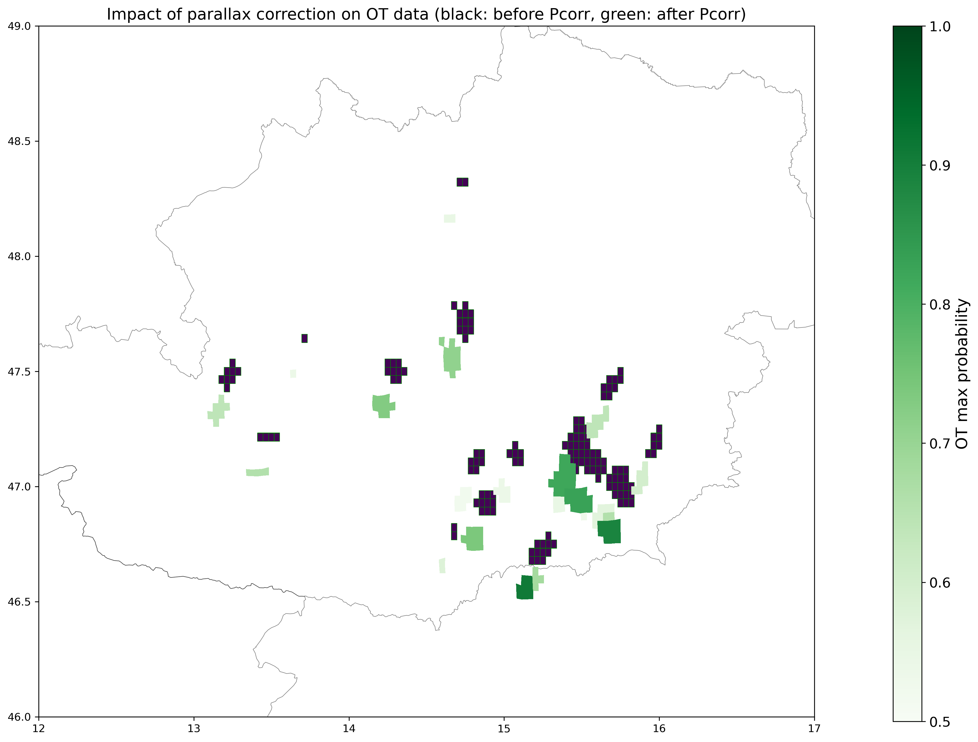

20/5

Meeting Edoardo:

* Dati OT (sia prima che dopo parallax correction) sono geolocalizzati da 1 punto lat/lon solo probabilmente perchè quello è il **CENTRO DELLA CELLA** (e non l’angolo superiore sx), di solito è convenzione comune ( **https://cfconventions.org/cf-conventions/cf-conventions.html** sia per dataset netcdf che xarray!), quindi questo risolverebbe tutto il problema della griglia non regolare dei dati OT processati: essendo che abbiamo le coordinate del centro delle celle da 4km di risoluz. Possiamo usare quelli per considerare un intorno di 60km e vedere i dati della rianalisi come si comportano!! –> chiedere per convenzione spaziale netcdf a colleghi

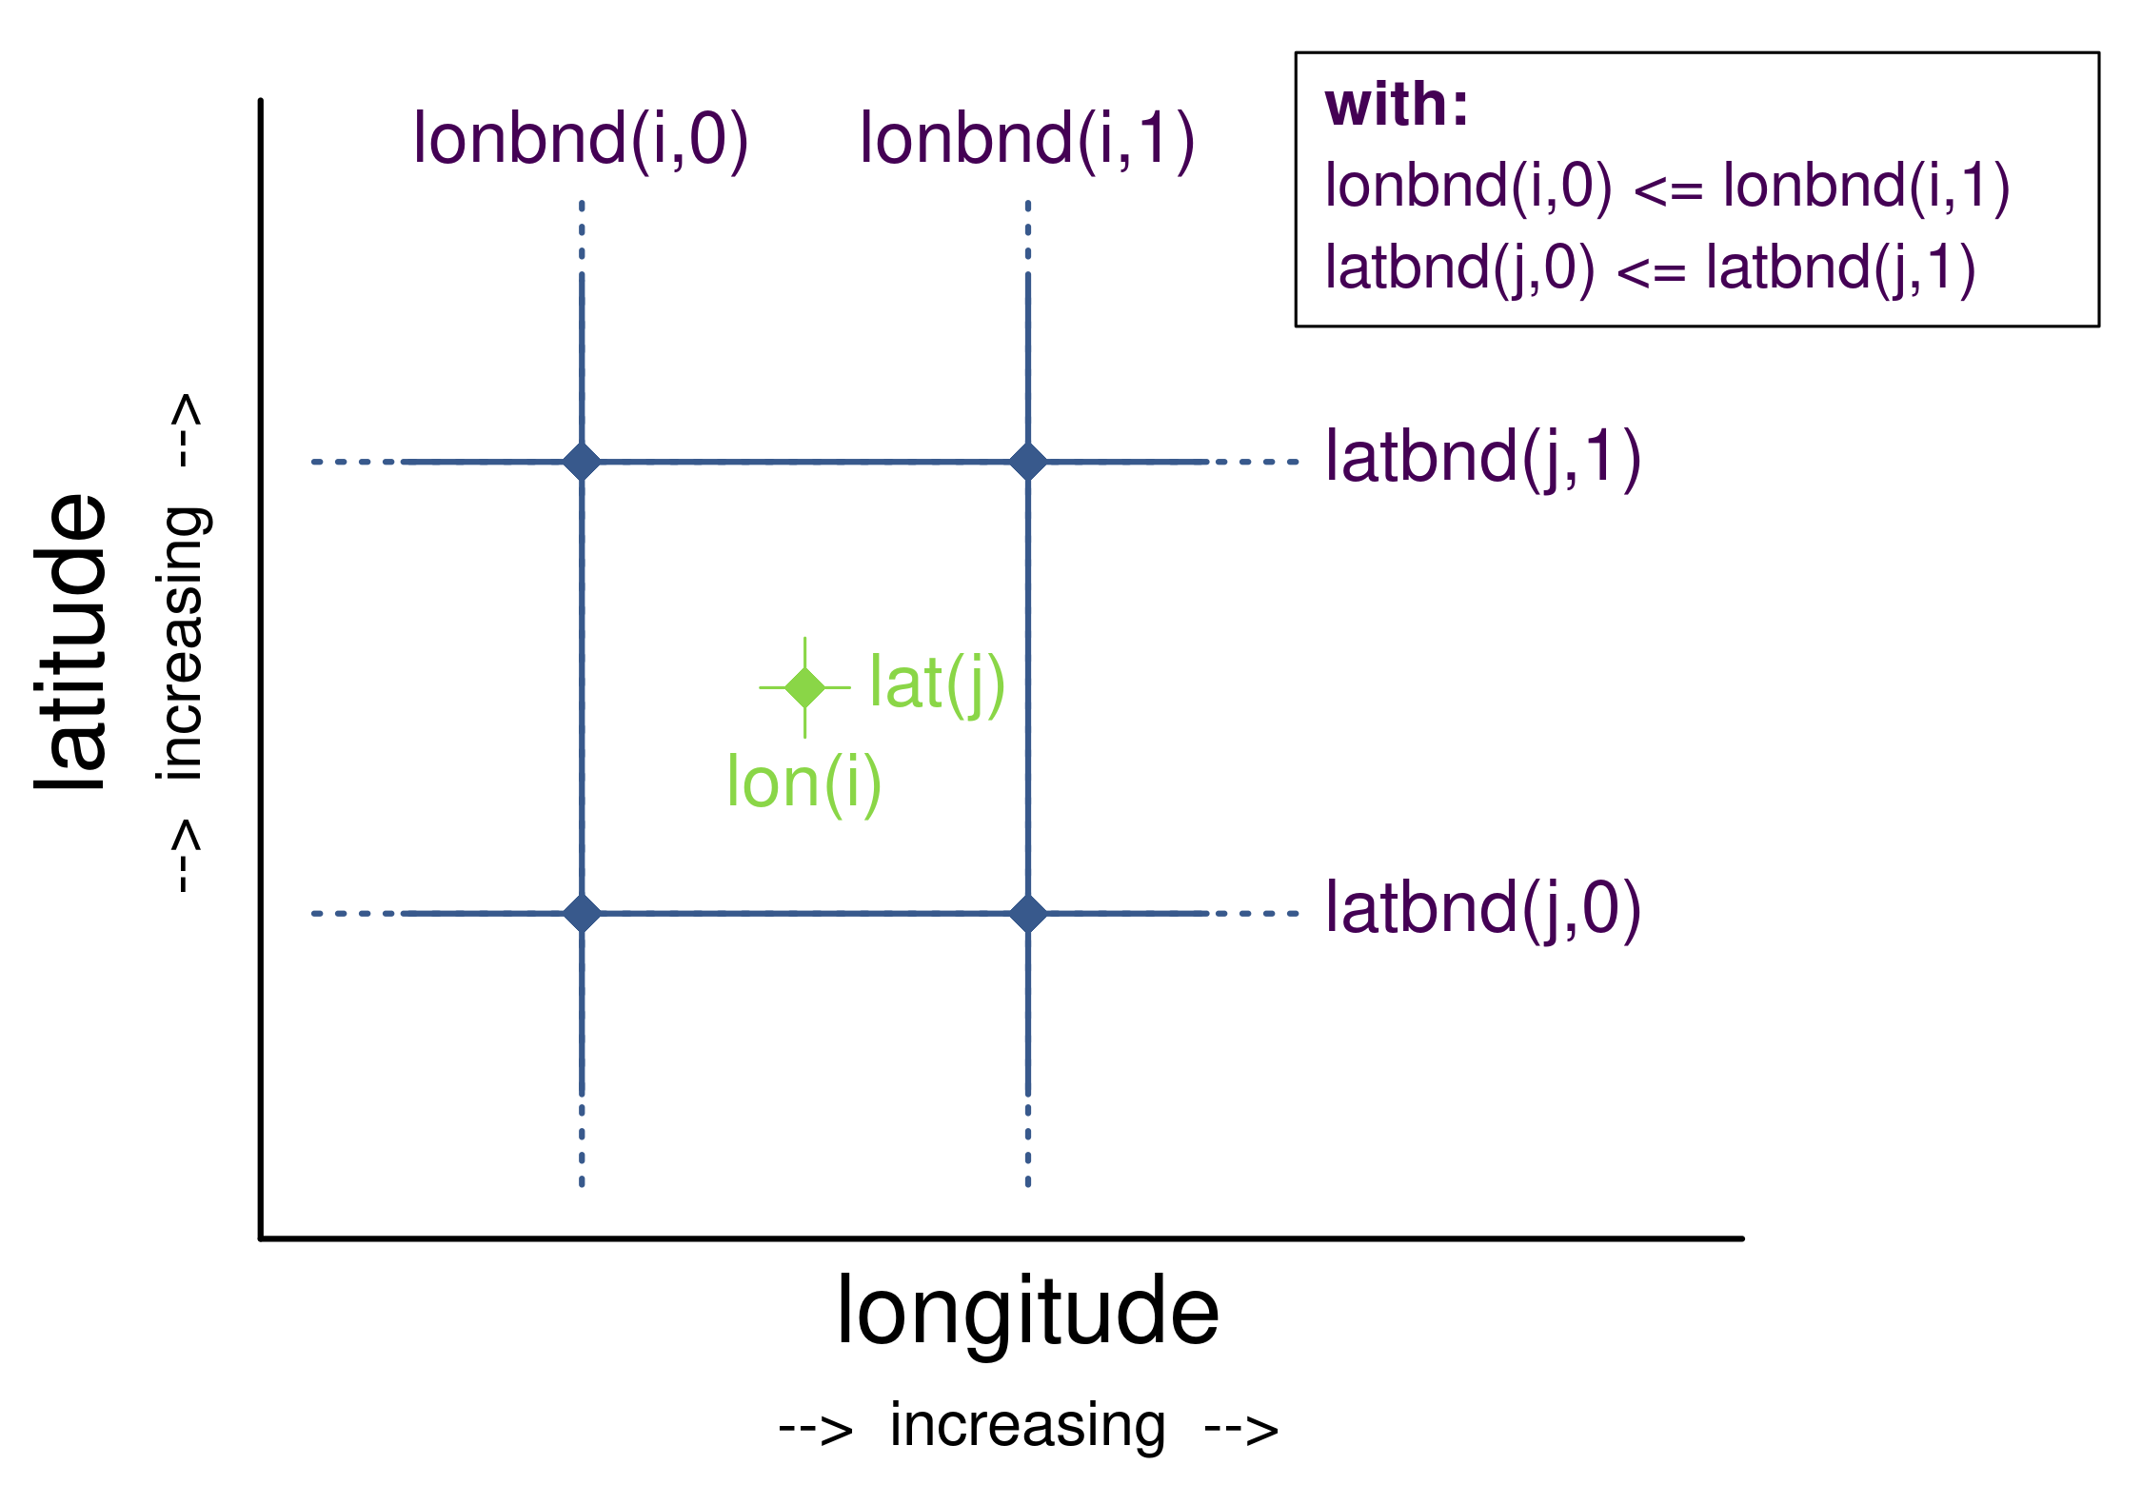

* Post-processo dei dati OT costruire Dataset (e non DataArray) con xarray, e inserire gli attributi affinchè siano riconoscibili poi come dataset disposto su griglia (anche se non regolare), così si riesce a plottare molto piu facilmente!

23/5

OT data seems to be referred to center of the grid: tried to plot the same data using xr.plot.pcolormesh (more suggested) and pl.pcolor (used up to now): the data plotted with xarray are now correctly plotted with geolocalization on the grid cell centers!

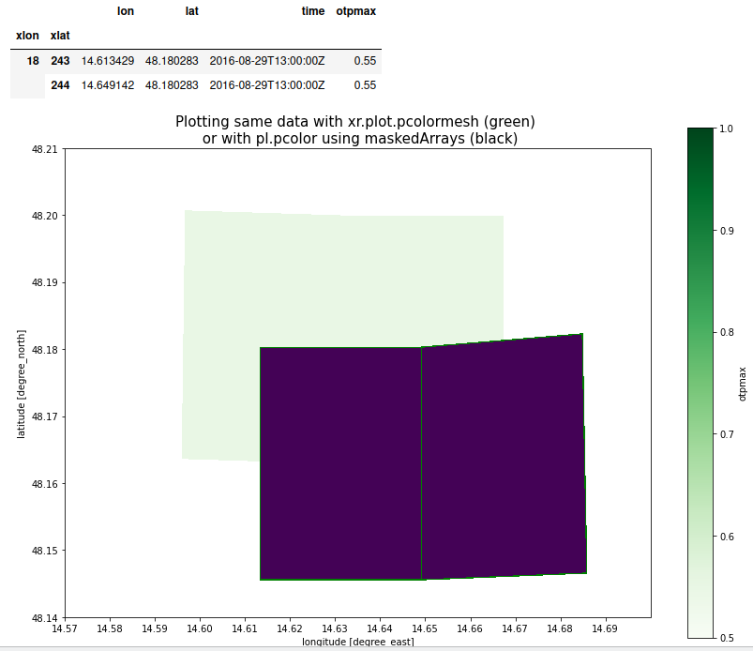

Then we can proceed in constructing the filter! When we seek matches between OT and SPHERA over a coarser grid (70km i.e. boxes of **0.63°**) we just need to build a 0.63°x0.63° grid cell around the center of every OT detection coordinates and check SPHERA data in that spatial subdomain (over the last 3-4 hours??)

0.63° approximates 70 km at all latitudes of the SPHERA domain (http://edwilliams.org/gccalc.htm):

Obtained first boxes built around every OT point:

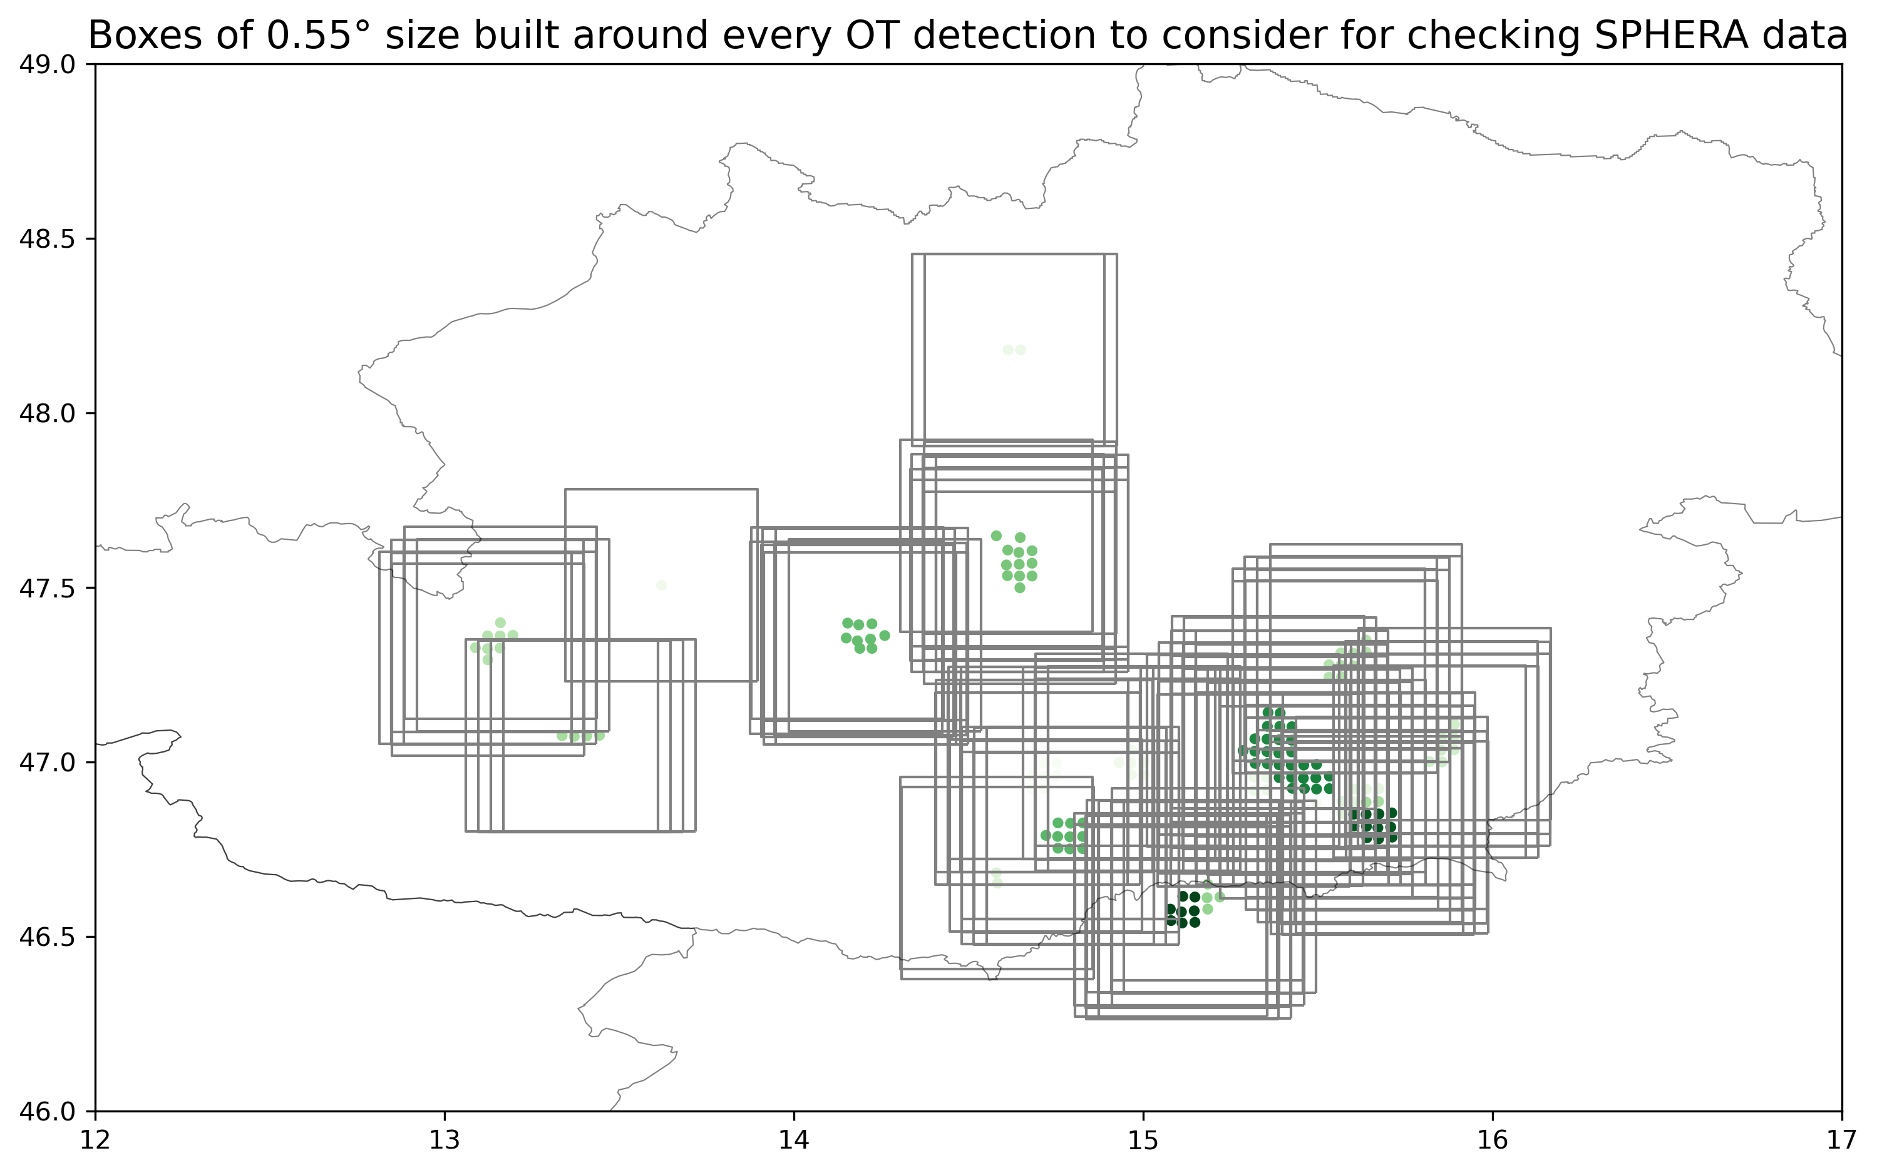

Also obtained first spatial filtering of SPHERA data around every OT detection (NOT GOOD APPROACH)

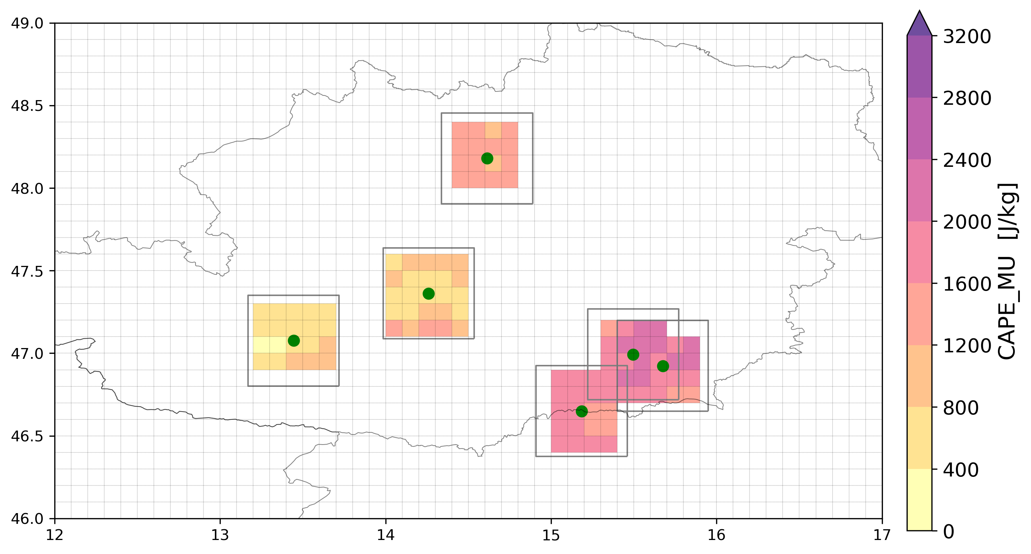

Now: how to deal with “non-filled” boxes of SPHERA data due to mismatches in grid resolutions (as every OT point is sparse and a box is built around them, so not like in a regular grid) -> CHANGE APPROACH:

* First idea: ~~enlarge the box size even more to contain at least 0.55°x0.55° SPHERA data in every case (but in this way every OT detection is filtered based on an individual aggregation of SPHERA grid cells i.e. not the same data representativity?~~
* ~~Second: interpolation of SPHERA subset to the coarser grid box?? (I WOULD AVOID INTERPOLATION AS A FURTHER SOURCE OF UNCERTAINTY!)~~
* Third: instead of building a box around the OT point and then fill with SPHERA grid cells, find the coordinates of the closest SPHERA grid cell (i,j) containing the OT point and build a square formed by e.g. 7x7 boxes having coordinates (i+-3,j+-3) -> around 70km squares (0.63°):

Example considering few SPHERA OT cells:

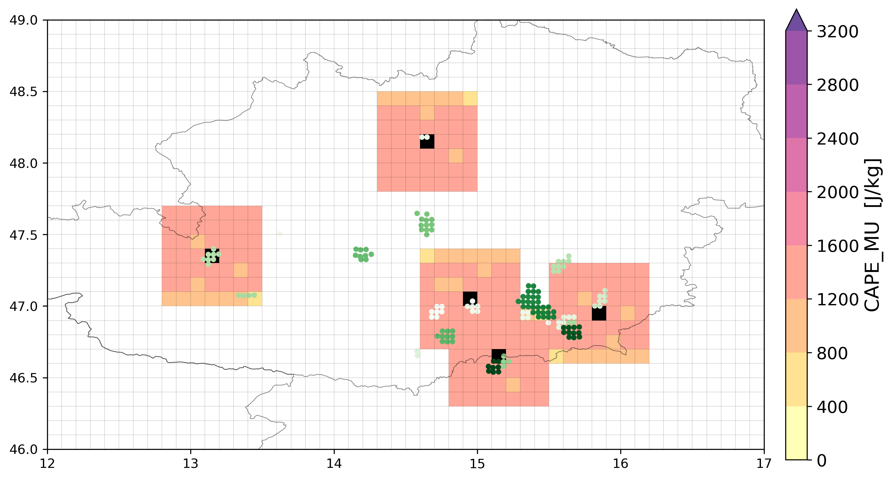

Considering the whole set of cells together for 1 OT file this is the result:

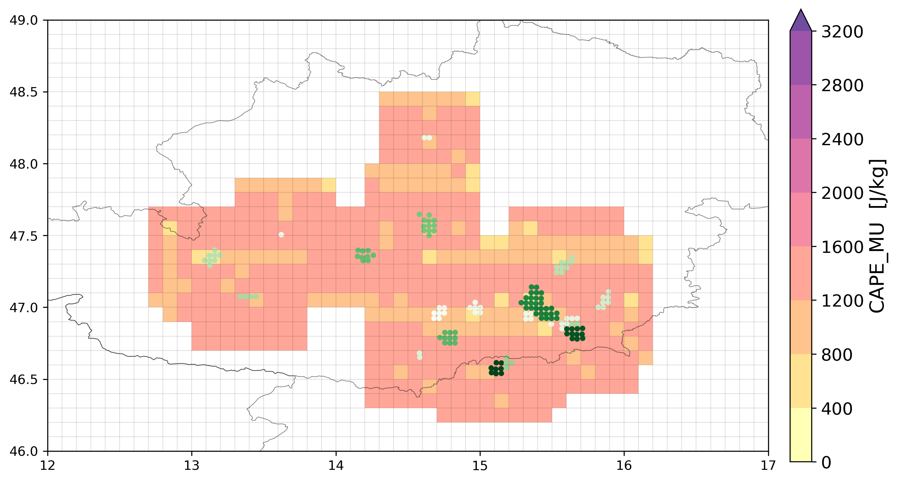

NEXT STEP: temporal match: consider SPHERA the max (or min) of parameters during 3-4 hours before OT occurrence to reduce temporal mismatches. Two ways:

* Extract max/min over 3-4hours over the whole SPHERA domain - then define spatial neighbourhood – then check over the spatial neighbourhood if at least 1 cell of param is below/above a certain threshold
* ~~Define spatial neighbourhood for every SPHERA dataframe over the 4 last hours – then extract temporal max/min - then check spatial aggregation with threshold~~

It should be equivalent to do in the two ways BUT the first way should be much less time consuming (since operations to define spatial neighborhood is a little demanding, and to do it 4 times in a row instead of only once should be much better!) -> Do in this way

ANNA: Come dati osservati ci sarebbero gli storm report di **Pretemp (Meteonetwork)**! Capire magari qualità dati, se disponibili, se altri studi gia fatti usandoli. Per 2016-2018 ci sono 688 report in Italia!  
Dataset non disponibile, dati estraibili su richiesta per eventi singoli e comunque dati che poi vengono inviati a eswd quindi non ha molto senso richiederli e costruire dataset da 0.

27/5

First design of the filter done for 1 full day of event: adapted SPHERA reading (to consider hours of the day before if OT hour is <= 2am

30/5

**Thresholds for SPHERA proxies definition:**

RECAP Heinz Jurgen method (2017) for defining thresholds:

* **Define the probability distributions (cumulative?)** for each reanalysis parameter based on presence of ESWD (percentile pnESWD) and presence of OTs (percentile pnOT)
  + For ESWD: extract all the SPHERA boxes containing reports and at the closest timing of ESWD report, and do distribution for each parameter.
    - Consider spatial and temporal windows exactly as in the OT-filter (sphera outputs in the 4h before, extract temporal max/min, consider spatial windows of 70km around center of ESWD report, extract spatial max/min) (with ERA-Interim this was not the case due both to the coarse spatial and temporal resolutions).
    - Concerning ERA5 with 1h res used in South Africa paper, the thresholds in the SA paper not based on distributions but defined “personally” (CAPE>100J/kg,DLS>1.5m/s, 2400m<z0<4845m) (furthermore the thresholds for DLS and z0 are exactly the same as those used in the Australia paper..)
    - Temporal coverage (and robustness): for 2016-2018 we have only 1400 reports over SPHERA domain (Apr-Oct, >=QC0+). Not possible to do it on period 1995-2018 (for which we have 6173 reports Apr-Oct, >=QC0+) as SPHERA data must be extracted...) HJ did it on period 2004-2014 using 12.282 ESWD severe-hail reports >=QC0+ (while set of 2475 with >=QC1 and declared temporal uncertainty up to 15 min is used as reference)!   
      HJ: it should be alright, will not give the smoothest distributions, it could be criticized as not but, it is right to try (if it is criticized we could think about extending the coverage in the past (to do after phd probably)). To do a check we could cross-check while considering only QC1> eswd reports (bt actually 1064 reports out of 1395 are QC1>, so 76%)
  + For OTs:...same process but much longer (need OT dataset on the same period, and extracting each SPHERA grid cell is much longer), and in the end threshold values eswd-based only or OT+eswd-based are just slightly different = Avoid it (Ok to use only ESWD data!)
* **Define limits** (llow(CAPE),...=p2ESWD(CAPE),...,lhigh(z0) = p98ESWD(z0) based on percentiles (2% for max parameters, 98% for min parameters) of the distributions. For max parameters (CAPE,DLS..) “the limit exceeds the respective percentiles of the distribution for OT detections: llow > p2OT. Similarly, for min parameters, lhigh < p98OT” is this a general rule or found empirically after comparison of the two distributions?-> This info is known only by comparing the two distributions (prob. Of rean. Param. Dependingly on ESWD report or OT presence)
* **Seeking the ranks rlow/rhigh** of these limits in the distribution for OT detections:  
  rlow(CAPE) = rOT(llow(CAPE))...rhigh(z0) = rOT(lhigh(z0))  
  Meaning: find out which are the positions of the values of the parameters’ limits (defined from the percentiles of the ESWD-based distribution) in the OT-based distribution.
* **Define the actual thresholds** t as the (rlow -2)th and (rhigh +2)th percentiles of that distribution:  
  tlow(CAPE) = pOTrlow(CAPE)-2(CAPE)...thigh(z0) = pOTrhigh(z0)+2(z0)  
  Why is this done in this way? Is there a statistical basis justifying this choice?
* Repeat same process but considering the median values (50th percentile instead of 2nd or 98th) to define the thresholds (focus on more severe hail)

- Why the double process of finding percentiles in the ESWD-based distr. And then from those find the ranks in the OT distribution and then define the thresholds as percentiles of the OT-based distribution having the found ranks +-2? Probably to include both ESWD and OTs information in the process to have a more justified choice of thresholds but it is fine to consider only ESWD data (and other studies also!)

- Furthermore: in the latest two articles employing the method (Bedka et al 2018, and Punge et al 2022) there is no more clarification or explanation of the filter methodology but only a reference to the original Punge 2017 hail-filter method, while the thresholds have been chosen “personally”

HJ: not happy with DLS=1.5 m/s threshold (Bedka 2018, Punge 2022): first of all it could be even negative (+-1.5m/s) -> check SPHERA values (probably absolute value already extracted? But CHECK!!)  
And also 1.5 it’s quite a small value, justified maybe by low reanalysis resolution, which does not apply in my case -> so it should be better to use an higher value (HJ suggests **10 m/s**, but it can also be some value justified by some study done)

**POSSIBLE PROPOSAL:**

Consider, for every ESWD report (approx 1400), SPHERA reanalysis proxies (with a spatial/temporal window processing retained from filter) for the 3 years period 2016-2018 (unfortunately I can not do it on 1995-2018 cause I would need to extract SPHERA data, long process), and look at their distributions (maybe compare it with the whole distribution of SPHERA data? NO better to compare it with SPHERA data in the ESWD subset with hail >=3cm and >=5cm), investigate percentiles and then based on that and on literature define some thresholds that could make sense.

(It would be nice to use also UNIPOL report data to build a distribution, given the much larger N of reports compared to ESWD, but probably there are too many uncertainties: spatial (centroid of the city considered), temporal (not reliable timing reported), fraud?)

4/6

Obtained **CDFs** of SPHERA parameters in presence of ESWD reports (with **FILTER4h**), both for the full set, for the reports with hail>3cm size and for hail>5cm size.  
Redone the same analysis considering **FILTER3h** , results very similar (not changing very much), reported in table below.

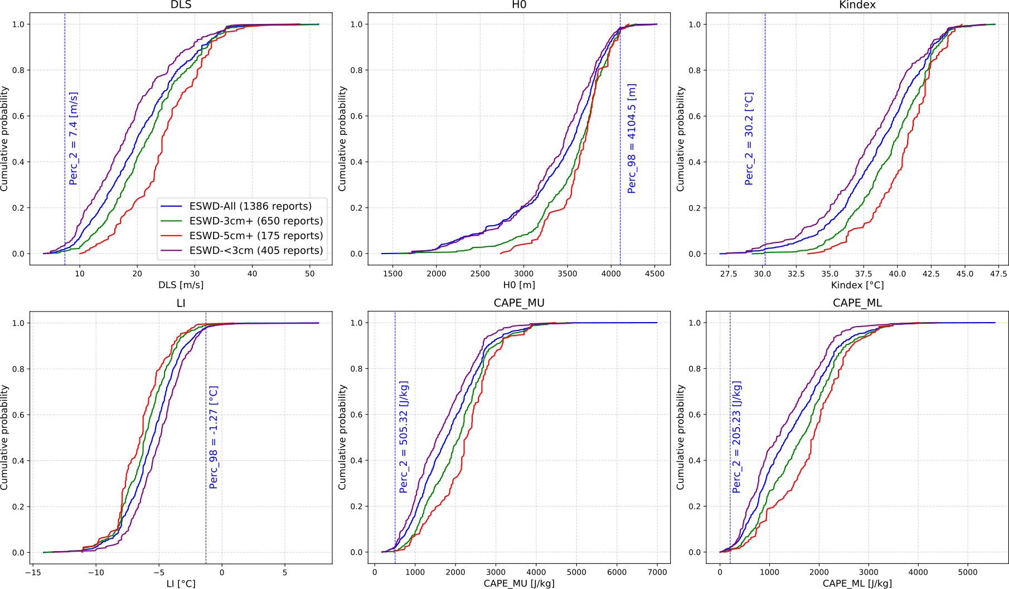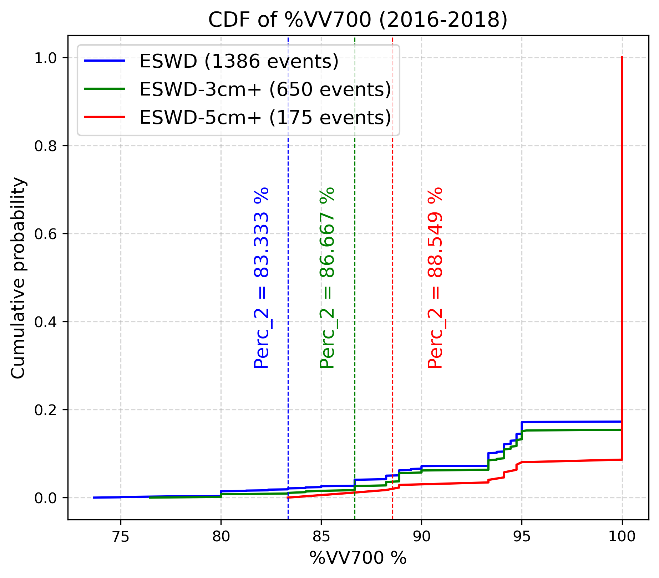

**FILTER4h  
FILTER3h**

|  |  |  |  |  |  |  |
| --- | --- | --- | --- | --- | --- | --- |
| **VAR** | **CAPE_MU** | **DLS** | **H0** | **K** | **LI** | **CAPE_ML** |
| **PERC 2%** | ~~532.15 J/kg~~  505.32 | ~~7.52 m/s~~  7.4 |  | ~~30.2 °C~~  30.2 |  | ~~261.91~~  205.23 |
| **PERC 98%** |  |  | ~~4099,9 m~~  4104.5 |  | ~~-1.38°C~~  -1.27 |  |
| **PERC 2%3cm+** | ~~703.31 J/kg~~  657.89 | ~~8.65 m/s~~  8.37 |  | ~~33.9 °C~~  33.7 |  | ~~383.67~~  343.9 |
| **PERC 98% 3cm+** |  |  | ~~4108.7 m~~  4135.5 |  | ~~-2.34°C~~  -1.89 |  |
| **PERC 2%5cm+** | ~~902.58 J/kg~~  747.35 | ~~12.0 m/s~~  11.8 |  | ~~35.2 °C~~  34.8 |  | ~~558.82~~ 408.84 |
| **PERC 98% 5cm+** |  |  | ~~4106.7 m~~  4136.4 |  | ~~-2.75 °C~~  -2.31 |  |
| **PERC 2%<3cm** | 485.18 | 6.08 |  | 29.3 |  | 194,69 |
| **PERC 98%<3cm** |  |  | 4091.5 |  | -1.20 |  |

Nice results!

* Higher/lower values than Punge 2017 or Bedka 2018 supposedly mainly due to the higher resolution of the model used (besides different sample size and spatial domains), and also for the different temporal and spatial aggregations adopted compared to when using ERA-Interim
* A parameter showing a low deviation in the percentile when considering ESWD=3cm+ or not is H0 (which even decreases when considering ESWD=5cm+), while CAPE_MU shows around 170J/kg difference from whole to 3cm+, and 200J/kg from whole to 5cm+
* The CDF of %VV700 well shows why this parameter is not well suited for this kind of analysis (i.e. not able to discern well enough different events?)

Based on this analysis, and on literature (CHECK WELL both Kunz 2007, Scarino et al. 2022 and **Kunz et al. 2020**!), we can set up a set of thresholds for the OT-filter:  
Values reported for **FILTER4h FILTER3h**:

|  |  |  |
| --- | --- | --- |
| **VARIABLE** | **THRESHOLD** | **MOTIVATION** |
| CAPE_MU | **~~Perc2 = 532.15 J/kg~~**  **Perc2 = 505.32 J/kg** | In previous studies (Punge 2017, Bedka 2018, Punge 2022) they used 0-10 J/kg or 100 J/kg mainly due to spatially and temporally coarse ERA-Interim reanalysis data, in our case having a much better resolved model and a method to aggregate the results extrating the maximum it makes sense to be more stringent and use approx 500J/kg as thresh |
| DLS | **~~Perc2 = 7.52 m/s~~**  **Perc2 = 7.4 m/s** | In previous studies they used 0m/s, and 1.5m/s similarly as for CAPE, so also here it makes sense to use an higher DLS value |
| H0 | **~~Perc98 = 4100 m~~**  **Perc98 = 4104.5 m** | In previous studies they used 4420 m (europe), 4845 m (Australia and South Africa) additionally they introduced a lower boundary of 2400 m for South Africa (due to comparison of distributions OT-based and passive-microwave-hail-based), in our case it makes sense using 4100 m: a lower value than Punge2017 mainly due to enhanced model performance which should be valid for Europe as well (furthermore eswd-based distrib for whole,3+cm or 5+cm do not differ very much!) |
| LI | **~~Perc98 = -1.38°C~~**  **Perc98 = -1.27°C** | Seems appropriate also comparing with Kunz 2007 where for the LI100 he prescribed an optimal threshold to distinguish between hail days and non-hail days of -2.07 °C over Europe (CHECK WELL!) |
| K | **~~Perc2 = 30.2°C~~**  **Perc2 = 30.2°C** | This is the parameter varying the most when considering whole, 3cm+ or 5cm+ ESWD-based distributions (From 30.2 to 35.2°C). In Kunz 2007 he used a modified version of K index and prescribed an optimal threshold for distinguishing between hail days and non-hail days of 38.9°C, while he used the original version of K (as ours) to distringuish between widespread and isolated hail days finding an optimal threshold of 31.1°C. So also this value seems appropriate |

Criterion for filtering OTs based on thresholds:

SImilarly to what done for defining threshold, if at least 1 of the 49 cell in the neighbourhood of a OT detection presents a value of a parameter exceeding its respective threshold (for each parameter valid) -> OT is kept, otherwise filtered (namely, is the same as extracting the max/min within the spatial neighbourhood and check that value instead).

Is this a good condition or should we maybe base it in a statistical sense (e.g. if the 95% percentile value of the distribution of the 49 cell exceed that threshold I keep the OT or not)? -> Actually inside every 10km SPHERA cell a distribution of approx. 25 SPHERA cells at its original resolution are already contained, so this should already provide a robust statistical estimate!

13/6

SPHERA CDFs with ESWD reports only over ITALY (**FILTER4h** + applying spatial mask over Italy):  
No large/significant differences, smaller sample of events, the thresholds at perc 2 (or 98) tend to slightly increase (decrease) for DLS, H0, LI and CAPE, only for K index they tend to decrease.

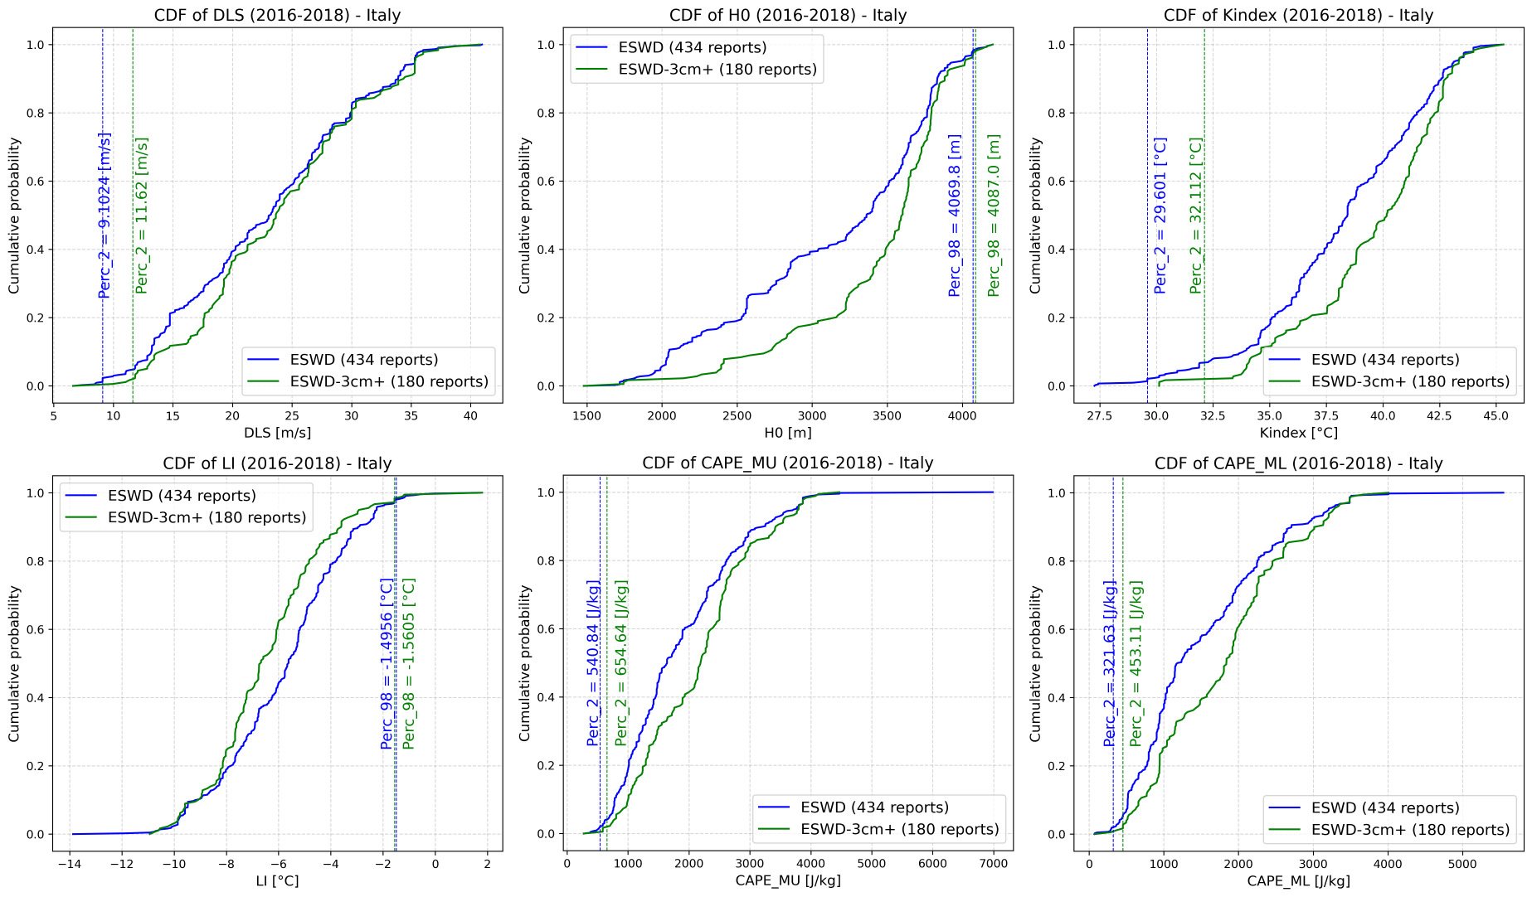

10/6

INTERESTING ARTICLES:

* “*Ambient conditions prevailing during hail events in central Europe*” **Kunz et al. 2020:**Characterization of environmental conditions (ERA-Interim) during hailstorms (2005-2014), distinction of hailstorms based on hailstone sizes and length of hailstorm tracks and investigation of frontal and non-frontal hailstorms: frontal hailstorms usually produce larger hailstones and have longer tracks. Dynamical proxies (DLS and SRH) show well distinguished characteristics when distinguishing between different hailstorms, while thermodynamical proxies (SLI and LR) only small differences. Furthermore: comparison of ERA-Interim with higher resolution reanalysis (coastDat-3) highlights how “higher model resolution has little influence on the spatial distribution of environmental parameters” and “it is mainly important for estimating thermodynamical parameters”. Interesting papers also to check some typical values for SLI and DLS
* “*Modelling Hail Hazard Over Italy with Era5 Large-Scale Variables*” **Torralba et al. 2022(CMCC):**Hail hazard estimation over Italy 1979-2020 with machine learning applied to select ERA5 convective proxies using the algorithm of **Prein and Holland 2018**, (read it again to get the main idea!)and validation of the models over Friuli region (hailpad observations) -> maybe ask for data to validate also my results (and build collaboration perhaps)? Ask Tiziana
  + Figure 1b: do a similar statistical characterization in my case with ESWD/UNIPOL reports!
  + For ESWD-filter they considered ERA5 environmental parameter in a spatial window of 90x90km (9 nearest grid point to hail report) and temporal window of +-6hours to characterize environments
  + Figure 4: VERY INTERESTING: useful in my case perhaps to define an optimal temporal window for the filter!   
    Also analysis of ERA5 parameters’ PDFs of having hail (daily basis), discerning between all hail (<=2.5cm) and severe hail (>2.5cm), Fig 5 is interesting: found values of CAPE >=500J/kg (generally favourable conditions for hail), or >=1000J/kg (severe hailstorms), K index varies between 20-40K for potential hail occurrences, DLS(0-6km) varies between 5-40 m/s for potential development of hailstorms  
    Also from their presentation:
    - K index: <20 (no thunderstorms), 20-25 (isolated thunderstorms), >26-30 (widely scattered, scattered, numerous thunderstorms) (reference?)
    - H0: too high H0 could lead to melting of hailstones before they reach the ground, but **too low H0 might limit the amount of supercooled water needed for hailstones to develop**!
  + Main product: Hail probability over Italy estimated as a product of single probabilities of ERA5 parameters to be in the range of potential hailstorms/severe hailstorms formation (extracted form their PDFs). Characterization of hail probability for two severity classes (all hail, and severe hail >2.5cm) and also by different months -> do similarly!
* “*How Many Types of Severe Hailstorm Environments Are There Globally?*” **Zhou et al. 2021:**Possibly interesting to understand in which environment we are in south-central Europe! READ IT
* “*Severe Convective Storms across Europe and the United States. Part II: ERA5 Environments*

*Associated with Lightning, Large Hail, Severe Wind, and Tornadoes*” **Taszarek et al., 2020**: possibly interesting to see characterization with ERA5 environments, for thresholds, and also for approach for validating results! READ IT

NEXT TO DO:

* Costruire sistema **validazione x OT vs eswd/unipol** e confrontare risultati prima e dopo filtro (FILTER3h):
  + **Sea-land filter**: considerare solo OTs (filtrati e non) sopra la terra e non sopra il mare (perchè solo quelli sopra la terra possono essere confrontati con le osservate!)
  + Per valutazione dati filtrati considerare gli hit, i missed (non ce ne devono essere tanti) e che diminuiscano i false allarm rispetto a non filtrati
  + **Finestra temporale** validazione OT-reports: provare con **+-5ore(?)** per UNIPOL (visto grande incertezza in dataset), mentre per ESWD usare **+-1.5ora** (mentre in Punge 2017 hanno usato 1h) piu che altro per approssimazione introdotta in dati OT (i.e. tutti i dati di un’ora sono collassati al timing di quell’ora precisa)
  + **Finestra spaziale** (considerare magari tra 17 e 35km di finestra (dimensione piu o meno delle dimensioni in una direzione del comune piu grande d’Italia, Roma? Punge 2017 ha usato 25km)?? Ho usato **25km** per ora. Provare a fare test per qualche caso in cui graficamente si vedono gli hit tra OT e report in mappa e vedere se tornano da verifica
* Consider **temporal window of 3hours** in the filter (**FILTER3h**) and redo the analysis (also for defining SPHERA thresholds values), then compare results with FILTER4h and without filter -> DONE see below
* Provare ad **aumentare soglie percentile 2%** per tagliare di piu i valori (usati 5%, magari 10%?? Mediana è troppo probabilmente), o considerare distribuz ESWD con >5cm per soglie e tenere il 2%? (magari fare confronto tra percentile2 con eswd>5cm e perc10 con eswd>0)

Further Possible Ideas:

* Ideally would be nice to **extend whole analysis over 2019-2020** (eswd reports in 2019 would be around 800, much more than the years before!! See Fig. 1a Torralba 2022: “more than 50% of hail events used (in period 2000-2020) are concentrated only in 2019 and 2020”)
* Validation of OT filtered set against **Friuli hailpad data** (as in Torralba et al. 2022)?? Possible development to discuss <https://www.meteo.fvg.it/grandine.php>
* **Filter sensitivity on parameters**: keeping for sure DLS and H0 but try to leave out one of the instability parameter( e.g. K index) and see how the results change ??

*Update 15/6*: Kris and Michael comment: better to consider a time window o**f 0-3 hours** for the OT filterbefore the OT/ESWD timing (as the times, e.g., 12, 15, 18, 21 are more convenient and correspond to the SYNOPTIC times compared to, e.g., 12, 16, 20, 00 UTC)

20/6

Comparison between OTs filtered and non-filtered during 23 event days with FILTER4h and FILTER3h (considering **2-98-perc** for thresholds):

During the 23 days of events considered a total of **65576** OTs (with prob >=50%) have been detected, over LAND instead **45992** (the **62%**)

* ~~After the filtering with F~~**~~ILTER4h~~****~~58487~~** ~~OTs remained (meaning that~~ **~~7089~~** ~~have been filtered, i.e. approx the~~ **~~10%~~**~~). Over LAND: after filtering~~ **~~40724~~** ~~remained (meaning that~~ **~~5268~~** ~~have been filtered over land, i.e.~~ **~~11%~~**~~)~~
* With **FILTER3h** instead **58120** OTs remained (meaning that **7456** have been filtered, i.e. **11%**). Over LAND: after filtering **40556** remained (meaning that **5436** have been filtered over land only, i.e. **12%**)

So, as expected no large differences between using 3 or 4 hours as temporal window for both filtering and defining SPHERA thresholds.

Distribution centered over Piedmont and not visually detected differences between the two sets (still very small sample!)

21/6

First results of OT-filtered/unfiltered data (with FILTER3h, 2-98perc Thresholds) validation with ESWD considering **+-1.5h** in a **25km** window around each OT occurrence during the 23 evdays only over LAND:

|  |  |  |
| --- | --- | --- |
| **2-98perc thresholds** | **Filt_OTset** | **All_OTset** |
| **N of initial ESWD reports** | 166 | 166 |
| **N of HITTED ESWD reports** | 138 (83%) | 139 (84%) |
| **N of MISSED ESWD reports** | 29 (17%) | 27 (16%) |
|  |  |  |
| **N of initial OTs (over land)** | 40556 | 45992 |
| **N of OTs HITTING ESWD reports** | 1364 (3.36%) | 1463 (3.18%) |
| **N of OTs MISSING ESWD reports (false alarms?)** | 39192 (96.63%) | 44529 (96.81%) |

Comparison with Punge et al. 2017 (Europe – old OT detection technique):

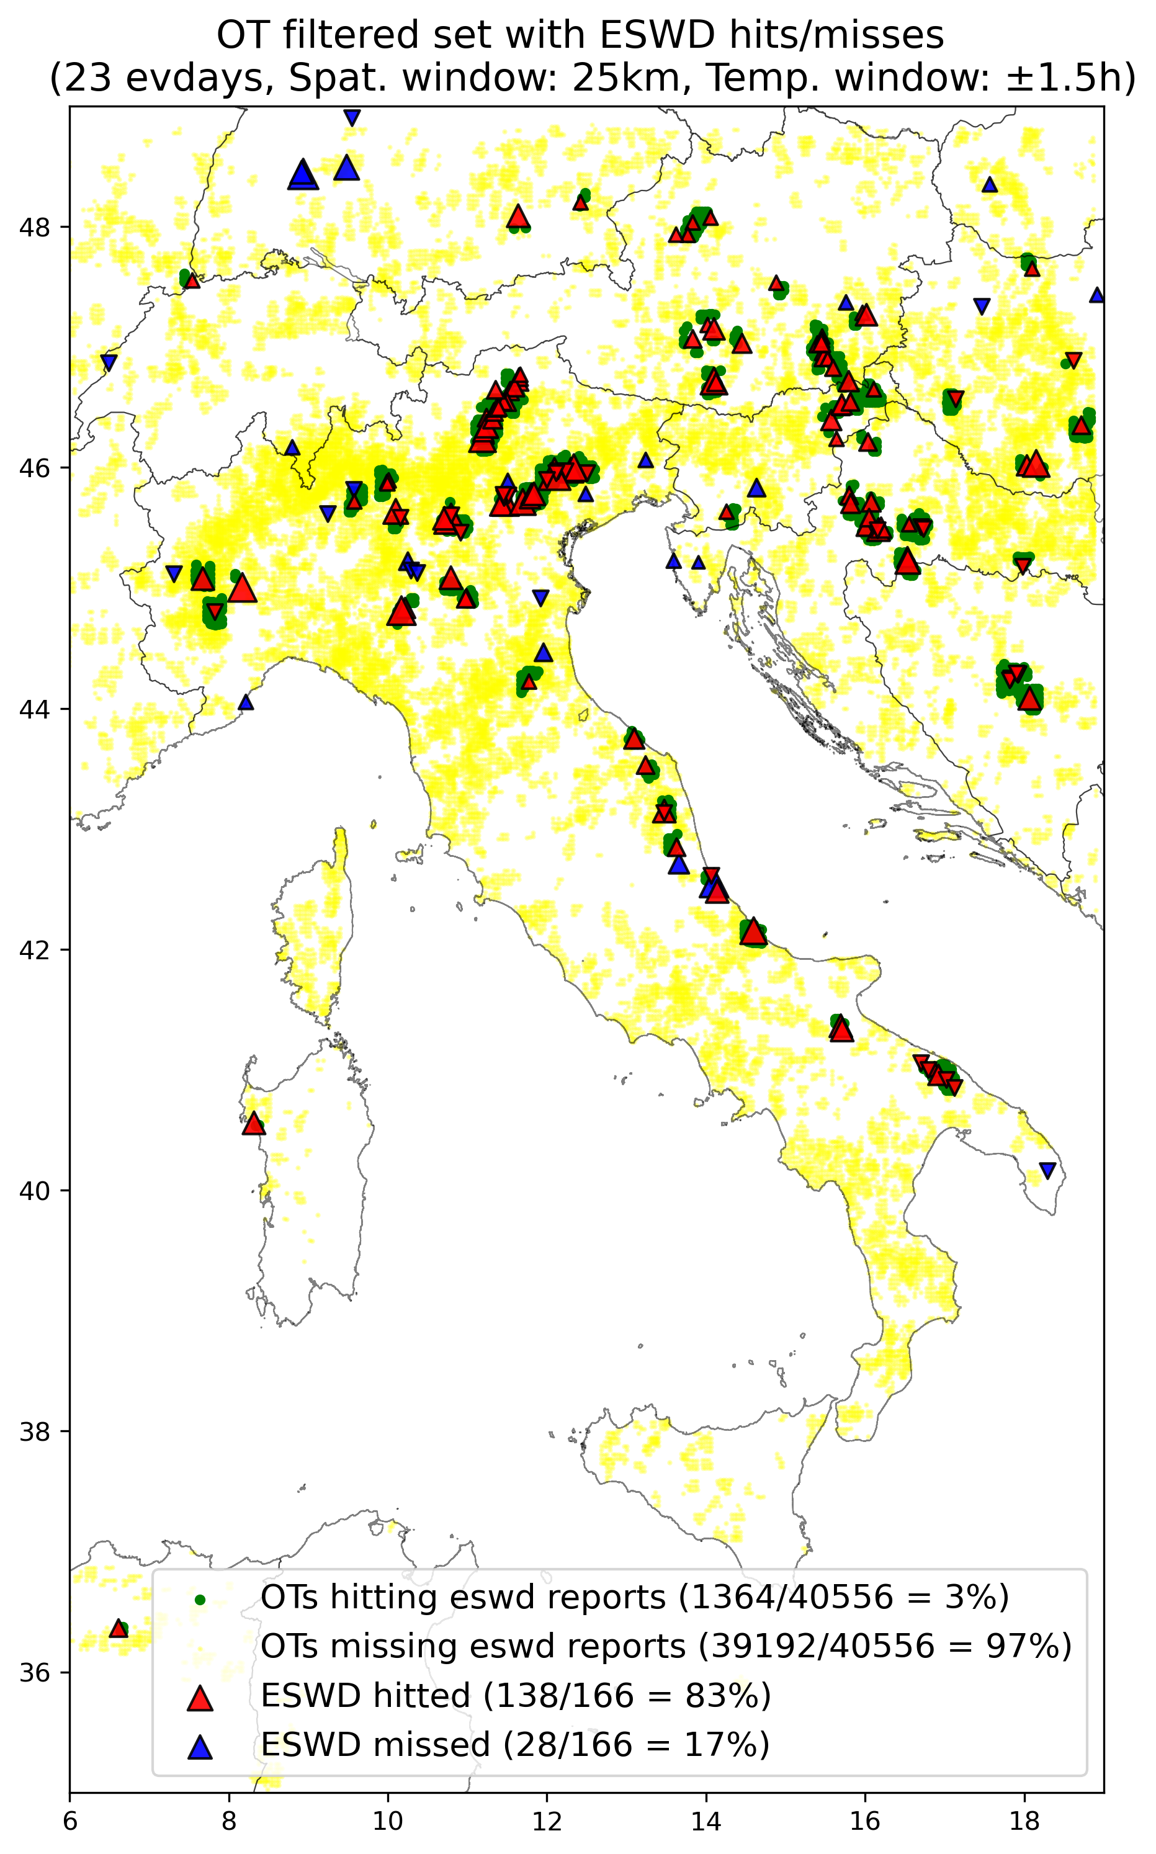

For the period 2004-2014:

* 12.282 ESWD severe hail reports (subset of 2475 reports QC1+)
* 696.135 OTs original (not only over land!),
* 542.137 OTs retained after filtering (78%) (also not only over land!)
* Fraction of OTs hitting ESWD reports (within range of 25km and time span +-1h) BEFORE filtering: **0.67%**, AFTER filtering: **0.84%**
* For the QC1+ eswd set: hit rate of eswd events decrease from **40.3%** BEFORE filtering to **39.7%** AFTER filtering

Comparison with Punge et al. 2022 (South Africa) ??

First results of OT-filtered/unfiltered data (with FILTER3h, 2-98perc Thresholds) validation with UNIPOL considering **+-5h** in a **25km** window around each OT occurrence during the 15 evdays (of 2017-2018) only overLAND and **only over ITALY**!

During the 15 event days in 2017-2018, over*LAND over ITALY, a total of **19868** OTs have been detected before filtering, and **18550** remained after filtering (meaning that **1318** OTs have been filtered over land over Italy (**6.6%**)).

A total of **27220** UNIPOL reports are reported during 2017-2018, but only **2461** are reported during the 15 event days, of this **643** (**26%)** are issued at 00:

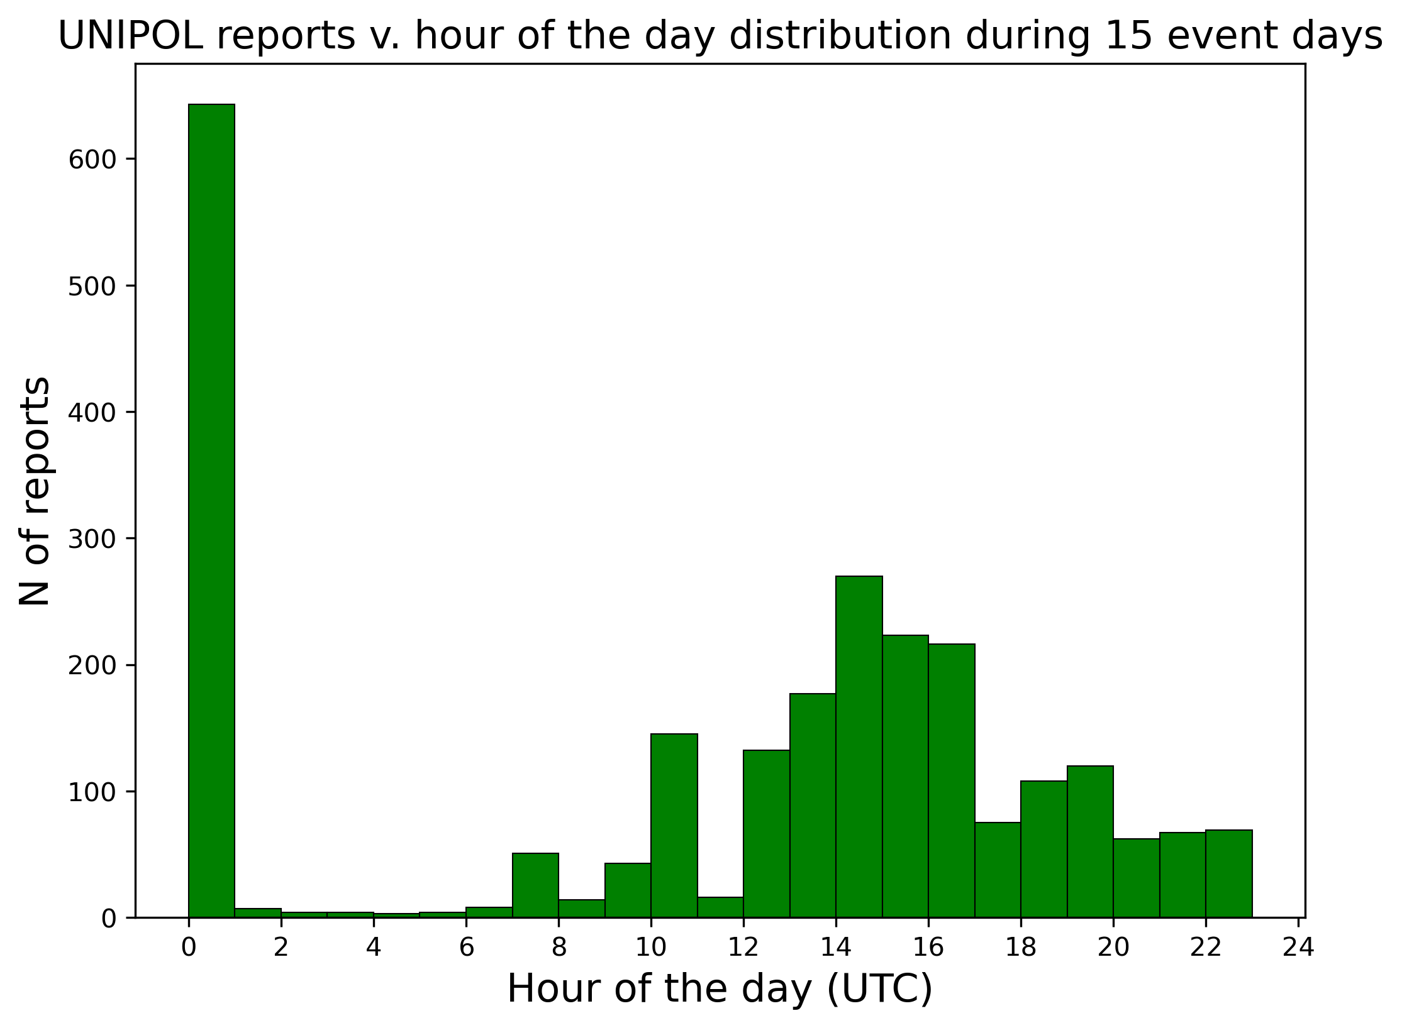

There is a large temporal bias as the majority of unipol reports are issued at 00UTC!!: IDEAS:  
- ~~Randomly resample the timing of the events at 00UTC to distribute them during the whole day~~ (non utile probabilmente)  
- ~~For each evdays check which is the median hour of the day (with the majority of unipol reports issued) and randomly resample the reports at 00 in a temporal window around that median value~~- Valentina suggestion: reset reports at 00 to 12 utc, test and see if there is a enhancemente of the scores, otherwise:  
- Delete reports at 00utc

|  |  |  |
| --- | --- | --- |
| **2-98perc thresholds (+-5h)** | **Filt_OTset** | **All_OTset** |
| **N of initial UNIPOL reports** | 2461 | 2461 |
| **N of HITTED UNIPOL reports** | 620 (25.2%) | 685 (27.8%) |
| **N of MISSED UNIPOL reports** | 1841 (74.8%) | 1776 (72.2%) |
|  |  |  |
| **N of initial OTs(over land over ITALY)** | 18550 | 19868 |
| **N of OTs HITTING UNIPOL reports** | 2923 (15.76%) | 3192 (16.07%) |
| **N of OTs MISSING UNIPOL reports (false alarms?)** | 15627 (84.24%) | 16676 (83.93%) |

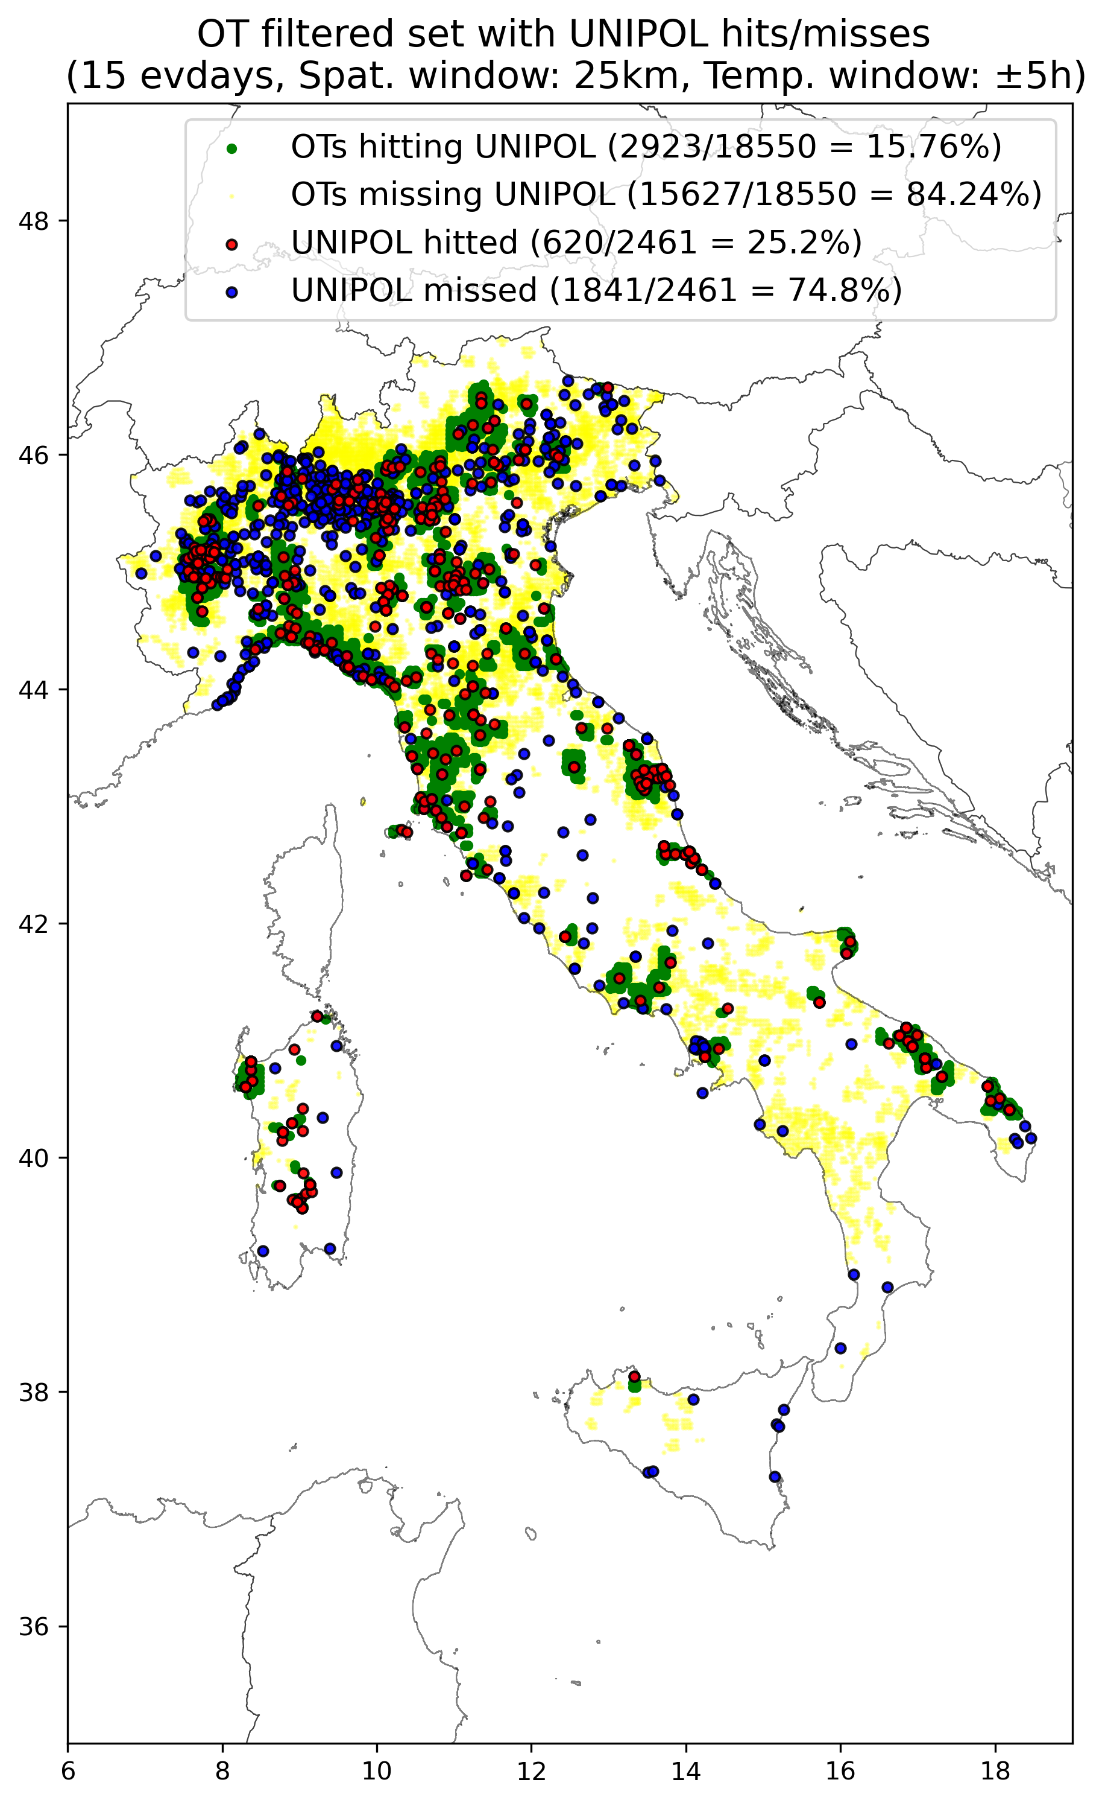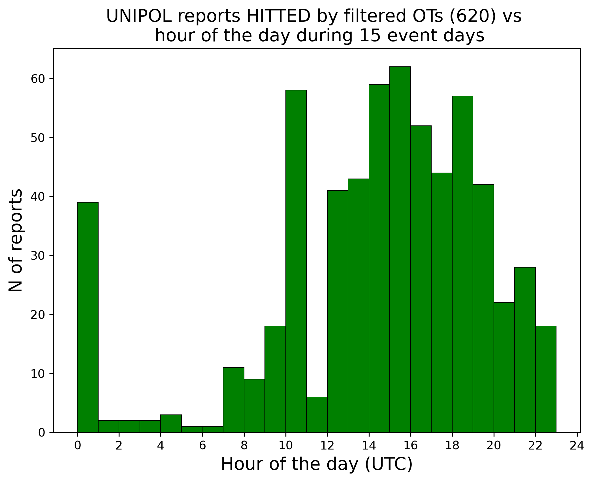

Doing the same NOT CONSIDERING reports at 00:

|  |  |  |
| --- | --- | --- |
| **2-98perc (+-5h)** | **Filt_OTset** | **All_OTset** |
| **N of initial UNIPOL reports** | 1818 | 1818 |
| **N of HITTED UNIPOL reports** | 581 (32.0%) | 637 (35.0%) |
| **N of MISSED UNIPOL reports** | 1237 (68.0%) | 1181 (65.0%) |
|  |  |  |
| **N of initial OTs (over land)** | ? | ? |
| **N of OTs HITTING UNIPOL reports** | ? | ? |
| **N of OTs MISSING UNIPOL reports (false alarms?)** | ? | ? |

28/6

OTHER OPTIONS FOR SPHERA PARAMETERS THRESHOLDS FOR FILTERING:

|  |  |  |  |
| --- | --- | --- | --- |
| **VARIABLE** | **Thr (USED): 2-98%-perc** | **Thr: 5-95%-perc** | **Thr: 10-90%-perc** |
| CAPE_MU | Perc2 = 505.32 J/kg | Perc5 = 618.42 J/kg | Perc10 = 822.08 J/kg |
| DLS | Perc2 = 7.4 m/s | Perc5 = 9.25 m/s | Perc10 = 10.62 m/s |
| H0 | Perc98 = 4104.5 m | Perc95 = 4039 m | Perc90 = 3961 m |
| LI | Perc98 = -1.27°C | Perc95 = -2.08 °C | Perc90 = -2.93 °C |
| K | Perc2 = 30.2°C | Perc5 = 32.5 °C | Perc10 = 34.2 °C |

1/7

**REDO THE FILTERING CONSIDERING 5-95perc as THresholds:**

Filter sample of 23 OTs event days with the new set of thresholds, validate with eswd and unipol and compare the results with previous filtering (2-98%),

* if enhancement decide if trying also 10-90% or to keep 5-95% and extend to the whole 3 years of data,
* if large detriment return to 2-98% thresholds

Comparison between OTs filtered and non-filtered during 23 event days with FILTER3h (considering **5-95perc** for thresholds):

During the 23 days of events considered a total of **65576** OTs (with prob >=50%) have been detected, over LAND instead **45992** (the **62%**)

After filtering with FILTER3h **52064** OTs remained (meaning that **13512** have been filtered, i.e. **21%**). Over LAND: after filtering **35800** remained (meaning that **10192** have been filtered over land only, i.e. **22%**)

**Validation with ESWD** OT-filtered/unfiltered data (with FILTER3h, **5-95perc** Thresholds) considering **+-1.5h** in a **25km** window around each OT occurrence during the 23 evdays only over LAND:

|  |  |  |
| --- | --- | --- |
| **5-95perc thresholds** | **Filt_OTset** | **All_OTset** |
| **N of initial ESWD reports** | 166 | 166 |
| **N of HITTED ESWD reports** | 127 (76.5%) | 138 (83%) |
| **N of MISSED ESWD reports** | 39 (23.5%) | 28 (17%) |
|  |  |  |
| **N of initial OTs (over land)** | 35800 | 45992 |
| **N of OTs HITTING ESWD reports** | 1234 (3.45%) | 1450 (3.15%) |
| **N of OTs MISSING ESWD reports (false alarms?)** | 34566 (96.55%) | 44542 (96.84%) |

19/7 - TEST: Validation with ESWD using **10-90perc** Thresholds (to justify why we used 5-95perc instead to extend the analysis) considering **+-1.5h** in a **25km** window around each OT occurrence during the 23 evdays only over LAND:

|  |  |  |
| --- | --- | --- |
| **10-90perc thresholds** | **Filt_OTset** | **All_OTset** |
| **N of initial ESWD reports** | 166 | |
| **N of HITTED ESWD reports** | 105 (63.3%) | 138 (83.1%) |
|  |  |  |
| **N of initial OTs (over land)** | 27888 | 45992 |
| **N of OTs HITTING ESWD reports** | 999 (3.58%) | 1450 (3.15%) |

Compare the three sets of thresholds for validation (ESWD, +-1.5h, 25km, 23evdays, over LAND):

|  |  |  |  |  |
| --- | --- | --- | --- | --- |
|  | **Filt 2-98perc** | **Filt 5-95perc** | **Filt 10-90perc** | **All_OTset** |
| **Tot ESWD rep.** | 166 | 166 | 166 | 166 |
| **HITTED ESWD rep.** | 138 (83.1%) | 127 (76.5%) | 105 (63.3%) | 138 (83.1%) |
| **% FilOT loss on AllOT** | **0%** | **-6.6%** | **-19.8%** |  |
|  |  |  |  |  |
| **Tot OTs (over land)** | 40556 | 35800 | 27888 | 45992 |
| **OTs HITTING ESWD** | 1364 (3.36%) | 1234 (3.45%) | 999 (3.58%) | 1450 (3.15%) |
| **%FilOT gain on AllOT** | **+0.21%** | **+0.3%** | **+0.43%** |  |

**Validation with UNIPOL** OT-filtered/unfiltered data (with FILTER3h, **5-95perc** Thresholds) considering **+-5h** in a **25km** window around each OT occurrence during the 15 evdays (of 2017-2018) only over LAND and **only over ITALY**!

During the 15 event days in 2017-2018, over LAND over ITALY, a total of **19868** OTs have been detected before filtering, and **17084** remained after filtering (meaning that **2784** OTs have been filtered over land over Italy (**14%**))

Like with 2-98p,a total of **27220** UNIPOL reports are reported during 2017-2018, but only **2461** are reported during the 15 event days, of this **643** (**26%**) are issued at 00

|  |  |  |
| --- | --- | --- |
| **5-95perc thresholds (± 5h)** | **Filt_OTset** | **All_OTset** |
| **N of initial UNIPOL reports** | 2461 | 2461 |
| **N of HITTED UNIPOL reports** | 598 (24.3%) | 685 (27.8%) |
| **N of MISSED UNIPOL reports** | 1863 (75.7%) | 1776 (72.2%) |
|  |  |  |
| **N of initial OTs(over land over ITALY)** | 17084 | 19868 |
| **N of OTs HITTING UNIPOL reports** | 2708 (15.85%) | 3192 (16.07%) |
| **N of OTs MISSING UNIPOL reports (false alarms?)** | 14376 (84.15%) | 16676 (83.93%) |

Tried a further test for UNIPOL validation using **+-12h** temporal window (to check whether the temporal uncertainty is the main factor influencing the low number of hits in UNIPOL reports):

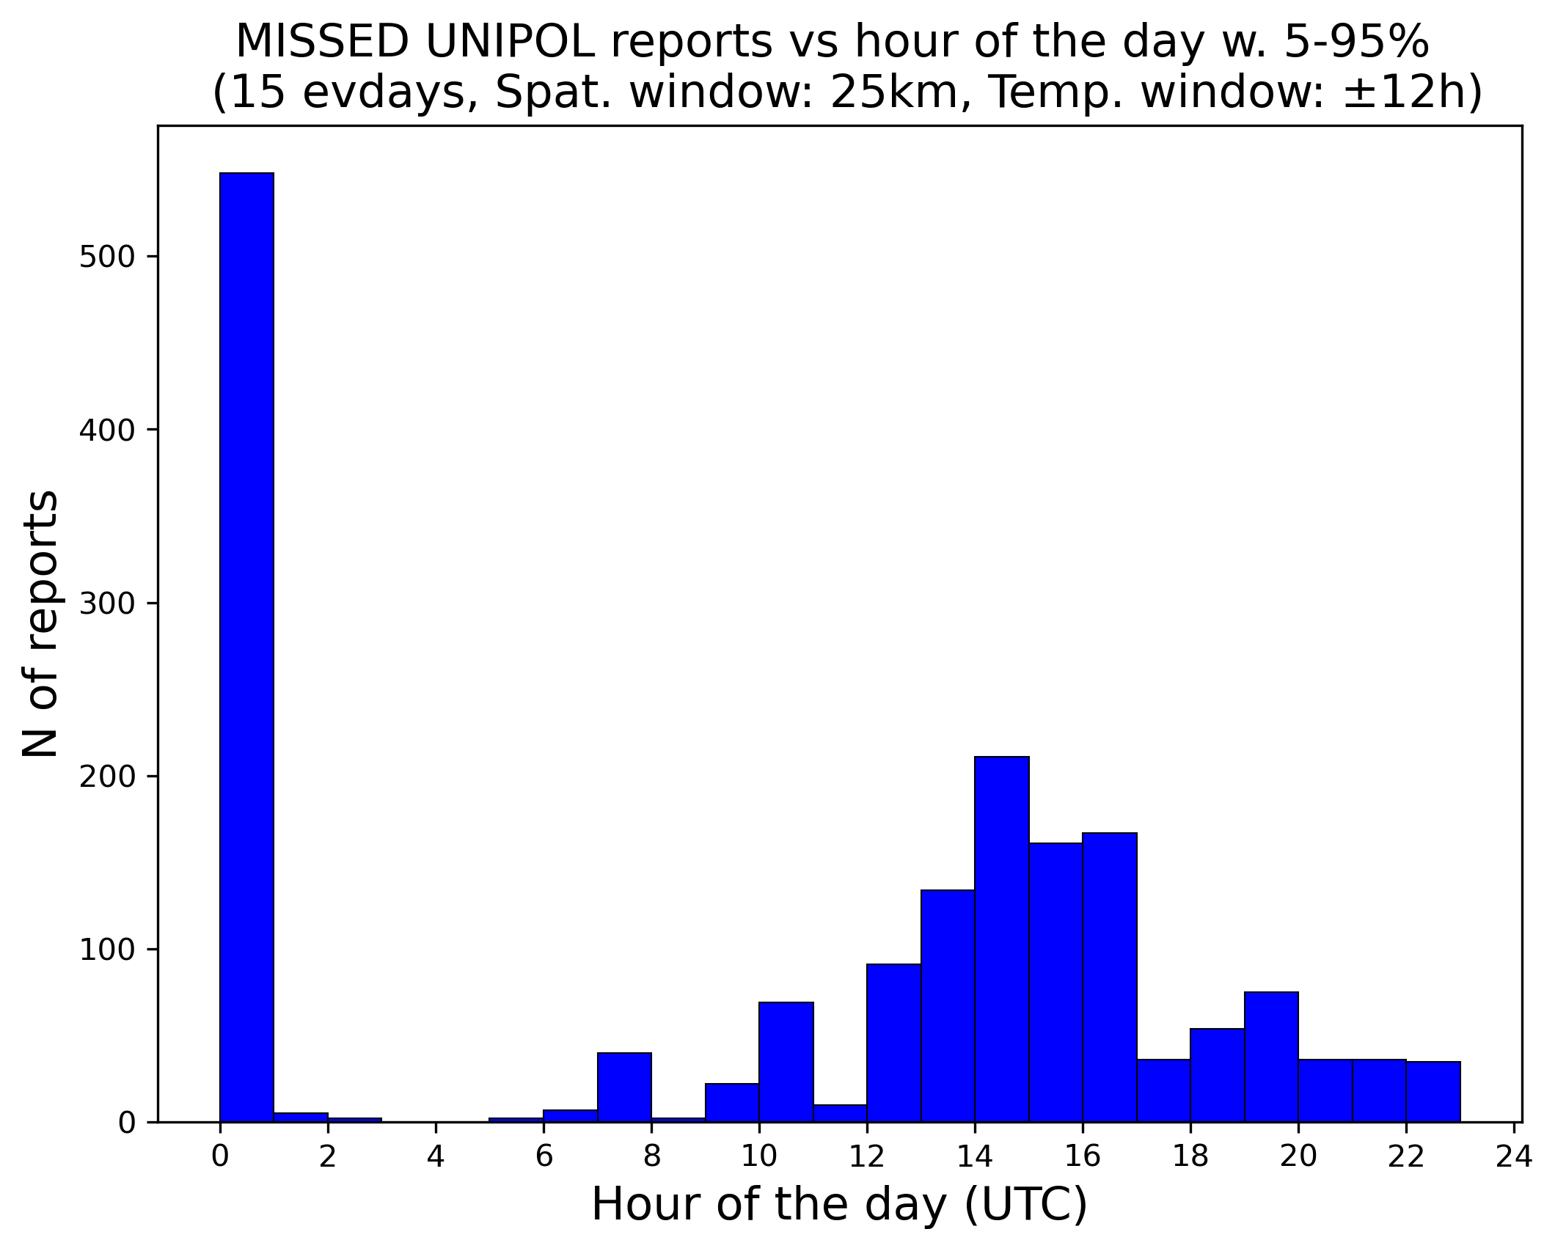

|  |  |  |
| --- | --- | --- |
| **5-95perc thresholds (± 12h)** | **Filt_OTset** | **All_OTset** |
| **N of initial UNIPOL reports** | 2461 | 2461 |
| **N of HITTED UNIPOL reports** | 718 (29.2%) |  |
| **N of MISSED UNIPOL reports** | 1743 (70.8%) |  |
|  |  |  |
| **N of initial OTs(over land over ITALY)** | 17084 | 19868 |
| **N of OTs HITTING UNIPOL reports** | 3270 (19.14%) |  |
| **N of OTs MISSING UNIPOL reports (false alarms?)** | 13814 (80.86%) |  |

Not real improvement, still the majority of misses is made at 00UTC:

Try redo the +-12h analysis withdrawing 00UTC data before

Test validazione OT filter 5-95% vs UNIPOL con reset ore 00 alle 12UTC e finestra temporale +-12h

|  |  |
| --- | --- |
| **5-95perc thresh (± 12h) + 00to12utc** | **Filt_OTset** |
| **N of initial UNIPOL reports** | 2461 |
| **N of HITTED UNIPOL reports** | 786 (31.9%) |
| **N of MISSED UNIPOL reports** | 1675 (68.1%) |
|  |  |
| **N of initial OTs(over land over ITALY)** | 17084 |
| **N of OTs HITTING UNIPOL reports** | 3625 (21.21%) |
| **N of OTs MISSING UNIPOL reports (false alarms?)** | 13459 (78.78%) |

Non c’è miglioramento significativo in risultati (da 29.2% a 31.9% di report di unipol hittati spostando i report delle 00 alle 12).

Fare ultimo test: eliminare dati alle 00 prima di avviare l’analisi e vedere se risultati finali migliorano

|  |  |
| --- | --- |
| **5-95perc thresh (± 12h) + No00** | **Filt_OTset** |
| **N of initial UNIPOL reports** | 1818 |
| **N of HITTED UNIPOL reports** | 623 (34.3%) |
| **N of MISSED UNIPOL reports** | 1195 (65.7%) |
|  |  |
| **N of initial OTs(over land over ITALY)** | 17084 |
| **N of OTs HITTING UNIPOL reports** | 2885 (16.89%) |
| **N of OTs MISSING UNIPOL reports (false alarms?)** | 14199 (83.11%) |
|  |  |

Non migliorano significativamente. A questo punto eliminare tutti i report UNIPOL alle 00 e tenere +-12h

Compare the three sets of thresholds for validation (UNIPOL, +-12h, 25km, no 00utc, 15evdays, over LAND over ITALY):

|  |  |  |  |  |
| --- | --- | --- | --- | --- |
|  | **Filt 2-98perc** | **Filt 5-95perc** | **Filt 10-90perc** | **All_OTset** |
| **Tot UNIPOL rep.** | 1818 | 1818 | 1818 | 1818 |
| **HITTED UNIPOL rep.** | 650 (35.8%) | 623 (34.3%) | 600 (33.0%) | 716 (39.4%) |
| **% FilOT loss on AllOT** | **-3.6%** | **-5.1%** | **-6.4** |  |
|  |  |  |  |  |
| **Tot OTs (over land IT)** | 18550 | 17084 | 13600 | 19868 |
| **OTs HITTING UNIP.** | 3110 (16.77%) | 2885 (16.89%) | 2556 (18.79%) | 3433 (17.28%) |
| **%FilOT gain on AllOT** | **-0.51%** | **-0.39%** | **+1.51%** |  |

RIUNIONE INES 1/7

* Per upscaling con media a 10km di SPHERA: possibile critica è che si smussano le caratteristiche ad alta risoluzione mediando sui 10km, però un’altra possibile giustificazione può essere che i campi a risoluz originale erano troppo rumorosi
* ~~Scrivere a UNIPOL per avere info su qualità dati usati: chiedere per incertezza temporale, se dati a 00 sono riferiti allo stesso giorno o a quello precedente, se il bias è solo orario o può essere anche giornaliero/mensile? NON serve, Valentina mi fornirà info in più (quantitativo danni + natura danni (campi,edifici,macchine)) ma altre info non ci sono nel dataset~~

RIUNIONE VALENTINA 4/7

* Falsi allarmi di OT stimati da validazione con eswd/unipol non sono affidabili per niente! A causa del dataset osservativo troppo parziale e non comprensivo!
* Inserire dati fulminazioni nell’analisi: sviluppare un dato di LJ come in Schultz et al. 2009 non è alla nostra portata, si potrebbe però provare ad utilizzare i dati di LAMPINET “raw” grigliati come condizione aggiuntiva prima della validazione delle osservate e per stimare il false alarm rate degli OT filtrati in presenza o meno di fulminazioni (tenere una soglia bassa e.g. 10 fulminazioni per rimanere più conservativi), FARE TEST SUI 23 GIORNI DI EVENTI E VEDERE COSA SI OTTIENE?
* Dati UNIPOL: bias orario evidente, possibile soluz: spostare dati delle 00 alle 12 dello stesso giorno, e vedere se tenendo finestra temporale 12h c’è un aumento significativo dello hit rate oppure no (Test sotto), in alternativa eliminare i dati alle 00 –> eliminare dati alle 00
* Dati UNIPOL concentrati in luglio perchè (probabilmente) la maggior parte sono attribuiti a danni all’agricoltura e luglio è il mese di picco di produzione (trovare fonte?) e quindi anche di maggiore impatto dannoso causato da grandinate
* ~~Per UNIPOL: Forse ci sono informazioni in più (come quantificazione danni), Valentina ci guarda e mi fa sapere~~
* Inoltre la maggiorparte dati UNIPOL sono relativi a danni agricoli sulle piantagioni (per questo picco in luglio spiegato), ottenere percentuali di report per danni agricoli, edifici, macchine? NO: dati separati da dataset unipol processato da valentina (con centroidi comuni, lat/lon)

**5/7 RECAP SITUA**

* **Definizione filtro OT**: fatto, decidere se usare soglie **~~2-98perc~~** o **5-95perc**: più propenso per 5-95 dato che il numero di OT filtrati aumenta ed aumenta la percentuale di OT rimanenti associati ad un report di grandine a fronte di una leggera diminuzione del numero di report Hittati
* **Validazione set OT filtrati**: finire test prima dell’estensione:
  + Per UNIPOL: capire se ~~spostare report 00 alle 12~~ o se **eliminare report alle 00**
  + **~~Caratterizzazione dati UNIPOL~~**~~: percentuali di report per danni agricoli/edifici/macchine?, ed entità danni?: NO~~
  + Altri dati per validazione?:
    - **Friuli hailpad data** (as in Torralba et al. 2022)?? Possible development to discuss <https://www.meteo.fvg.it/grandine.php>
    - **Passive Microwave Imagers**: global gridded climatologies of hailstorm detections per year, with grid steps of 2°. These can be used for comparing the results of my approach with a more robust climatology at the end?
* **Dati fulminazioni LAMPINET:** LJ non si può sviluppare, quindi due possibilità (capire comunque opinione Kris e Michael):
  + Usare dati LAMPINET “raw” grigliati come condizione aggiuntiva nel filtro degli OT, prima della validazione delle osservate, e per stimare il false alarm rate degli OT filtrati in presenza o meno di fulminazioni (tenere una soglia bassa e.g. 10 fulminazioni per rimanere più conservativi)
  + Verificare solo la corrispondenza in un intorno spazio-temporale di presenza di OT con dati fulminazioni grigliati senza ulteriormente filtrare gli OT
* **Estensione analisi a 2019-2020**: ideale in quanto dataset eswd per validazione (e anhce unipol) molto piu numerosi, capire tempistiche produzione SPHERA
* **Analisi sensitività a parametri SPHERA**: tenere DLS e H0 ma magari capire se possiamo fare a meno di uno dei parametri di instabilità atmosferica (CAPE,K e SLI)? (non so se c’è il tempo)
* **Preparare presentazione per EMS 6/9!!! + iscrizione + viaggio +missione unibo!**
* **Partecipare ad American Hail Workshop 20-22/9 Boulder, Colorado virtually (**submission up t 1/8, registration 0$ for university students (also phd students??) due by august 1, **), chiedere a Kris e Michael**

In più:

* ~~Revisione articolo Ines entro 22/7~~

30/6

Obtained OT data 2016-2018 Apr-Oct from Kris: Domain bound is 4-24°E, 35-50°N, 28 pixels/degree resolution.

2 Missing days: 2017091 (1 April, but no eswd nor unipol reports), 2018091 (1 april) 2018168 (17 June, but no eswd reports and 6 unipol reports)

Furthermore I noticed that the OT probability (otpmax) in the new data, when comparing a day event of the previous sample (e.g. 2016-08-29) are a little higher than before (from 0.55 to 0.58, from 0.71 to 0.70) and this cause a slight increase in the number of OTs having p>0.5 (in the event case considered with the previous data we had 145 OTs with this new data 149 over the whole SPHERA domain)

6/7

Iniziato filtraggio dati OT periodo completo 2016-2018 (Apr-Oct) usando filtro **5-95perc**, 70km spatial window, 0-3h temporal window

**DETECTED MISSING DATA DURING FILTERING:**

* 2016185 (3-7-2016): missing SPHERA whole day (only 32 OTs detected, no ESWD reports)
* 2016186 (4-7-2016): missing SPHERA data only 00UTC (no OTs detected, no ESWD reports)
* 2016201 (19-7-2016): missing SPHERA data 11-23UTC (no OTs detected, no eswd reports)
* 2017091 (1-4-2017): missing OT data whole day (no eswd/unipol reports detected)
* 2018091 (1-4-2018): missing OT data whole day
* 2018168 (17-6-2018): missing OT data whole day (but no eswd reports and 6 unipol reports)

15/7 Riunione Ines:

* Per confronto dati OT filtrati/non-filtrati interessante vedere confronto tra dataset e poi anche validazione con eswd/unipol caratterizzata temporalmente (mesi) e spazialmente (magari considerare subdomain con numero maggiore di report di grandine e.g. >44°N) per vedere se il filtro ha dei “bias” come ad esempio il filtraggio di tutti gli eventi primaverili per condizioni convettive diverse, e/o se in determinate regioni temporali è più o meno efficace
* Per grafici validazione con report unipol considerare densità report in una determinata griglia (e.g. 10km) invece che riportare i report puntuali (vista la grande quantità di sovrapposizioni!)
* Fare prova filtro usando 10-90% in campione di 23 eventi, anche solo per giustificare la scelta di considerare il 5-95% come soglie definitive!

18/7

**RESUTS ANALYSIS OT FILTERING 2016-2018, 5-95% THRESHOLDS, 70KM SPAT.WINDOW 0-3H**

Table reporting the amount of OTs (with p>=50%) detected during each year in April-October over the **whole SPHERA domain**:

|  |  |  |  |  |
| --- | --- | --- | --- | --- |
| **YEAR** | **N days** | **OT UNFILTERED set** | **OT FILTERED set** | **OT REMOVED set** |
| 2016 | 211 | 171.947 | 126.599 (73.6%) | 45.348 (26.4%) |
| 2017 | 213 | 189.613 | 143.468 (75.7%) | 46.145 (24.3%) |
| 2018 | 212 | 270.840 | 198.823 (73.4%) | 72.017 (26.6%) |
| 2016-2018 | 636 | 632.400 | 468.890 (74.1%) | 163510 (25.9%) |

Same as above but only over **LAND**:

|  |  |  |  |  |
| --- | --- | --- | --- | --- |
| **YEAR** | **N days** | **OT UNFILTERED set** | **OT FILTERED set** | **OT REMOVED set** |
| 2016 | 211 | 106.094 | 75.568 (71.2%) | 30.526 (28.8%) |
| 2017 | 213 | 133.634 | 100.892 (75.5%) | 32.742 (24.5%) |
| 2018 | 212 | 152.012 | 106.579 (70.1%) | 45.433 (29.9%) |
| 2016-2018 | 636 | 391.740 | 283.039 (72.3%) | 108.701 (27.7%) |

During 2016 a total number of 149 out of 211 days report at least 1 hailstorm-favouring OT over LAND in the filtered dataset (i.e. the 70.6% of the days), compared to the 166 out of 211 days (78.7%) of the unfiltered (original) dataset over LAND.

During 2017 instead: 137 out of 213 (64.3% of the days) in the filtered dataset, compared to the 162 out of 213 days (76.1%) of the unfiltered (original) dataset over LAND

During 2018 instead: 182 out of 212 days (85.8% of the days) in the filtered dataset, compared to the 193 out of 212 days (91.0%) of the unfiltered (original) dataset over LAND

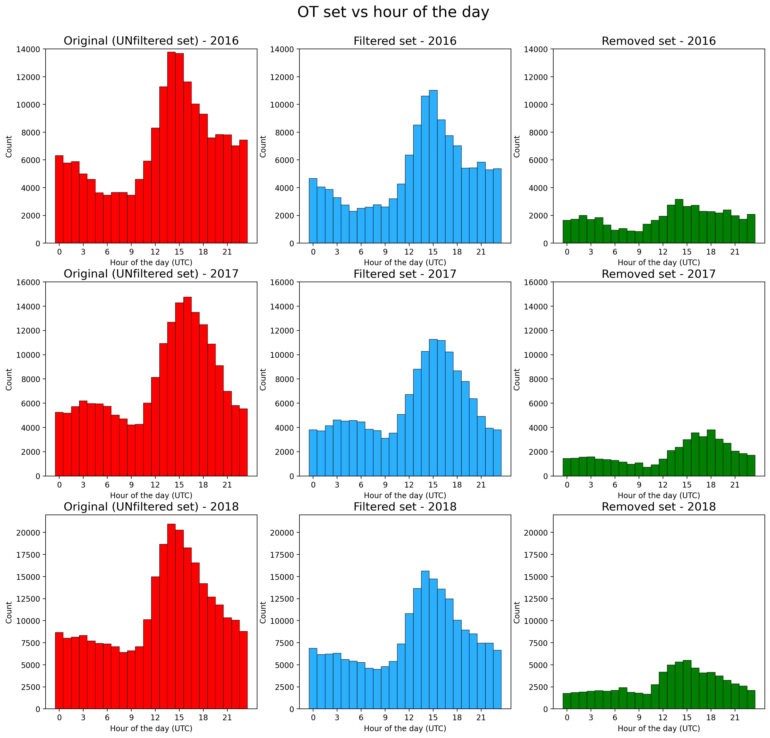

From analysis on different OT sets dep. On hour of the day there is coherence during all the years with the diurnal cycle of convection: max amount of OT detected always around 14-16utc, as well as the max number of filtered OTs.

From distributions of OTs depending on the month for 2016 and 2017 agreement with max N of OTs during the summer season (JJA) and September (due probably to residual convective instability during early fall in Mediterranean area), **while strange distr. in 2018: the majority of OTs are detected in October (73.449, >27%!), while July and Sept. are the least populated months after April! Why?**

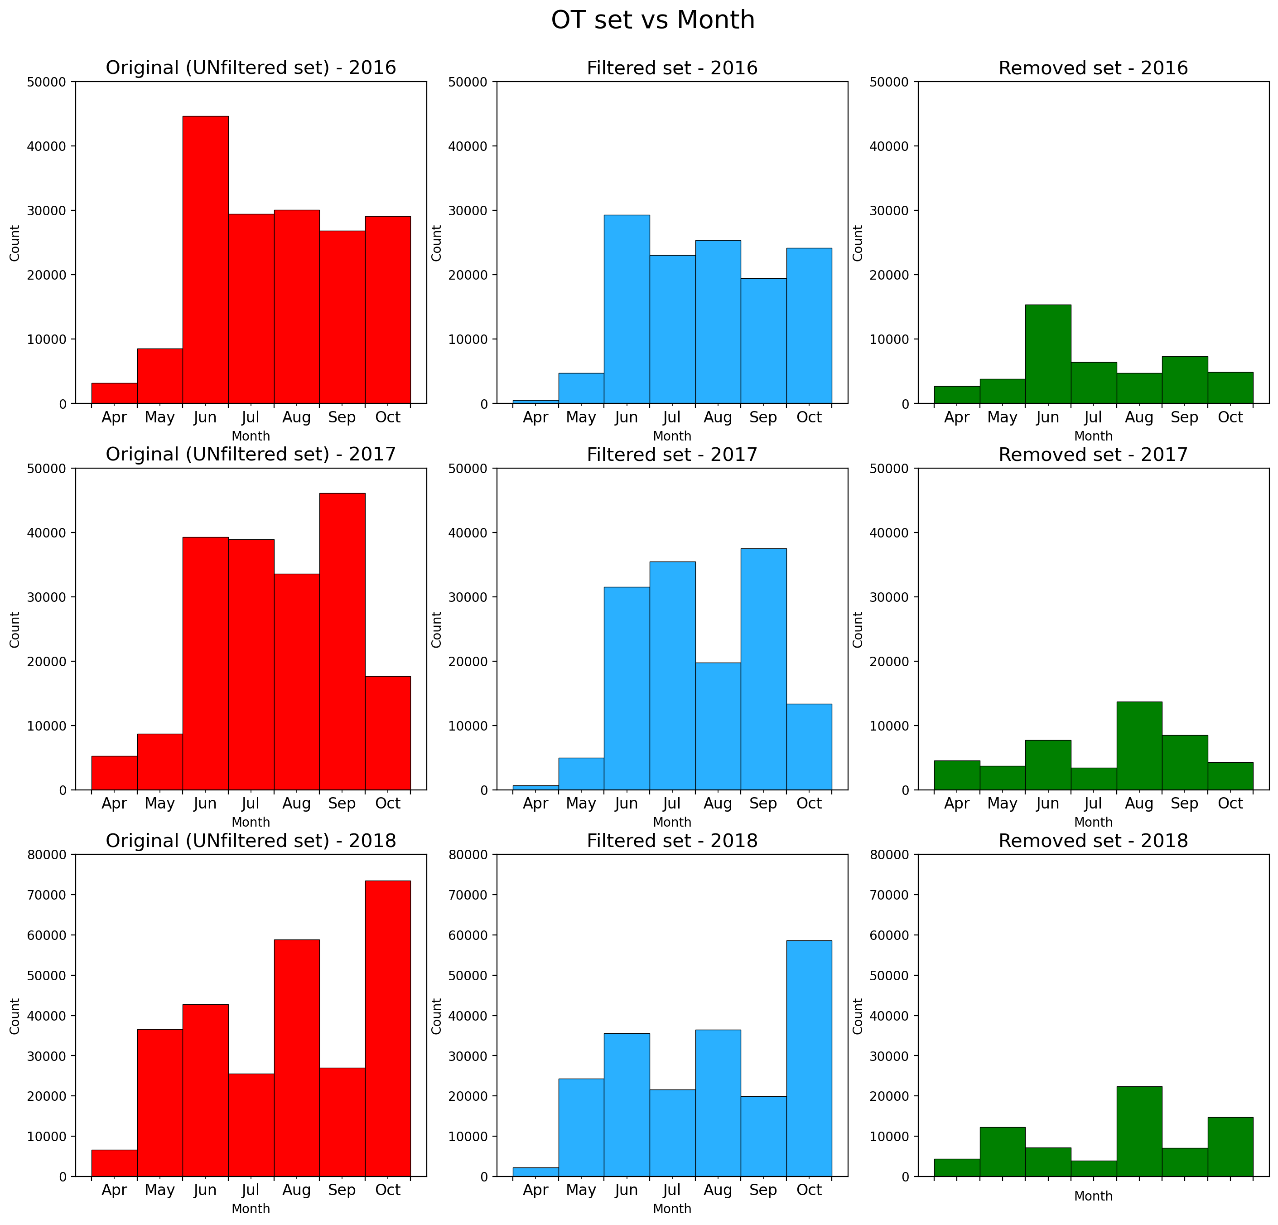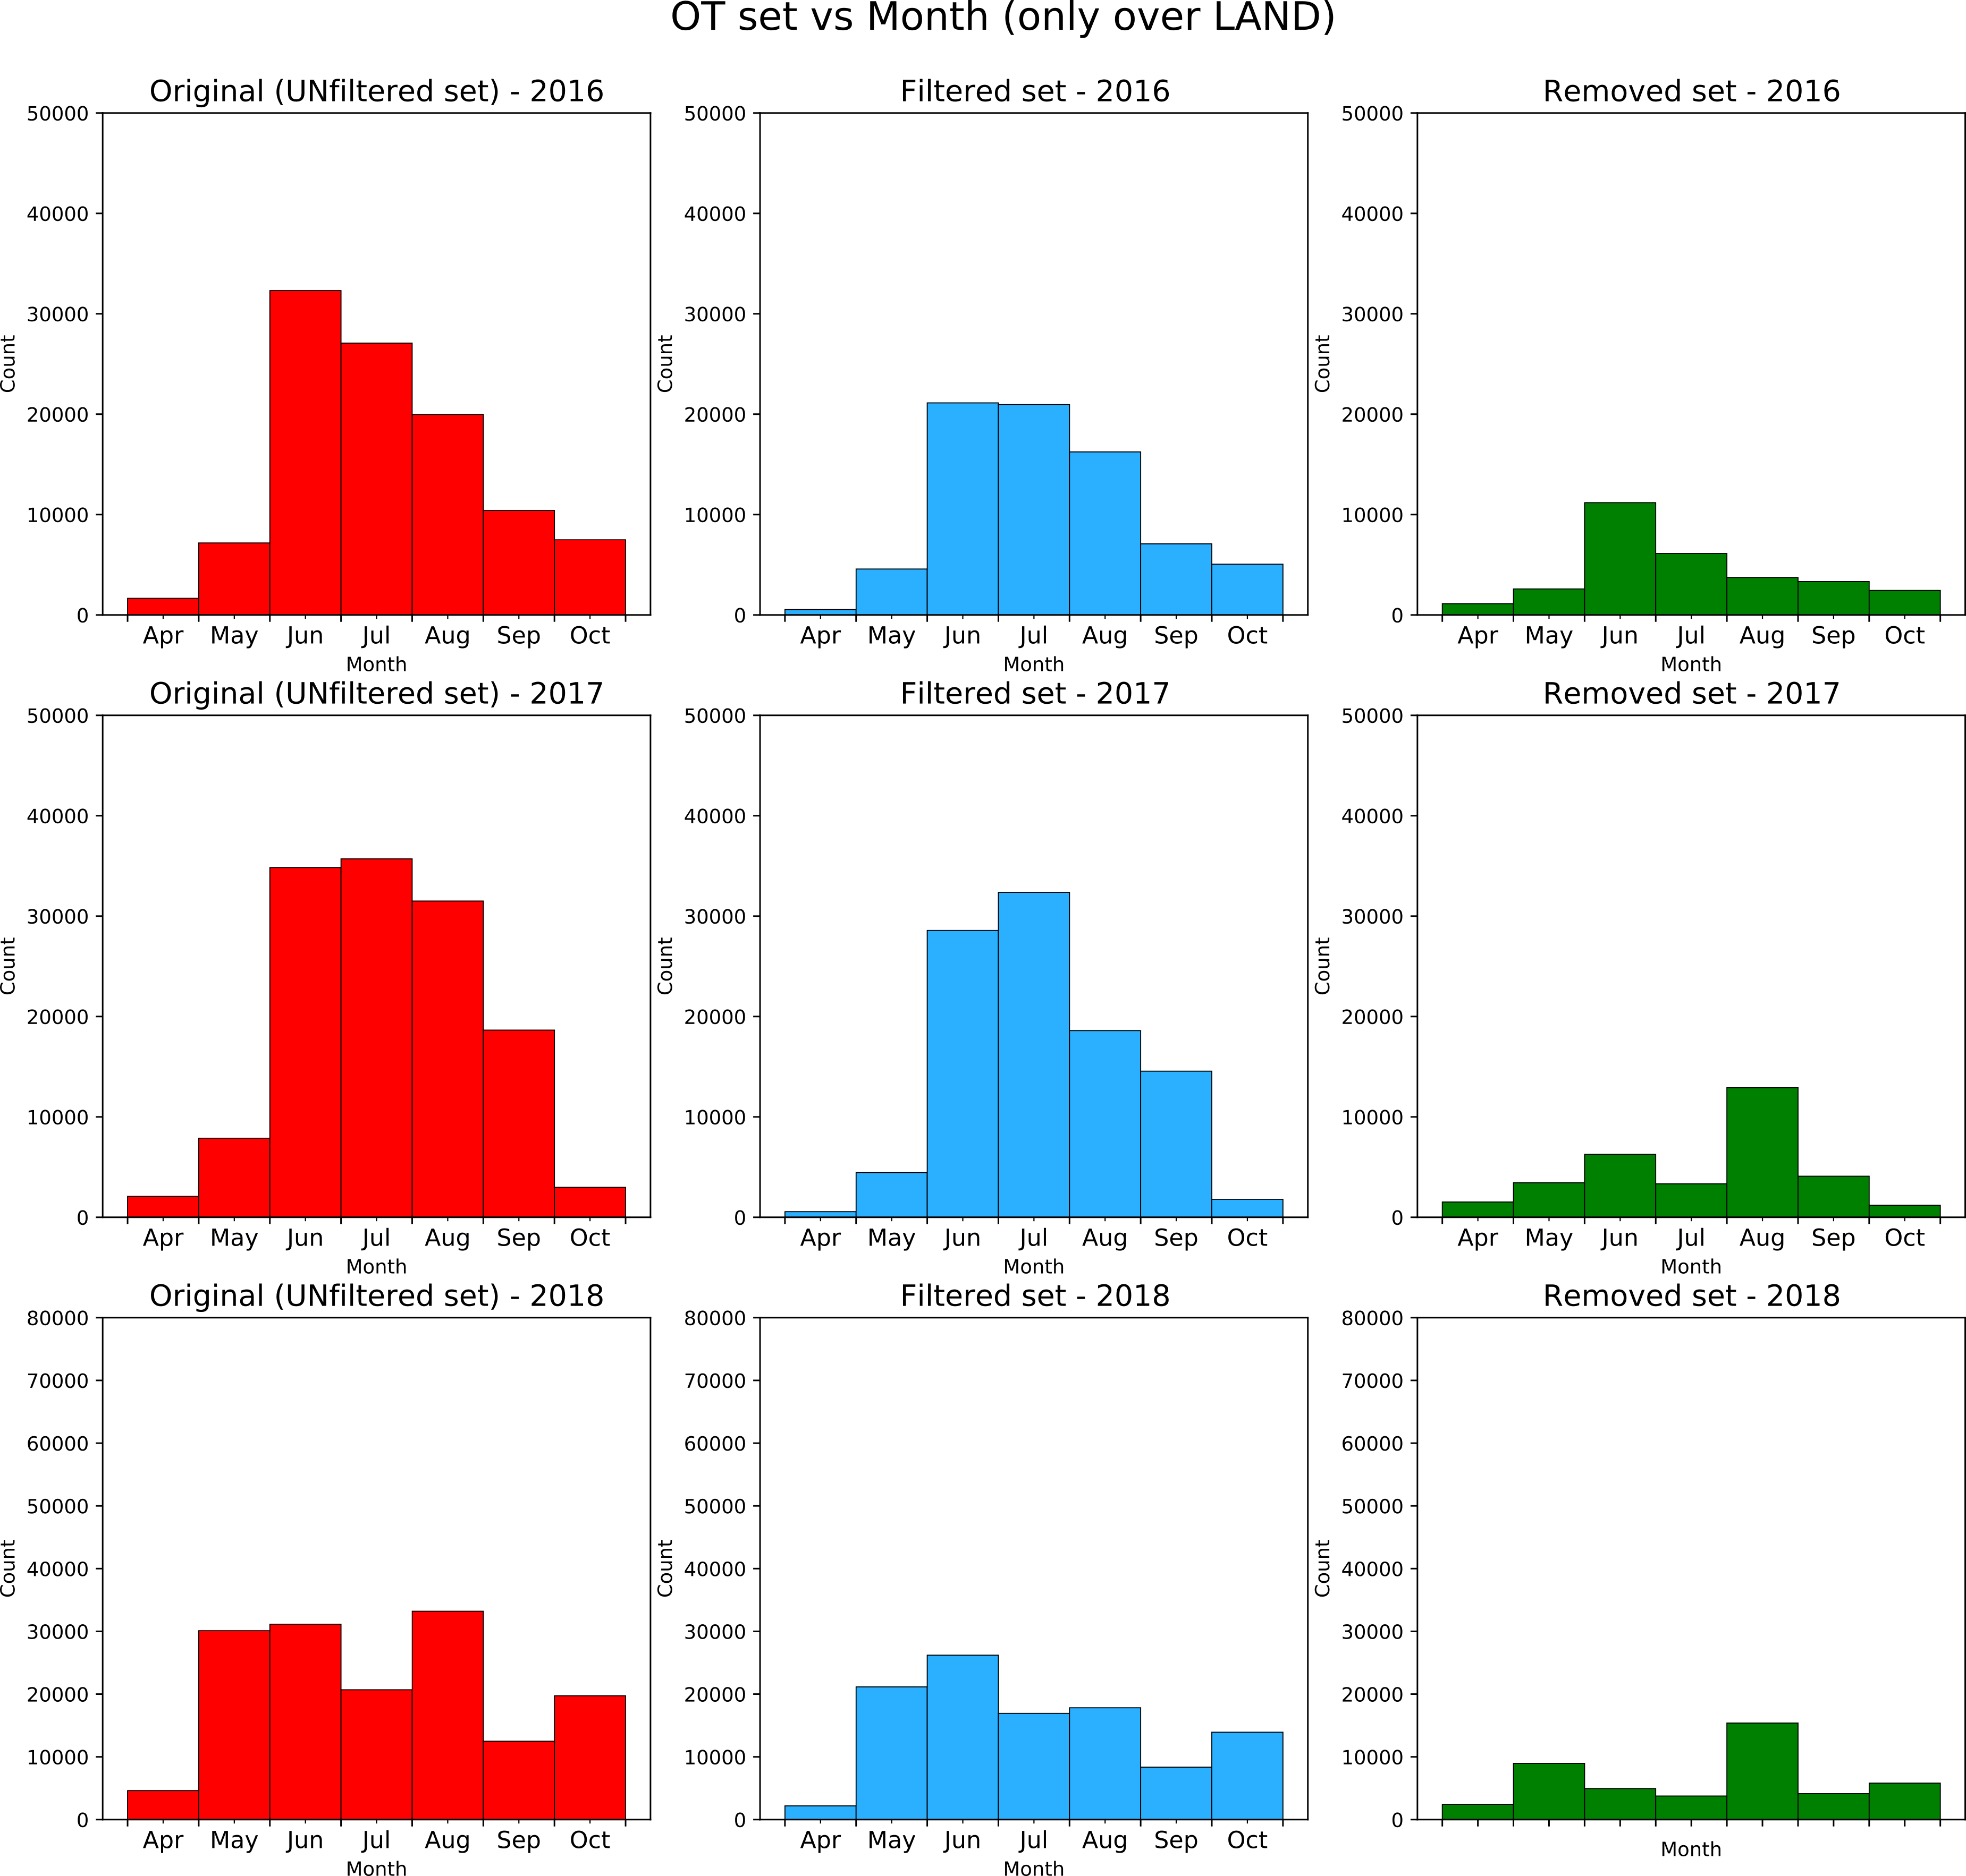

Considering only over LAND: JJA peaks even more evident, in 2018 lower number in October (19.738 (13%)) than Aug,Jun,May

And aggregating all years together:

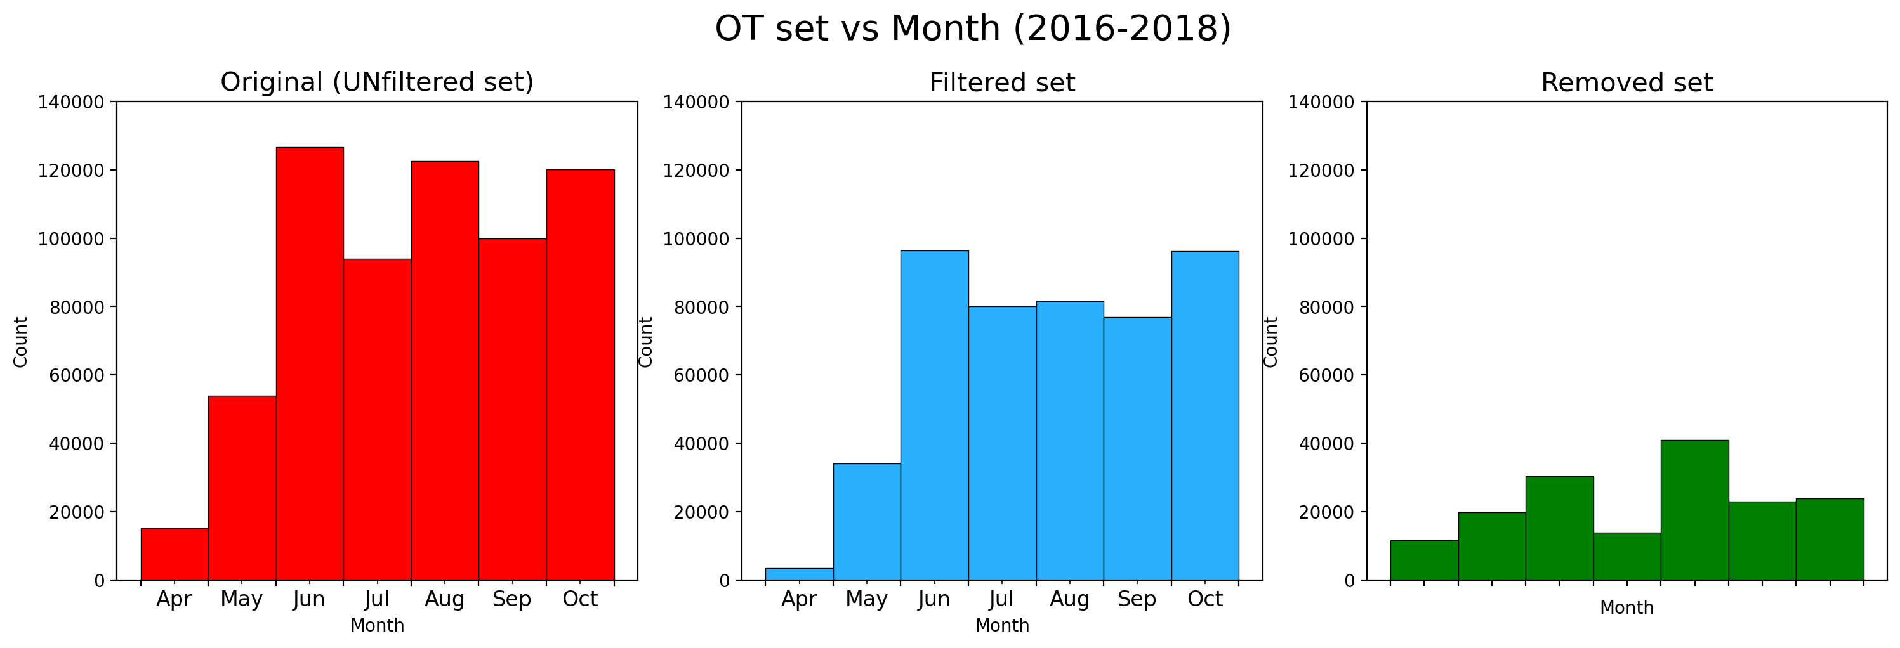

Plot of the spatial distributions of the three OT set over the domain through **KDE plot** (Kernel Density Estimate: data representation using a continuous probability density curve – maybe too smoothing function?): filter is most effective in removing OTs in the central and eastern Alpine area (especially Italian-Austrian-Slovenian border), in northern Algeria, and along the Apennines

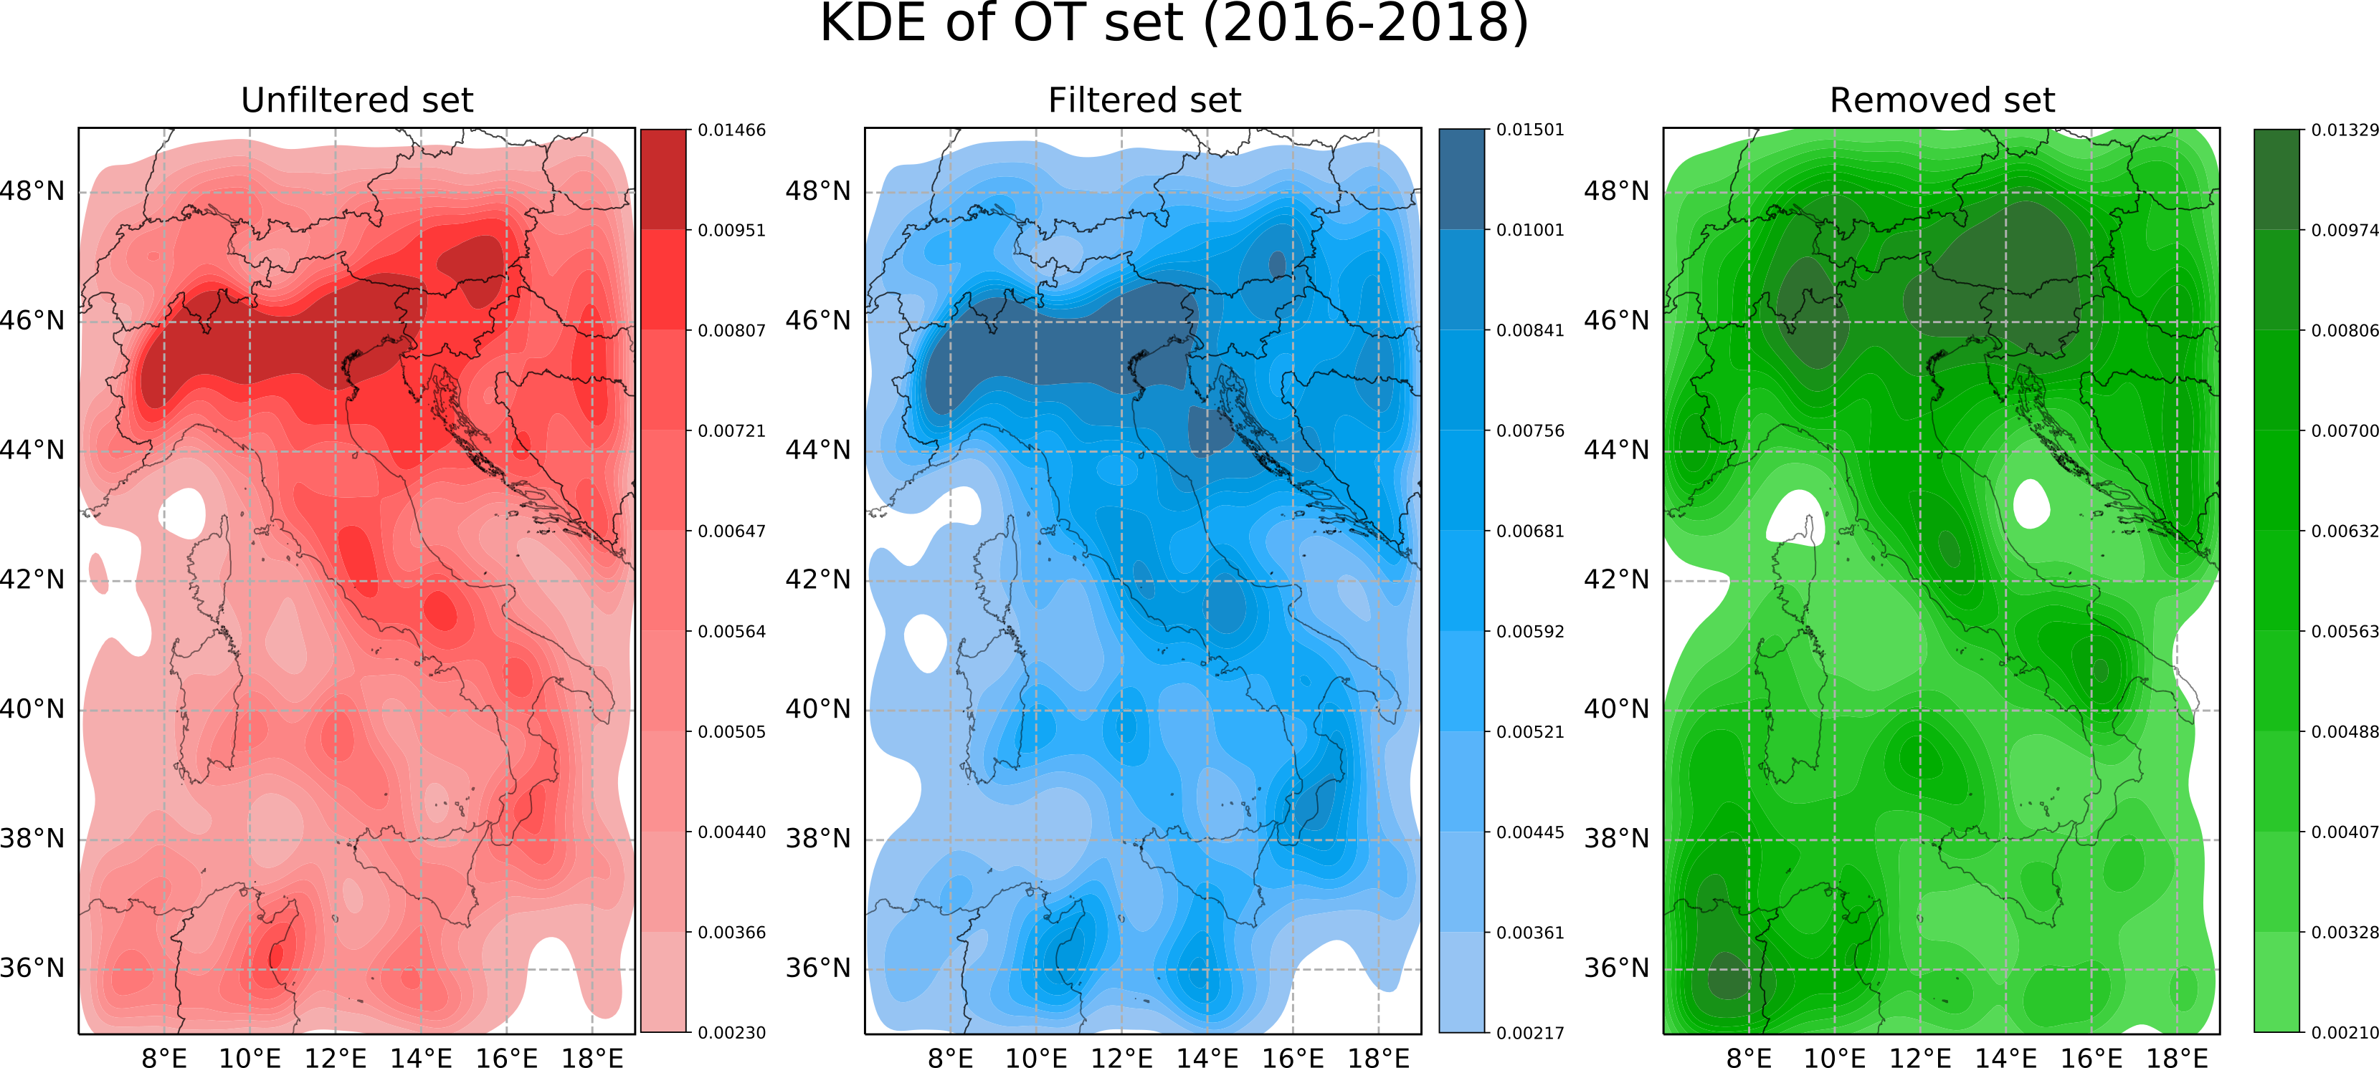

Similar information gained when considering OT data distributions summed in 2016-2018 on a 10km regular grid:

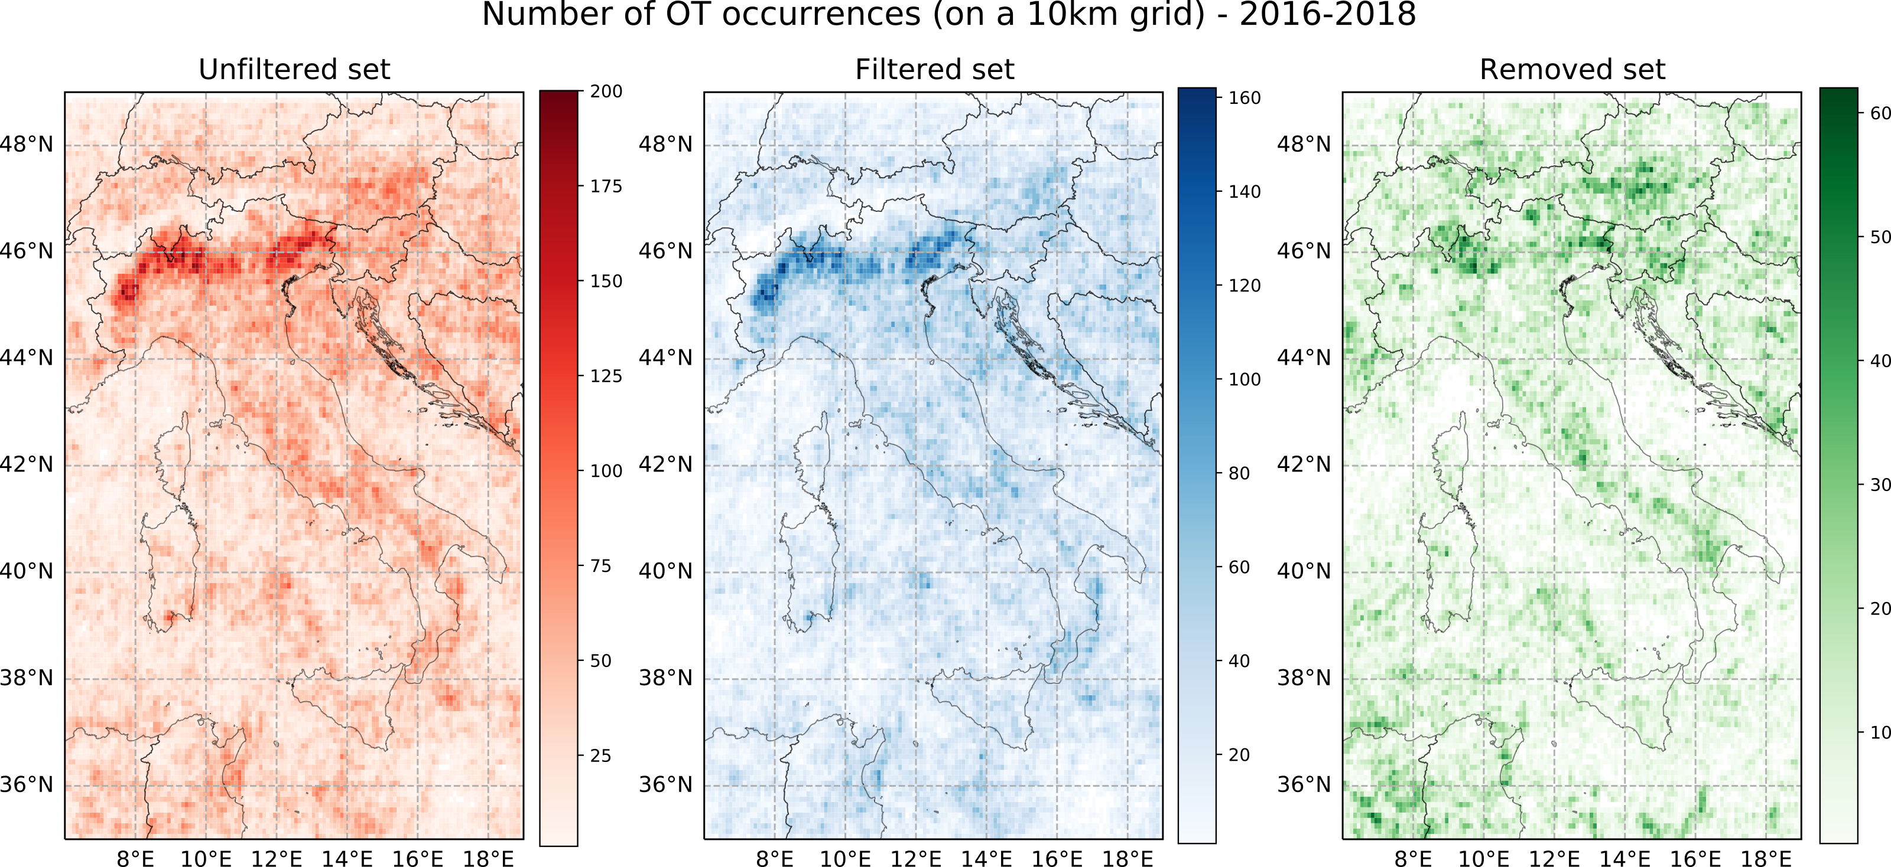

**RESULTS VALIDATION OT ORIGINAL/FILTERED SETS VS ESWD/UNIPOL HAIL REPORTS:**

* **Validation vs ESWD (2016-2018)** (considering +-1.5h temp. window, and 25km spat. Window around each OT, only over LAND):

A total of 75 days with at least 1 ESWD report are reported in 2016, 73 days in 2017 and 80 days in 2018.

ESWD reports data distribution 2016-2018 Apr-Oct:

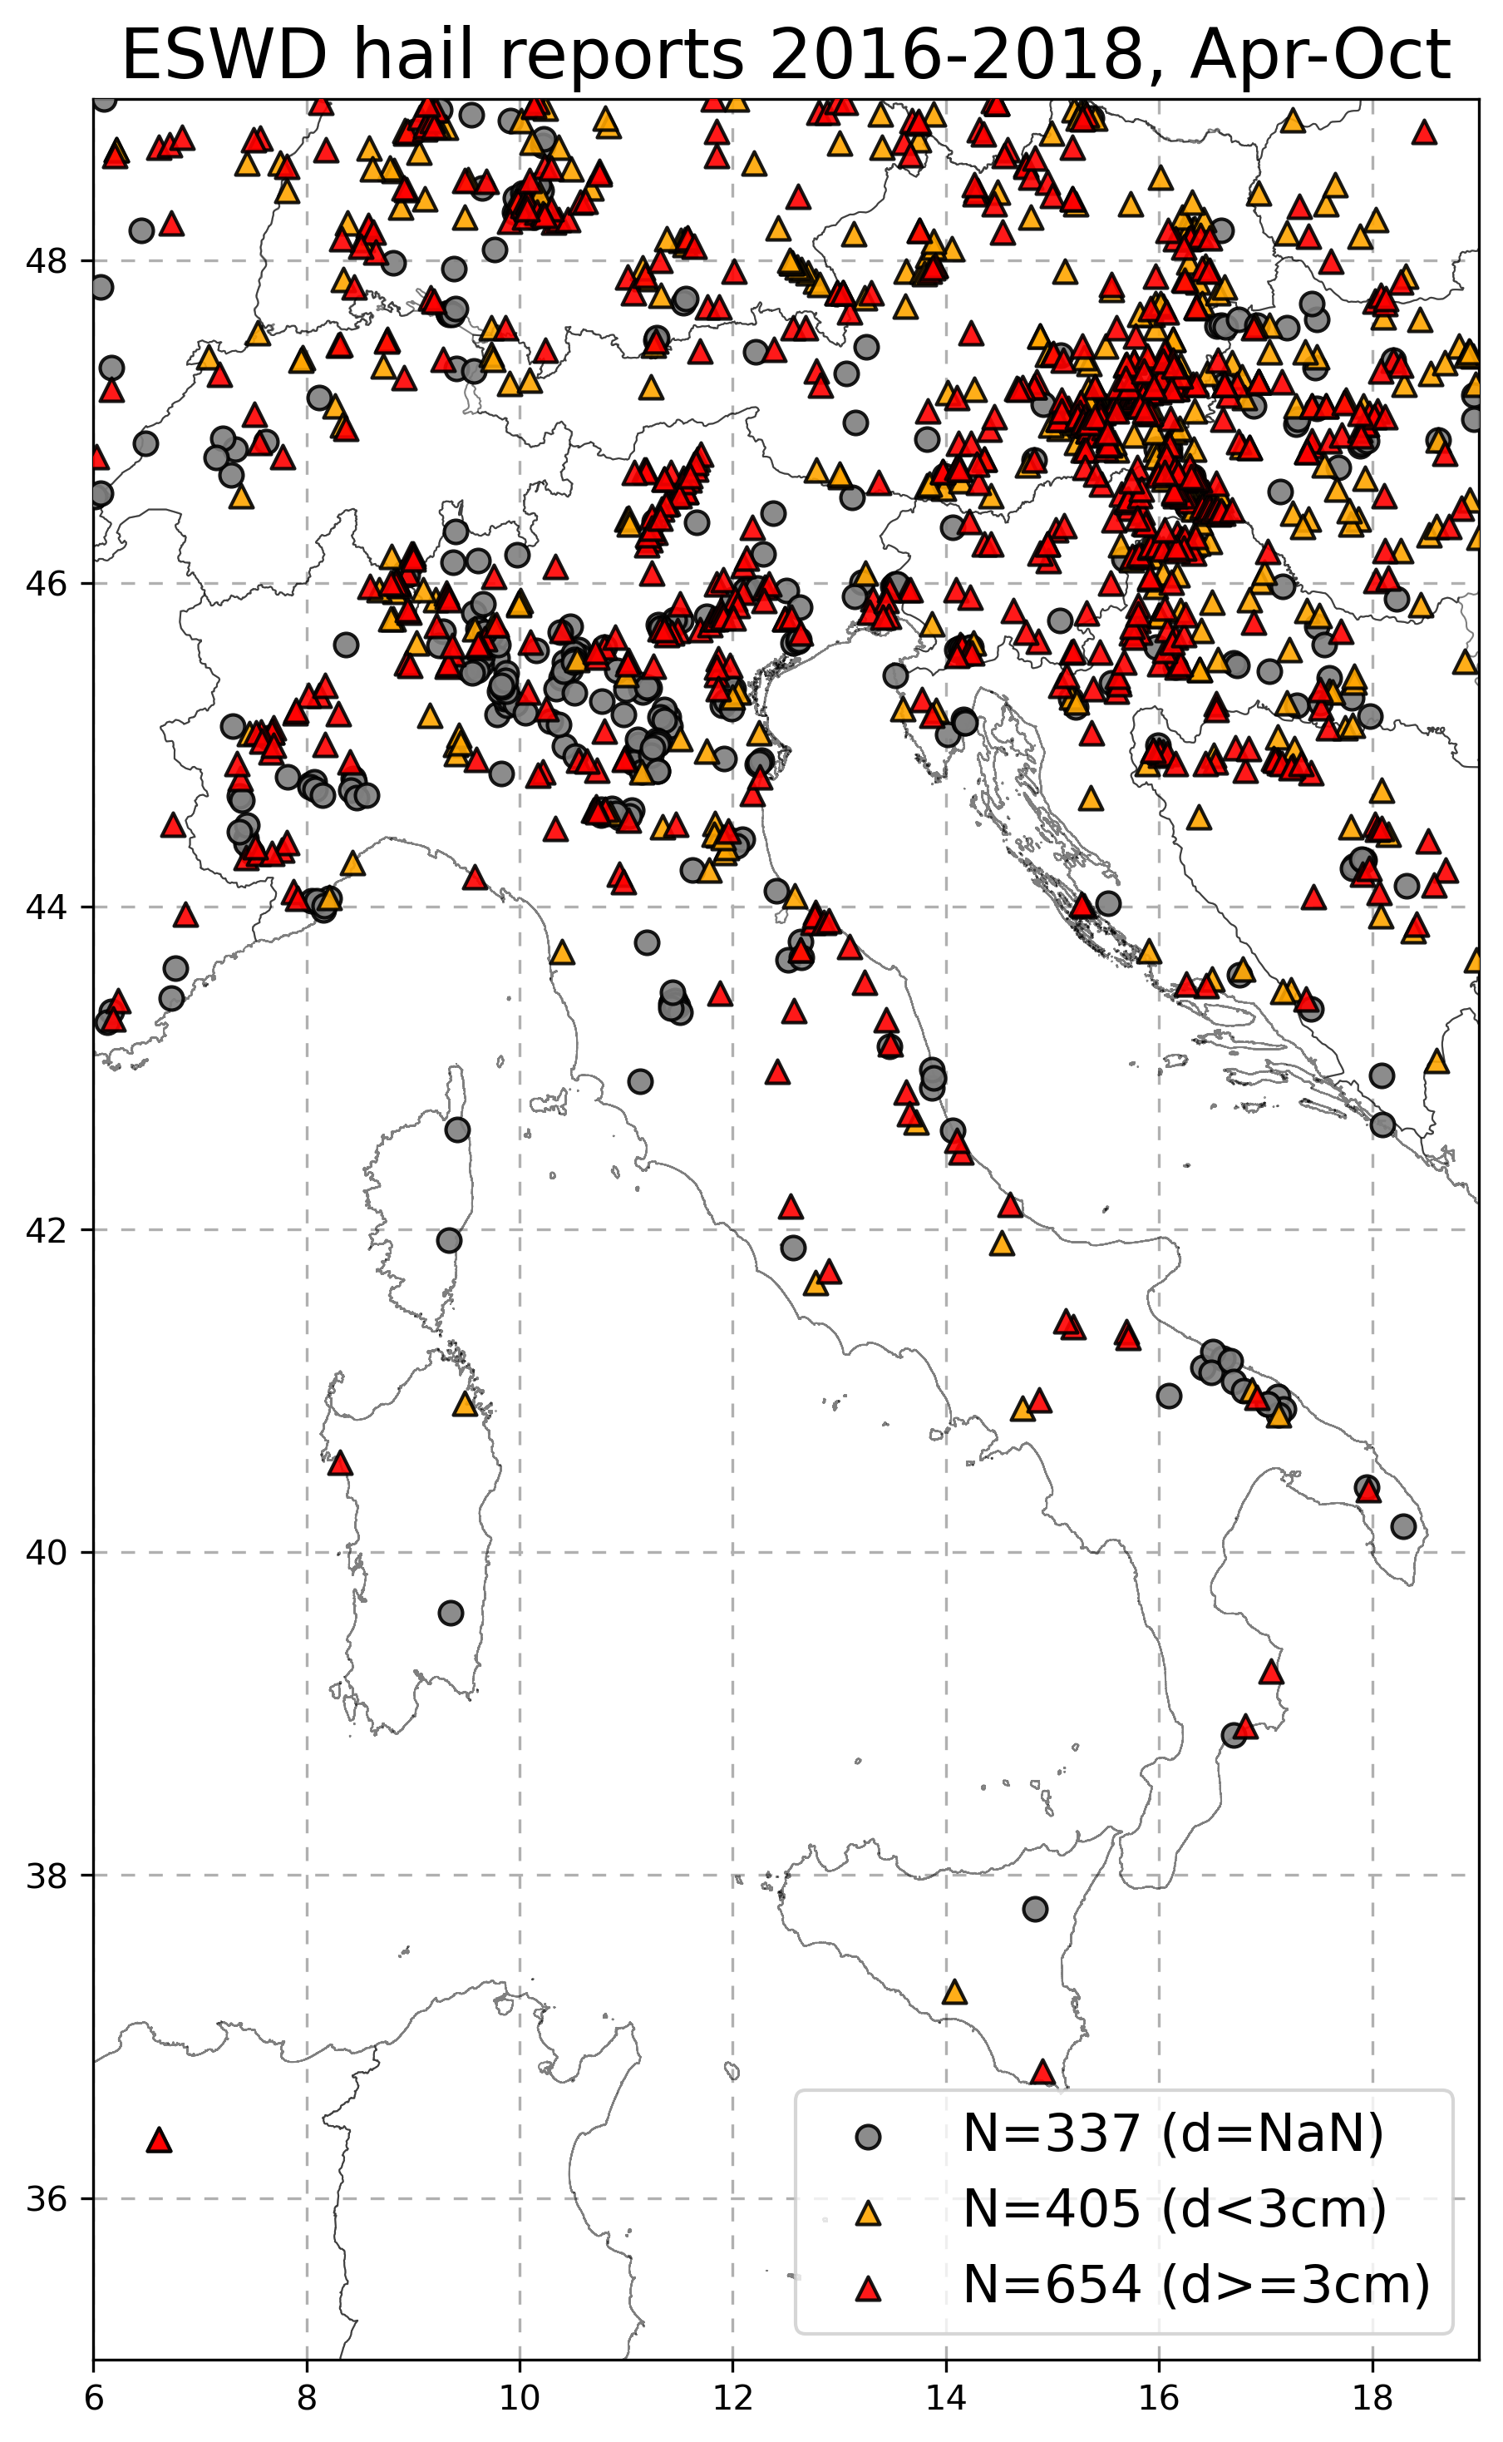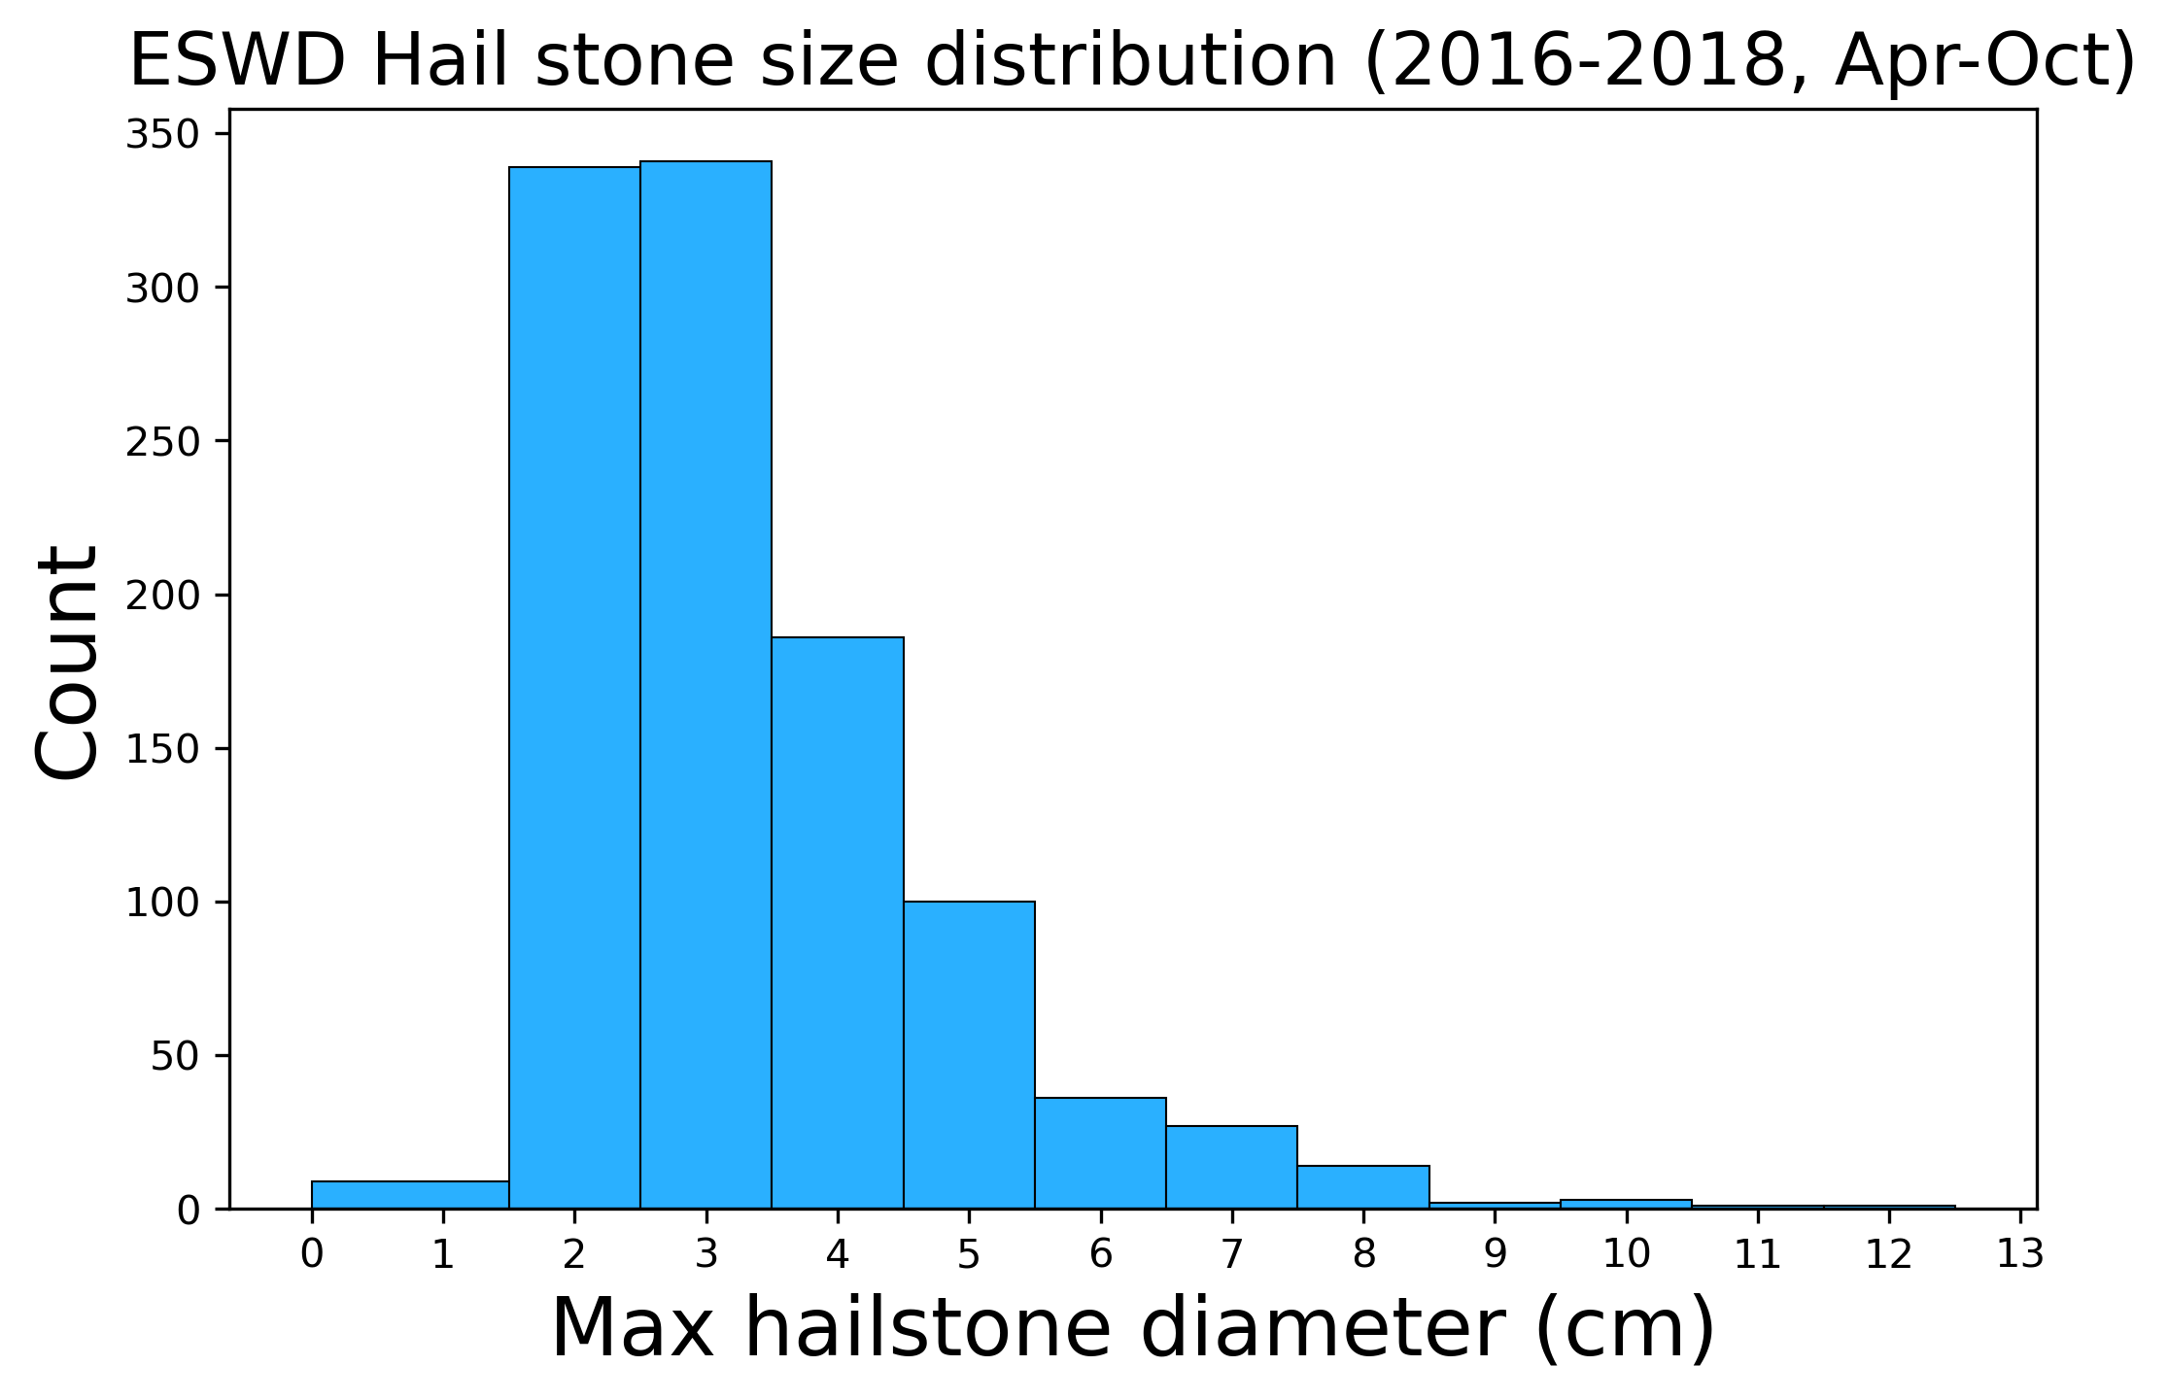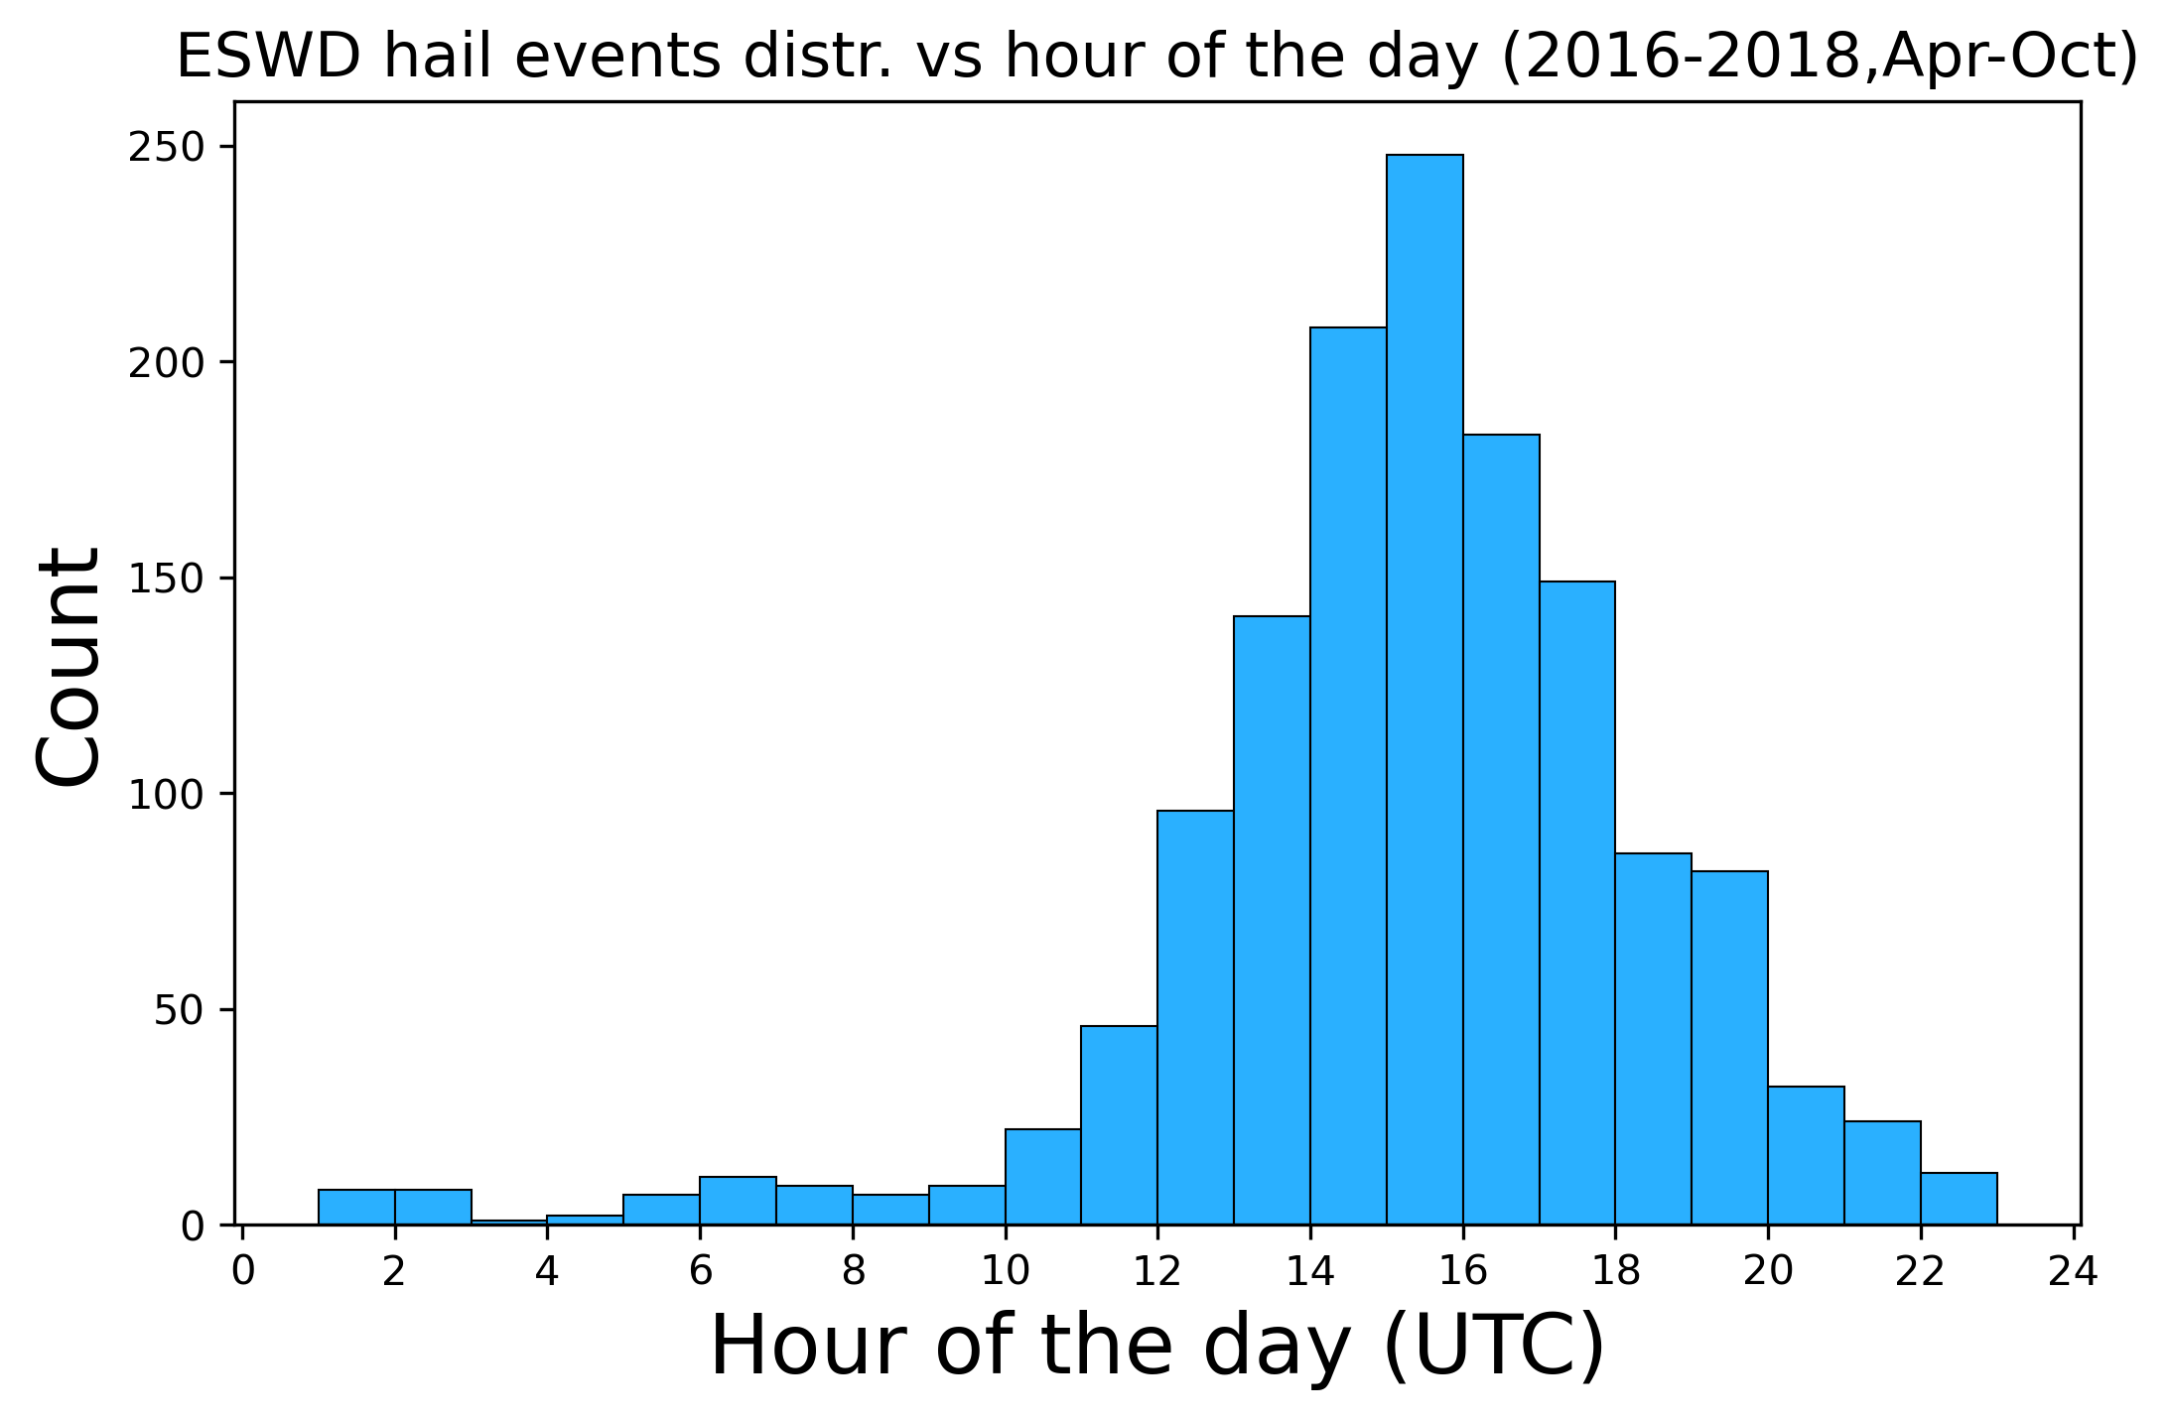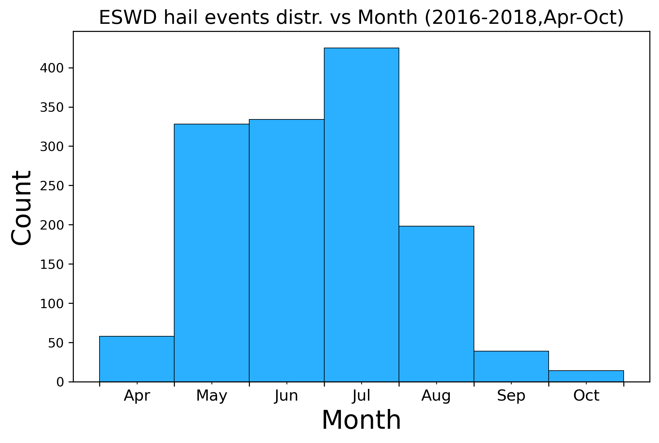

|  |  |  |  |  |  |  |  |  |
| --- | --- | --- | --- | --- | --- | --- | --- | --- |
|  | **2016** | | **2017** | | **2018** | | **2016-2018** | |
|  | **FilOT** | **AllOT** | **FilOT** | **AllOT** | **FilOT** | **AllOT** | **FilOT** | **AllOT** |
| **Tot ESWD rep.** | 437 | | 480 | | 479 | | 1396 | |
| **HITTED ESWD rep.** | 258 59% | 291 66.6% | 338  70.4% | 377  78.5% | 275  57.4% | 301  62.8% | 871  62.4% | 969  69.4% |
| **% FilOT loss on AllOT** | **-7.6%** | | **-8.1%** | | **-5.4%** | | **-7.0%** | |
|  |  |  |  |  |  |  |  |  |
| **Tot OTs (over land)** | 75568 | 106094 | 100892 | 133634 | 106579 | 152012 | 283039 | 391740 |
| **OTs HITTING ESWD** | 2127 2.81% | 2484  2.34% | 3296  3.27% | 4014  3.00% | 2505  2.35% | 2858  1.88% | 7928  2.80% | 9356  2.39% |
| **% FilOT gain on AllOT** | **+0.47%** | | **+0.27%** | | **+0.55%** | | **+0.41%** | |

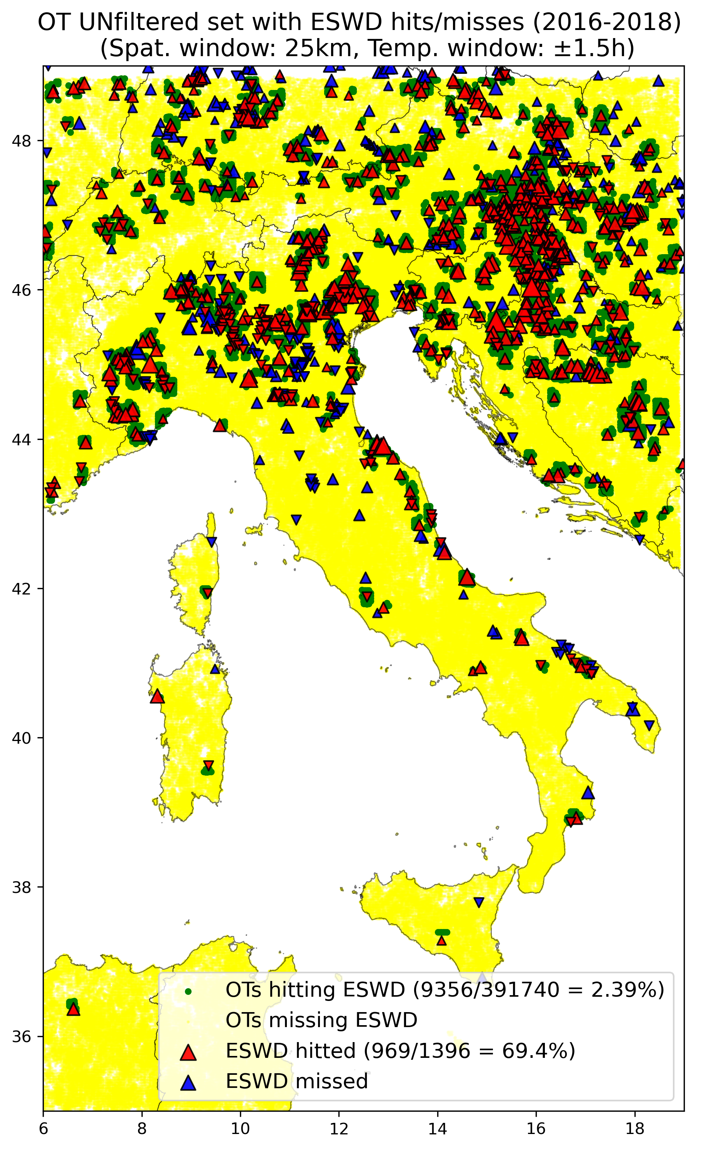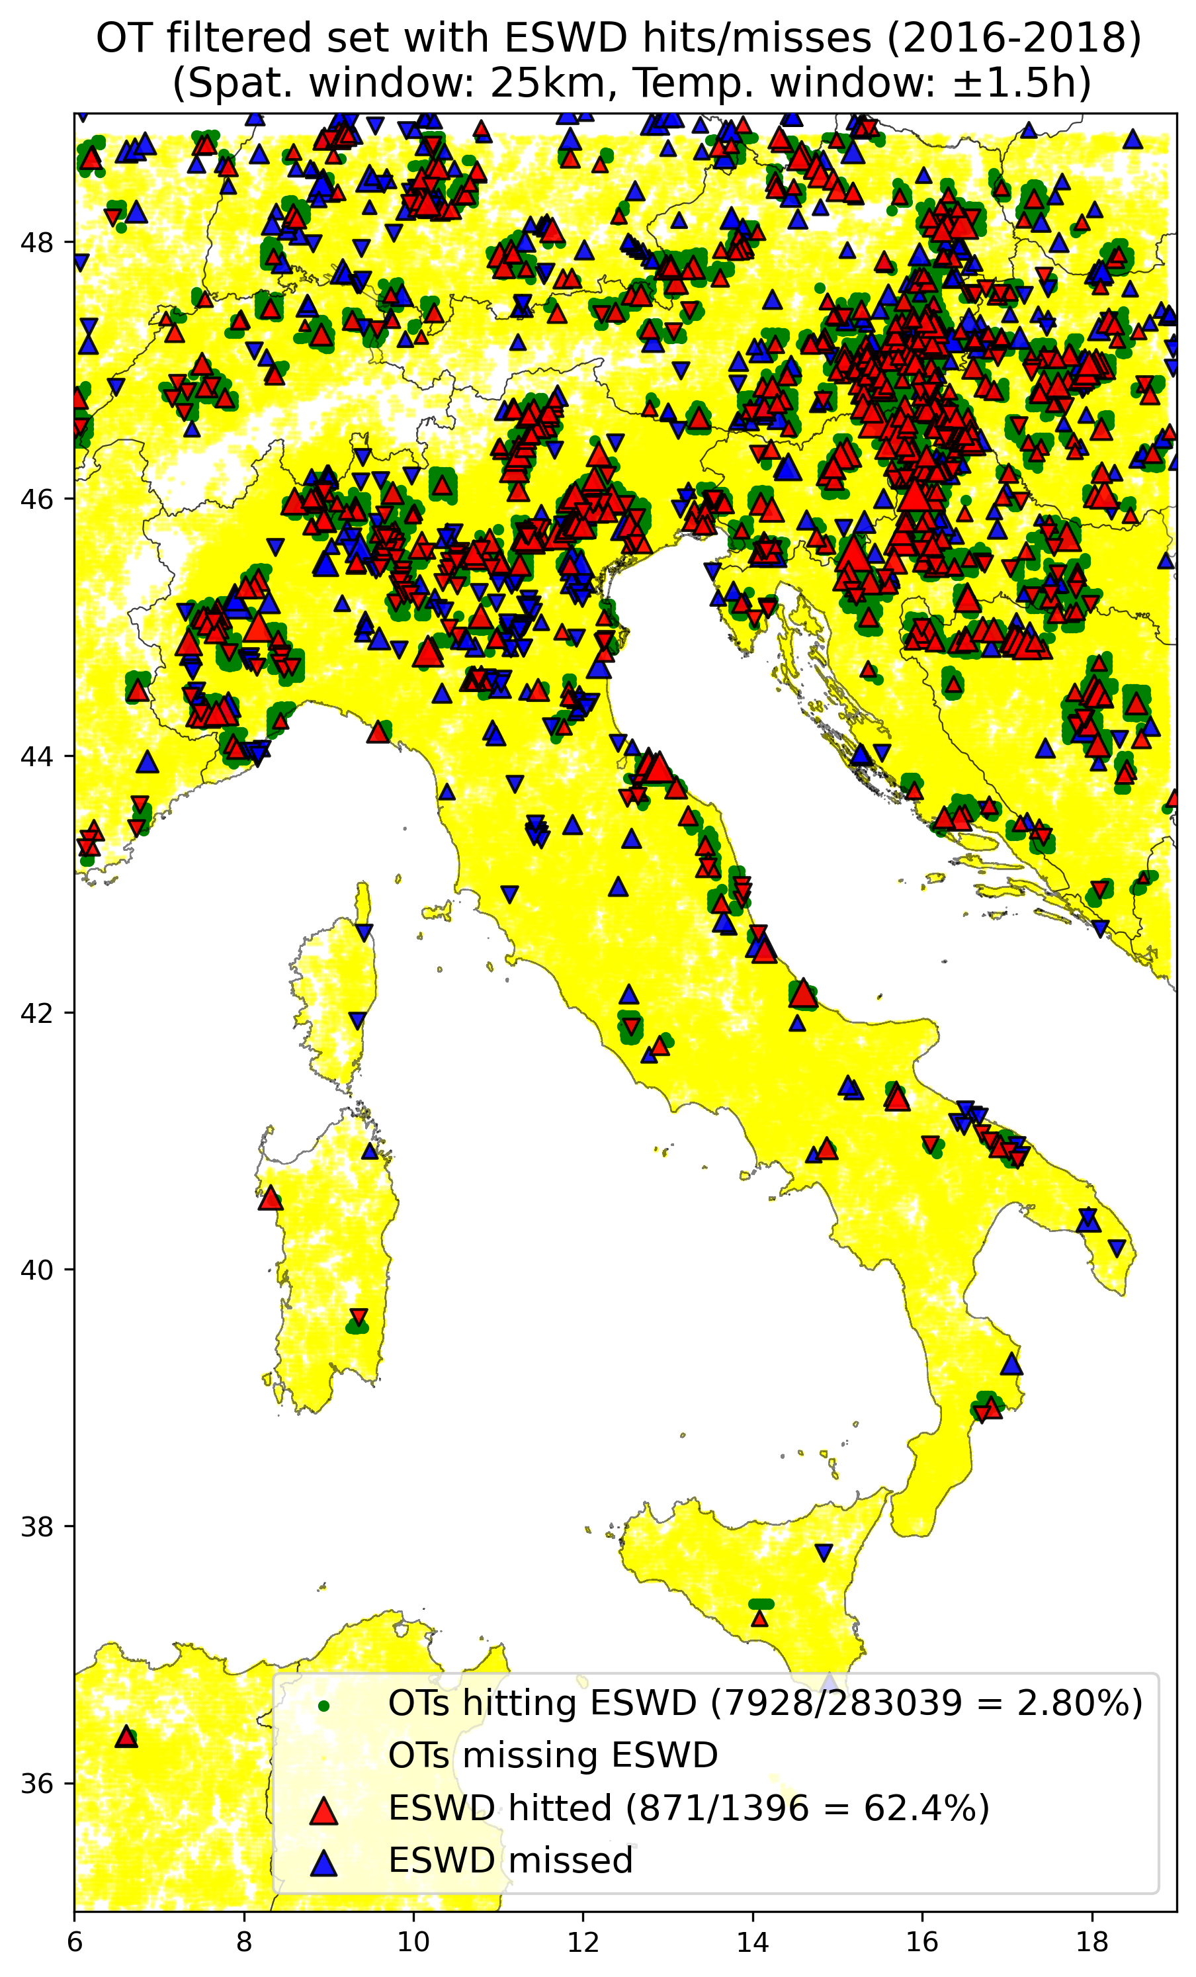

* **Validation vs UNIPOL (2017-2018)** (considering +-12h temp. window, 25km spat. Window around each OT, only over LAND and over ITALY):

All data issued at 00UTC (2988/27220, 11%) have been removed. Futhermore: a consistent portion of data is issued at 23UTC (2286/27220 = 8.4%) which cause bias after filtering (see below), remove also them?

Furthermore: 12408 reps. (46%) are issued in July

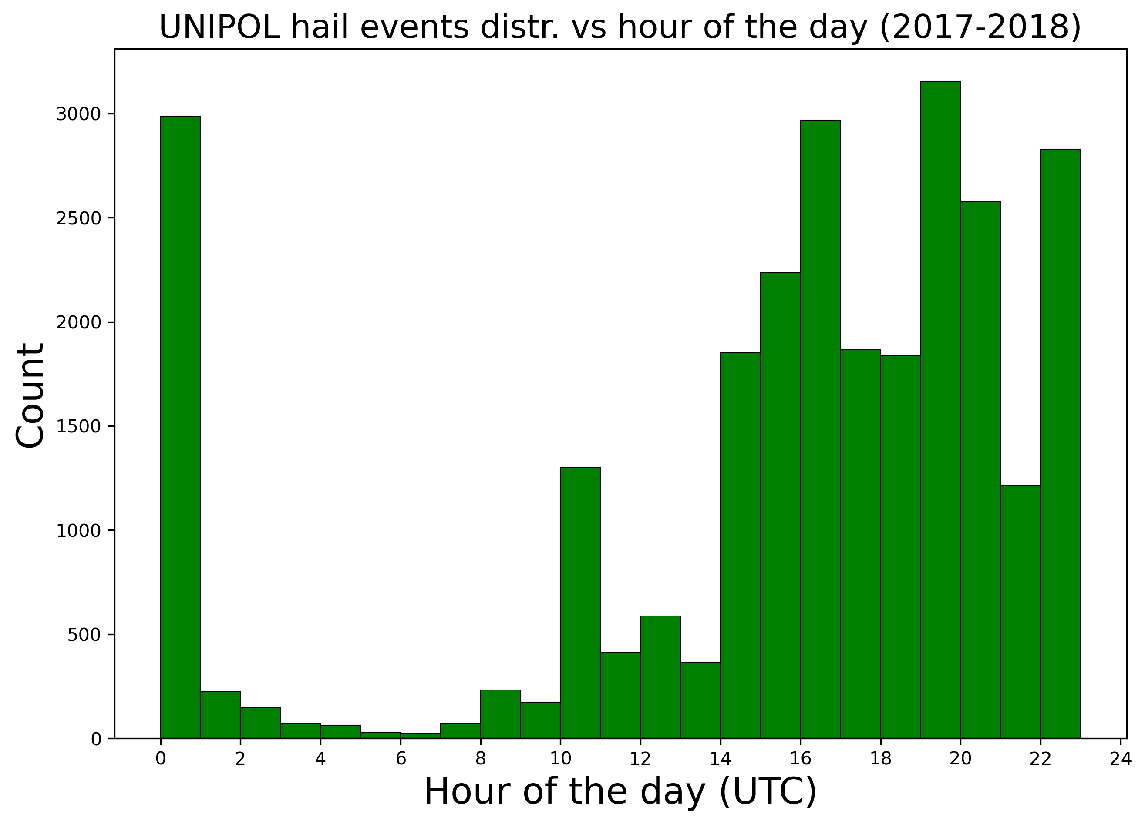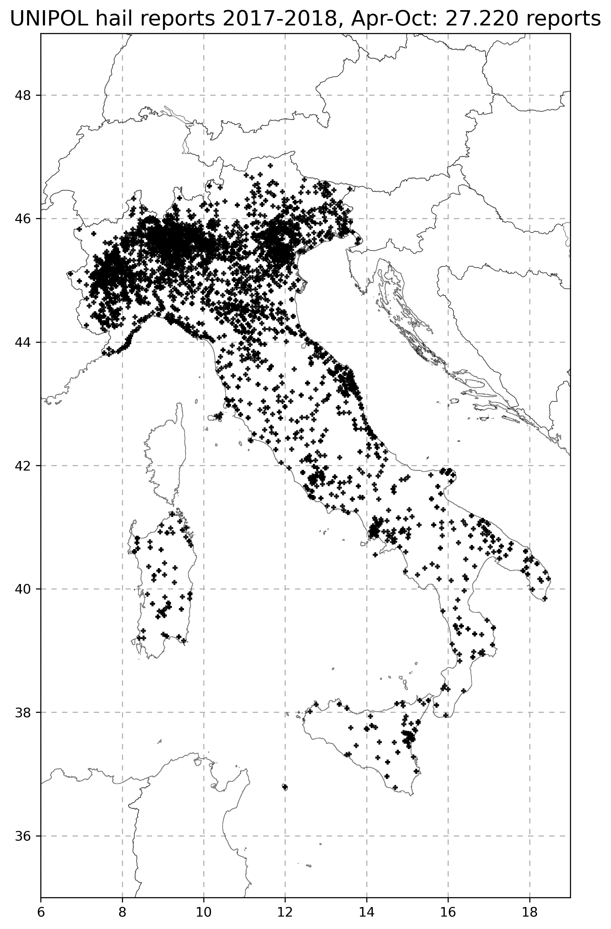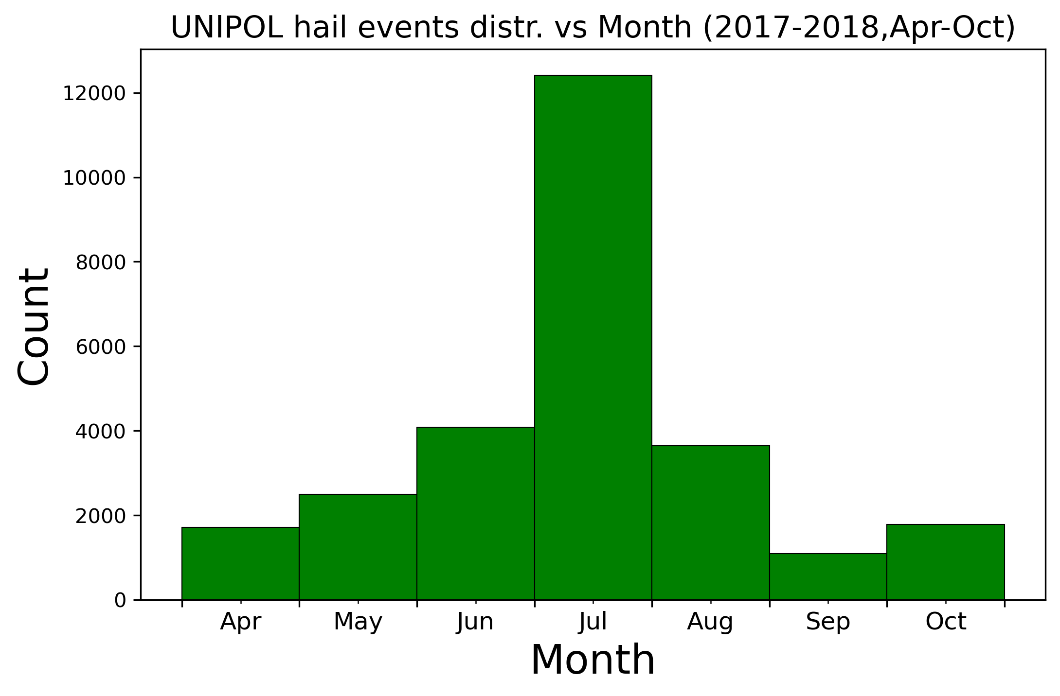

A total of 72 days with at least 1 UNIPOL report are reported in 2017, 199 days in 2018

|  |  |  |  |  |  |  |
| --- | --- | --- | --- | --- | --- | --- |
|  | **2017** | | **2018** | | **2017-2018** | |
|  | **FilOT** | **AllOT** | **FilOT** | **AllOT** | **FilOT** | **AllOT** |
| **Tot UNIPOL rep.** | 812 | | **23420** | | 24232 | |
| **HITTED UNIPOL rep.** | 368  45.3% | 378  46.6% | 4645  19.8% | 5212  22.25% | 5013  20.69% | 5590  23.07% |
| **% FilOT loss on AllOT** | **-1.3%** | | **-2.45%** | | **-2.38%** | |
|  |  |  |  |  |  |  |
| **Tot OTs (over land ITA)** | 45122 | 54333 | 48598 | 65012 | 93720 | 119345 |
| **OTs HITTING UNIPOL** | 2974  6.59% | 3153  5.80% | 11465  23.59% | 13812  21.25% | 14439  15.41% | 16965  14.22% |
| **% FilOT gain on AllOT** | **+0.79%** | | **+2.34%** | | **+1.19%** | |

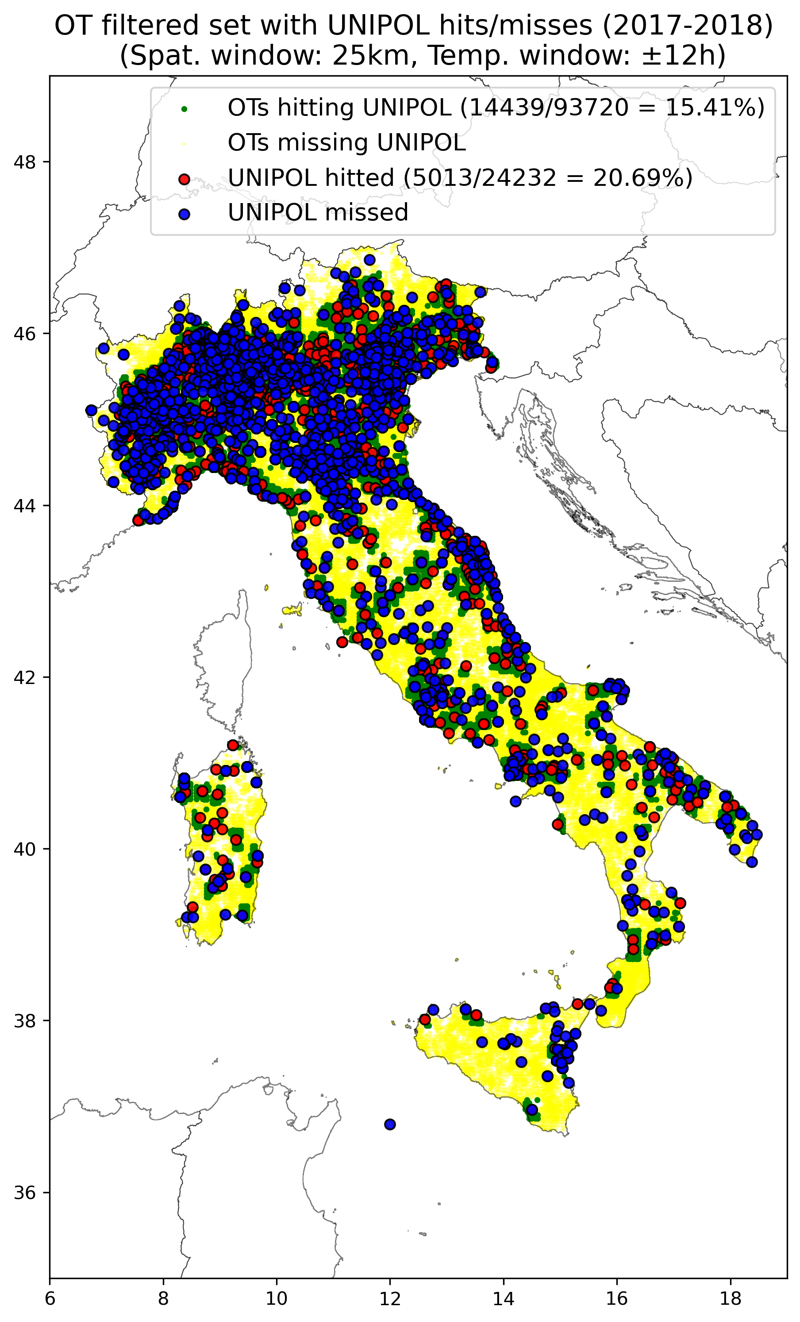

Investigating HITTED/MISSED UNIPOL reports to check if some bias is present due to some reason:

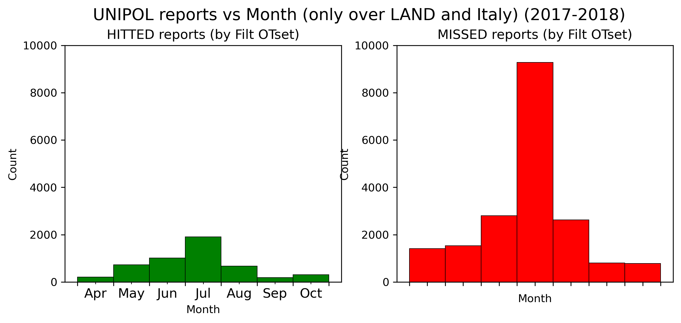

In the months no bias is detected

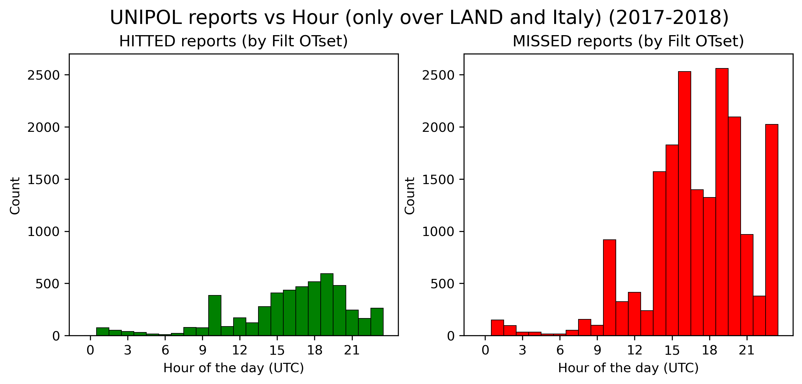

In the hour of the day a significant portion of missed events (2023/19219 i.e. 10.5%) is issued at 23UTC, could this be a bias? Maybe we should remove also all data at 23UTC?

No evident spatial bias is detected

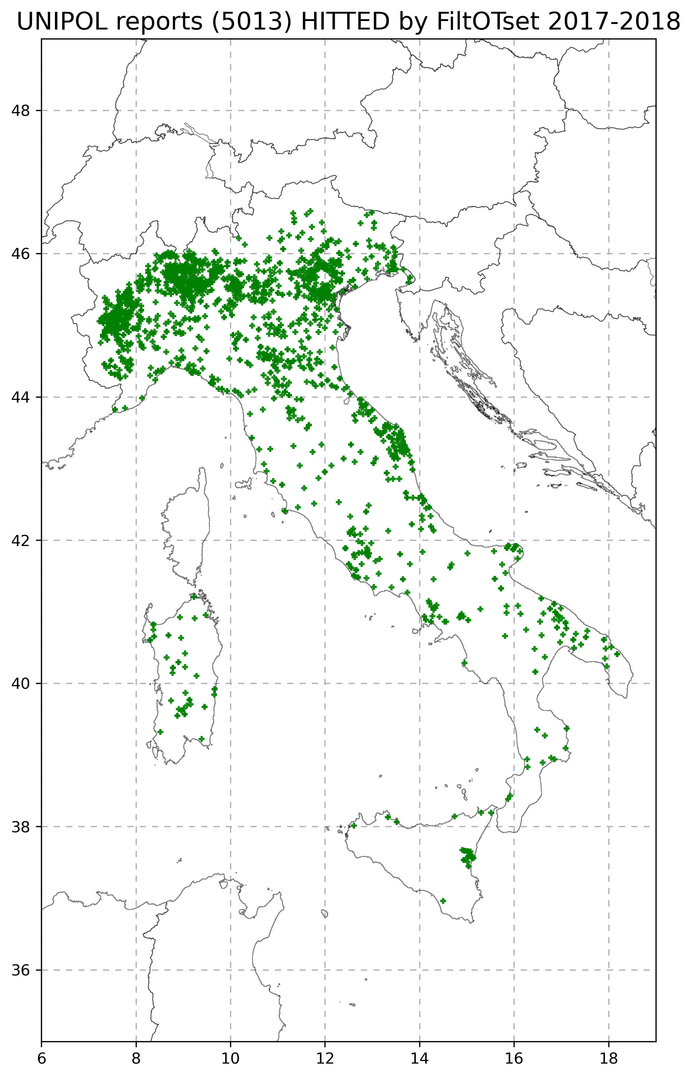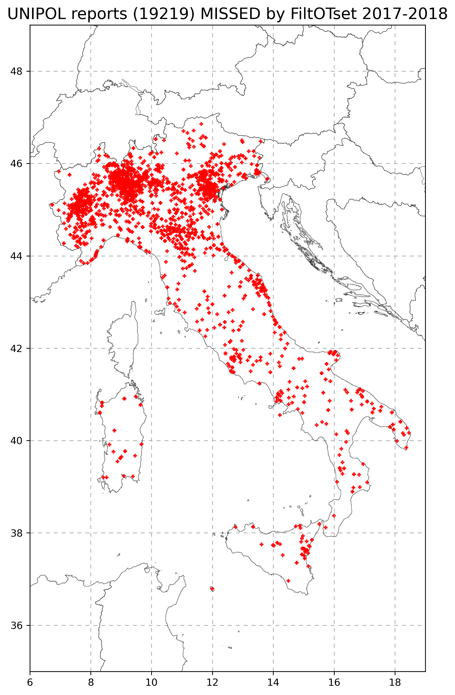

20/7

**MEETING WITH MICHAEL AND KRIS:**

* Filtering thresholds:
  + K: values obtained are higher than what HJ used (e.g. CAPE=100...), so his filter was to retain where convection at all could possibly have happened and getting rid of really gross outliers/false detections, while with the values of my filter we are more in line towards getting real hail-potential environments, and these thresholdings could potentially get rid of all those occasions where hail almost certainly has not formed (or marginal cases) (i.e. this approach get rids of the “NO” instead of emphasizing the detections) and we are left with strong updrafts in environments where hail could have possibly formed/occurred (this is the way how HJ did it in the last papers), but there’s also value in doing thing in the opposite kind of way: emphasizing hail from non-hail occurrences, which would need to change the way of doing the analyses (or along the line of machine learning, or logistic regression, or whichever tool to combine statistical parameters in getting “Yes hail” from “No hail” prediction). Theres pros and cons in both ways (probably a reviewer would be more appealed to the emphasis on hail detection than on filtering out non-possible hail occurrences).  
    Regarding machine learning approaches (since I think they could certainly provide better results): there’s hail situations presenting high CAPE-low Shear, or low CAPE-high shear environments, and trying to train a ML model with all the best possible conditions (lot of hail events, big training dataset, large area ecc) the prediction would probably be something in the middle between these two convective environments. So ML does not necessarily solve all the possible problems. Certainly with my approach (filtering OTs, which not all are correct, based on environmental hail favouring conditions) in a climatological perspective has value.  
    Furthermore with ML without having a good set of correct negatives (like instead they had in Scarino et al. 2022) things are really much more complicated!
  + M: regarding role of spatio/temporal resolution of driving reanalysis dataset for defining thresholds for parameters: CAPE values of HJ analysis were completely different mainly due to temporal frequency of ERA-Interim (6h mi pare) which had a major role in defining CAPE distribution (probably more important than spatial resolution!)
  + M: the 3 different thresholdings have been applied to all kinds of convective situations (no matter whether on a specific day there are 10 or 200 OTs), would it be possible to do some kind of separation instead? (in order to not ending up in putting too many completely different days in the same category). Michael did this in the past by looking if in a specific day and area there was a thunderstorm or not (if yes it would be categorized as “thunderstorm day”) and looked for different thresholds in the parameters, but now he would not apply this approach (different thresholdings) but instead separate the days according to the convective situation (easiest thing using number of OTs) as very different conditions are obtained if we have a very high number of thunderstorms compared to few scattered thunderstorms in a day -> Look at OT-daily distributions for each day!
* Filter results:
  + K: regarding the fact that in 2018 240.660/632.400 (38%) OTs were detected over ocean means that there were a lot of thunderstorm over ocean in that year (INVESTIGATE)
  + M: (connecting to previous point) in the filtered/unfiltered/removed OTs distributions dont consider only the number of OTs (dep. On hour or month) but also the number of days with a significant number of OTs! Because e.g. the “strange” distribution in 2018 (i.e. largest amount of OTs detected in october) could be dominated by 1 or 2 single events!
  + K: didnt have an opportunity to quality control OT data he provided, maybe there could be some bad image or something justifing the strange distribution in 2018 -> try plotting the number of OT as function of day of the year, I should see some wiggles but if in 1 day there is e.g. a huge peak it could be due to e.g. the calibration of the image was bad or something, so it would be best to withdraw these data. Must test to check quality of OT data
  + M: we also have to remember that there is a huge year-to-year variability: e.g. last year was one of the year with the smaller number of thunderstorm in northern Italy ever seen (using lightning data and convective days), which firstly suggested in their analysis to have used corrupted data or technical issues but in the end it seemed to be not the case, so there could be large uncertainty and must not be too “strict” in judging the distribution of data (especially when considering such a short period like only 3 years). So: must check there is not technical issues first  
    Besides the hihg number of OT in October it is also a bit weird the gaps in OT frequency in July and September
  + K: spatial distribution: since we are using H0 as parameter in the filtering, I wonder if in complex terrain areas with topography around 3-4000m the freezing level is appropriate for filtering -> It would be interesting to see which are the individual contributions to the filter of the singular parameters (like HJ did in 2017 paper) to check which one is doing the main work in different areas, and this could help adjusting a little bit the filtering approach  
    e.g. also the area in Slovenia-Austria-NE Italy which is the most affected by filter removal is one of the main hail hotspot in central Europe, so an high removal rate there is questionable.  
    M: in 2017 HJ showed that H0 was most effecting in filtering OTs mostly in northern Africa, and was not directly related to topography (but of course its case used a much coarser resolution and the Alps were not good represented)
  + M: for spatial maps: use same scale of the colorbars for comparison!!!
  + K: having obtained a hit rate of filtered OT set vs ESWD data of 62% is a pretty good result. We have to remember regarding OT data, that having an image every 15 minutes limit the data representativity of deep convective phenomena as a lot can happen in a storm in 15 minutes  
    M: maybe it would be interesting to see where we obtained a higher hit rate in the geographic region, as Italy is a rather stretched region in N-S direction there are huge differences in convective conditions over the whole area, so
  + M: an idea could be to use the ambient conditions not only to define the filter but to train a model to our ambient conditions to estimate convective conditions for a climatological period of 30 years or so (HOW TO??). There is a bunch of literature using ambient conditions to quantify thunderstorm frequency, but M is very skeptical about that because there is big discrepancy between frequent favourable modelled convective conditions and the decrease in lightning activity, BUT there is no other possibilities as we dont have data for a 30 years period long, so using an estimate from ambient conditions and trying to separate different characteristics of the events and different states of the atmosphere leading to the same final result (convective hailstorms) (as e.g. the low-shear high CAPE/high-shear low CAPE hail environments). This is towards the approach of Anya Radler who published two papers dedicated to conv storms of different intensity (hail sizes) which she related to ambient conditions and quantified:
    - In 1st paper the trends: “Detecting Severe Weather Trends Using an Additive Regressive Convective Hazard Model (AR-CHaMo)” <https://journals.ametsoc.org/view/journals/apme/57/3/jamc-d-17-0132.1.xml?rskey=JBIS1V&result=1>
    - In 2nd paper what can be expected in the future: “Frequency of severe thunderstorms across Europe expected to increase in the 21st century due to rising instability” <https://www.nature.com/articles/s41612-019-0083-7.pdf>
  + Maybe it could make sense to apply this method to separate between different states of the atmosphere and going one step beyond: try to separate the sample according to convective activity to focus on days with huge number of OT events, or events producing a huge number of OTs which are certainly different kinds of convective storms compared to those producing only few OTs. K: Applying this for each ambient parameter and looking at the whole population for the hitted/missed eswd samples separately maybe some different separation could emerge, look at parameter x parameter spaces (eg compare CAPE and shear) and see if there are some different kinds of constraint than the typical hail environment (ie high CAPE high shear), so detect more unusual convective regimes favourable for hail to get an idea if the filter is ineffective for some kinds of regimes and cause some events to be missed as well
  + K: It could be also useful perhaps to take a look at the tropopause relative brightest temperature for the OTs of the hitted eswd events sample vs the missed ones to understand whether if those storms we missed were characterized by really low tops and really warm and there is no way the OT algorithm would ever detect that (because if it would have been designed to detect also these marginal kind of events we would obtain a lot of false alarms also)
* Next directions:
  + Extending to 2019-2020 would be a really good point (and I think one of the less time consuming tasks)
  + M: we could consider to employ also a different reanalysis dataset from EURO-CORDEX also to compare with SPHERA quantify what is the effect of the spatial/temporal resolution (he did a similar thing in a paper couple of years ago (I think its Kunz et al., 2020) with ERA-Interim and downscaling of ERA-Interim and turned out that for dynamical parameters (DLS or SRH) the spatial/temporal res. did not really matter, but it mattered for thermodynamical parameters (CAPE,SLI) mainly in terms of high temporal resolution of 1h which made a big difference) -> this in order to answer the question which kind of resolution is needed to adequately build up a relationship between OTs and ambient conditions
  + K: for other data validation: Im welcome to access passive microwave data (GPM, AMSR)
  + K: lightning data: maybe we could compare lightning flash rates in general matching ESWD reports and see if there is some steady progression/dependency with hail severity (like between SPHERA ingredients and ESWD hail severity as shown from the CDFs) and see if the storms producing the bigger hail give the more dense lightning or not, and if so a map could be developed to see a hailstorm-lightning activity relationship (but this is probably not so usefull and kind of much less sophisticated of what I already obtained)
  + K: if I think the best thing would be to extend to 2019-2020 Kris could provide the OT data in the next month or so, I just have to inform him through the summary!

Write and send a summary to M and K on the outcome of the meeting and the next directions I intend to pursue in order all of us to agree on that